Title
A Psychological Intervention with Virtual Reality-Based Exposure and Exercise Training to Reduce Social Physique Anxiety in Women with Obesity: A Feasibility Randomized Controlled Trial

Running title
Psychological Intervention with VR and exercise for SPA

Authors
Aurélie Baillot^{1,2,3}, Giulia Corno^{3,7,9}, Jennifer Brunet⁴, Laura Torres Duque^{2,5}, Marine Asselin⁶, Julia Hussien, Shaina Gabriel⁷, Stéphane Bouchard ^{3, 7, 8}, Ahmed Jérôme Romain^{9,10}, Annie Aimé⁷

Affiliations
¹ École Interdisciplinaire de Santé, Université du Québec en Outaouais, Gatineau, Québec, Canada
² Institut du Savoir Montfort, Ottawa, Ontario, Canada
³ Centre de Recherche du Centre Intégré de Santé et Services Sociaux de L'Outaouais, Gatineau, Québec, Canada
⁴ School of Human Kinetics, Faculty of Health Sciences, University of Ottawa, Ottawa, Ontario, Canada
⁵ Institut Santé et Société, Faculté des sciences humaines, Université du Québec à Montréal, Montréal, Québec, Canada
⁶ Université de Lorraine, 2LPN, F-57000 Metz, France
7 Département de Psychoéducation et de psychologie, Université du Québec en Outaouais, Gatineau/St-Jérôme, Québec, Canada
⁸ HEI‐Lab: Digital Human‐Environment Interaction Lab, Lusófona University, Lisbon, Portugal
⁹ Centre de recherche de l’Institut Universitaire de Santé Mentale de Montréal, Montréal, Canada
¹⁰ École de Kinésiologie et des Sciences de l’Activité Physique, Faculté de Médecine, Université de Montréal, Montréal, Canada

Corresponding author: aurelie.baillot@uqo.ca
ORCiD
Aurélie Baillot: https://orcid.org/0000-0003-4874-0481
Giulia Corno: https://orcid.org/0000-0003-0308-3908
Jennifer Brunet: https://orcid.org/0000-0003-3242-5444
Laura Torres Duque: https://orcid.org/0009-0008-9381-7963
Marine Asselin: https://orcid.org/0000-0001-5128-2755
Julia Hussien: https://orcid.org/0000-0001-7434-228X
Stéphane Bouchard: https://orcid.org/0000-0002-5995-340X
Ahmed Jérôme Romain: https://orcid.org/0000-0003-1690-1375
Annie Aimé: https://orcid.org/0000-0002-9081-4440

Ethics and Integrity statements
Trial registration: The study protocol was registered on clinicaltrials.gov (NCT04630184; 2020-11-03)

Funding
This project was funded by Institut du Savoir Monfort (2020-012 VIRTUAL R)

Ethics approval statement
Human research ethics committees approved the study protocol [Montfort Hospital (20-21-11-035), Centre Intégré de Soins et de Services de Santé de l’Outaouais (CISSSO) (2020-322_180), and Université du Québec en Outaouais (UQO) (2021-1591)].

Conflict of interest statement
The authors report no conflict of interest.

Data availability
The raw data are available upon reasonable request.

Citation
Baillot, A., Corno, G., Brunet, J., Duque, L. T., Asselin, M., Hussien, J., … Aimé, A. (n.d.). A Psychological Intervention with Virtual Reality-Based Exposure and Exercise Training to Reduce Social Physique Anxiety in Women with Obesity: A Feasibility Randomized Controlled Trial. Retrieved from osf.io/preprints/psyarxiv/f5y7b_v1
Title
A Psychological Intervention with Virtual Reality-Based Exposure and Exercise Training to Reduce Social Physique Anxiety in Women with Obesity: A Feasibility Randomized Controlled Trial

Abstract
This feasibility randomized controlled trial: (i) assessed the feasibility and acceptability of a cognitive-behavioral therapy intervention with virtual reality-based exposure plus exercise training (CBTVR+ET) in women with obesity and study protocol, and (ii) provided SPA data to inform a future full-scale trial. Forty-five women with obesity were randomized to: (i) CBTVR+ET, (ii) a psychological supportive intervention plus exercise training, or (iii) a waitlist group. Feasibility data (e.g. recruitment, retention, attendance) were compared against predetermined targets. Acceptability was assessed via questionnaires and interviews. SPA was measured with questionnaires at baseline, post intervention, and six-month follow-up.
Over a 19-month, 8.4 participants were recruited monthly. Retention was 86.7% (two dropouts per group). Attendance rates were ≥ 85 % for psychological and exercise sessions. All feasibility targets were met. Acceptability data were positive, though interviews identified areas requiring refinement. To report on critical parameters needed for the future trial, SPA scores in the CBTVR+ET group were 37.3±5.1 and 30.8±6.4 at baseline and post-intervention, respectively (Hedge’s g=-1.13), with baseline-post correlation of r=0.567 across groups. The intervention and study methods are viable for a full-scale trial, pending revisions. A definitive trial is warranted to provide robust efficacy evidence for this intervention addressing SPA in women with obesity.

Keywords: body image, cognitive behavioral therapy, virtual reality, obesity, women, physical activity

Introduction
Physical activity (PA) improves both physical (e.g., physical fitness, cardiometabolic risk factors) and mental health outcomes (e.g., well-being, depression) (Pedersen & Saltin, 2015), and can also contribute to the reduce risk of certain diseases (e.g., type 2 diabetes, hypertension) (Pedersen & Saltin, 2015). Still, many adults do not meet PA recommendations of 150 minutes of moderate-to-high intensity PA (MHPA) per week (Baillot et al., 2022). Moreover, women are less likely to meet PA recommendations than men (Colley et al., 2023). Addressing factors that may lead women to avoid PA, such as social physique anxiety (SPA) that is a subtype of social anxiety that refers to a person’s concerns about a perceived or actual negative evaluation of their physical appearance by others (Hart et al., 1989), is essential to increase PA levels.
Studies suggest that SPA is associated with PA-related attitudes and behaviors, and that exercising in public PA environments can increase SPA (Frederick & Morrison, 1996; Sabiston et al., 2014). The social (e.g., presence of others) and physical environments (e.g., lined with mirrors), along with situations with particular attention to physical appearance (e.g., gym, swimming) can amplify body image concerns for women, especially among individuals who internalized socially prescribed appearance ideals that are unrealistic and distant from their own bodies (Karazsia et al., 2017; Paterna et al., 2021). In response, individuals with high SPA may avoid situations where their bodies might be visible or evaluated, such as engaging in PA. However, it may motivate some individuals with high SPA to increase their PA to align with perceived societal ideals, which represents an external motivation for PA. Notably, external motivation for PA can be detrimental to mental health and lead to negative emotions like frustration if people do not measure up to the internalized ideal. In addition to impacting PA participation, SPA has also been found to predict low competence, low enjoyment, increased self-consciousness, and low self-efficacy related to PA (Brunet & Sabiston, 2009; Cox et al., 2011; Marquez & McAuley, 2001; Ransdell et al., 1998), creating a negative feedback loop, putting individuals at higher risk of dropping out.
Besides, women with a higher body mass index (BMI) are more likely to report body image concerns and SPA (Hausenblas et al., 2004; Treasure et al., 1998; Zartaloudi et al., 2023). Feelings of dissatisfaction based on one’s physical appearance, body shape, and/or body size is more common among women with obesity than among women with lower weight status (Weinberger et al., 2016), leading to avoidance of PA (Baillot et al., 2021). In turn, avoidance of PA can contribute to worsening physical and psychological health outcomes. Some strategies such as wearing baggy clothes, opting for PA in private spaces, or finding more inclusive PA environments (e.g., women-only gym) may help people feel less exposed and reduce the fear of being negatively evaluated by others during PA. However, reducing exposure or increasing avoidance to PA settings to prevent social scrutiny can contribute to the maintenance of maladaptive beliefs and the intensification of fear of judgment (Tolin, 2016), in part, because such strategies do not help people overcome their fear of being negatively evaluated by others regarding their physical appearance during PA.
Cognitive-behavioral therapy (CBT) could be a treatment of choice for addressing SPA in PA settings as it is considered as the most effective treatment for anxiety-related disorders disturbances (Bouchard et al., 2017; Fernandez-Alvarez et al., 2019; Knowles & Tolin, 2022) and it is widely used for body image disturbances (Farrell et al., 2006; Magrini et al., 2022). Alongside CBT-based psychological intervention, exposure-based interventions, wherein individuals are exposed to the feared and avoided stimulus until their distress diminishes, or a sense of mastery is attained (Tolin, 2016), should be considered. For SPA, this would involve being exposed to social situations where their body would be exposed and they would fear negative judgement from others like a pool or a gym. Several mechanisms are theorized to be at work during exposure, such as extinction of the emotional (fear) response through inhibitory learning, fear tolerance, and increased self-efficacy (Bouton, 1993; Craske et al., 2008; Knowles & Tolin, 2022; Tolin, 2016). Exposure-based therapy has demonstrated efficacy for social anxiety, suggesting it could help address SPA (Bouchard et al., 2017; Shahid et al., 2024). However, having a clinician intervene during “real-world” SPA-inducing situations can lead to incomplete exposure (e.g., if others are not present) and unplanned exposure because it is hard to control the stimulus and ensure a safe exposure. Therefore, virtual reality (VR) exposure therapy is emerging as an alternative because it provides a safe, adaptive, and controlled environment for facing fears. Importantly, the use of VR has been found to be as effective as “in-vivo” exposure interventions in the treatment of social anxiety (Bouchard et al., 2017; Wong et al., 2023). VR is already used in the treatment of eating disorders and body dissatisfaction in individuals with obesity, and has been well accepted by this population (Bell et al., 2024; Manzoni et al., 2016; Riva et al., 2003), but has yet to be employed to reduce SPA.
Current study
The main aim of the current study was to assess the feasibility and acceptability of a study protocol and a CBT-based psychological intervention involving VR-based exposure and exercise training in women with obesity. The secondary aim was to provide data on trait SPA (primary outcome for future efficacy trial), body appreciation, weight bias internalisation, and PA behavior (secondary outcomes for future efficacy trial) to inform a future full-scale trial.
It was hypothesized that the study protocol and the intervention would be feasible based on a priori satisfaction feasibility criteria being met. A priori feasibility criteria targets were set based on our experience, our regional context without a clinic dedicated to obesity management reducing recruitment opportunities and scientific literature (Eldridge et al., 2016; Fernandez et al., 2015; Fewtrell et al., 2008; Teresi et al., 2022); these were: (1) recruitment rate ≥ 5.6 prospective participants screened per month, (2) refusal rate ≤ 30% of persons who declined to participate in the study during the screening, (3) study retention rate ≥ 70% of participants who provided consent to participate complete post-intervention assessments (T2), (4) missing data ≤ 10% of overall data, (5) randomization acceptance rate ≥ 90% of participants accept their group assignment, (6) intervention attendance rate ≥ 80% of overall supervised intervention sessions offered (k=32), and (7) intervention attrition rate ≤ 20% of participants would not complete the intervention after starting it.
This manuscript presents the results related to feasibility and acceptability outcomes, primary and secondary outcomes for a future full-scale trial, along with sample characteristics. Results on exploratory outcomes (i.e., state SPA) and key theoretical constructs that predict initiation and maintenance of PA (enjoyment, motivation, self-efficacy, affects and perceived effort) will be presented in forthcoming communication.
Materials and Methods
Study Design, Reporting, Registration, and Ethics
This study was a three-arm parallel randomized controlled feasibility trial. The Consolidated Standards of Reporting Trials (CONSORT) reporting standards for extension to randomized pilot and feasibility trials (Eldridge et al., 2016) and the Template for Intervention Description and Replication (TIDieR) (Hoffmann et al., 2014) were followed to report this study and results (Supplemental File, Appendix A). The study protocol was registered on clinicaltrials.gov (Anonymized), and amendments to the registered protocol are presented in Supplemental File, Appendix B. Written informed consent was obtained from all study participants by the research assistants during the first in-person visit at UQO prior to their participation and human research ethics committees approved the study protocol UQO.

Recruitment and Participants
A target sample size of (15 participants per arm) was pre-specified for this feasibility trial as this sample size has previously been found to be acceptable for feasibility studies (Whitehead et al., 2016). Forty five participants were recruited over a 19-month period (August 2021 – March 2023), through the distribution and posting on bulletin boards of a recruitment flyers: (1) on site and by emails to employees at the UQO, (2) on site at Montfort Hospital, (3) on local Facebook pages, and (4) on the UQO campus and surrounding neighborhoods. Participants self-referred to the study by contacting a research assistant by email or telephone, after which point an initial telephone interview was scheduled to determine eligibility. If eligible, participants were scheduled for an in-person initial assessment session at UQO.
To participate, individuals had to meet the following inclusion criteria: (1) self-identify as a woman, (2) self-report < 150 minutes of MHPA per week with the Global PA Questionnaire (GPAQ), (3) be between 18 and 45 years of age, (4) have a BMI ≥ 30 kg/m², and (4) be able to attend sessions at the study site (UQO) twice weekly for 12 consecutive weeks. Participants were excluded if they: (1) scored < 27 out of 45 on the SPA scale (assessed at the initial phone interview), (2) reported severe motion sickness, epilepsy, and/or vestibular disorder(s), (3) were currently pregnant or intending to become pregnant within the next year, (4) were taking weight loss medication(s) (e.g., liraglutide [Saxenda®], naltrexone/bupropion [Contrave®], orlistat [Xenical®]), (5) had undergone metabolic and bariatric surgery, (6) had a physical contraindication to PA (assessed with the Get Active Questionnaire (Canadian Society for Exercise Physiology, 2017)), (7) had participated in a supervised PA program within the last six months, or (8) self-reported any of the following (a) an intellectual disability, (b) severe, persistent, diagnosed psychiatric disorders (e.g., psychosis, bipolar disorder), or (c) bulimia. Additionally, individuals currently undergoing psychotherapy were excluded from the study but invited to contact the research team for potential future participation after completing their psychotherapy.

Randomization
After baseline assessments, participants were randomly assigned (1:1:1 allocation ratio) using computer-generated random numbers (studyrandomizer.com) to: Group 1 – CBT-based psychological intervention with VR-based exposure and exercise training (CBTVR+ET), Group 2 – psychological supportive intervention and exercise training (ST+ET), or Group 3 – waitlist without intervention (WL). A second randomization schedule was generated using computer-generated random numbers (studyrandomizer.com) to assign WL participants to CBTVR+ET or the ST+ET (1:1 allocation) after their waiting time. Randomization was performed by the first author (AB), and the initial and second schedules were sealed in opaque envelopes and only known after the initial assessment to the study participants and to the psychologists delivering the CBTVR or ST. The kinesiologists delivering the exercise training and research assistants assessing the participants remained blind to group assignment.

Data Collection Procedures
The following sections describe the data collection procedures, intervention, and outcomes relevant to this publication. All participants completed a baseline evaluation session at the UQO prior to randomization (T1), and two more assessments: post-intervention (approximately one-week post-intervention; T2), and six-month follow-up (T3). Participants in the WL group also completed an assessment at the end of their three-month wait time (T1wait), before beginning the intervention based on their new group assignment. Each assessment session lasted approximately two hours and consisted of: i) the collection of anthropometric and body composition data (T1, T2, and T3), ii) the completion of online questionnaires on the LimeSurvey® platform [sociodemographic data, health conditions and immersive tendencies (T1); PA and body-image related outcomes (T1, T2, T3); intervention acceptability (T1, T2)]. Participation in the online survey was voluntary and may be discontinued at any time. However, progression to the subsequent questionnaire is only possible once all questions from the current questionnaire have been completed. Following each assessment session, participants were given an accelerometer to wear for seven days and asked to complete a logbook of their PA and accelerometer wear times. For each assessment session, participants were offered $15 CAD to cover their travel and parking fees. Participants were also asked to take part in a virtual focus group or individual interview to share their perceptions, opinions, and experiences with the intervention and study protocol within the three months of completing the intervention. Figure 1 provides an overview of the timing of intervention delivery and assessment sessions by group. Due to measures taken by the province of Quebec to reduce the transmission of COVID-19, 21 participants (46.7%) enrolled in the project and the research team were required to wear face masks during assessments or interventions at UQO between November 2021, and April 2022.
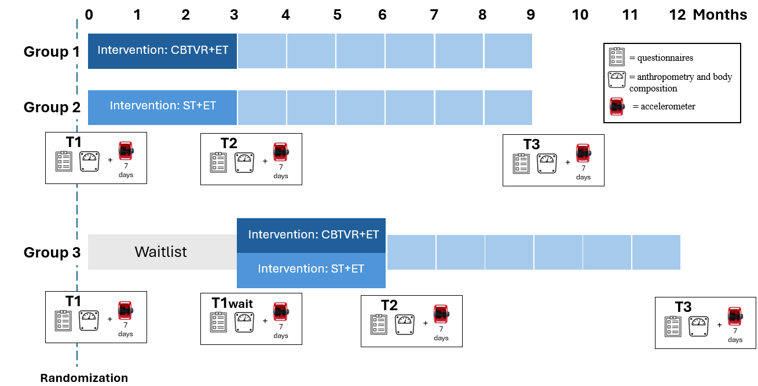
Figure 1: Timing of intervention and evaluation study sessions
Note. CBTVR+ET = CBT-based psychological intervention with VR-based exposure and exercise training. ST+ET= psychological supportive intervention and exercise training. T1, T1wait, T2, and T3 are assessment sessions.

Interventions
Psychological interventions
All intervention sessions were held in-person in a 1:1 setting (i.e., one participant, one counsellor) using private rooms at UQO. The rooms were dedicated to counselling, ensuring confidentiality. Standard-height chairs without armrests were available to maximize comfort for counsellors and participants. When possible and to reduce travelling to UQO, sessions were scheduled on the same day participants had their exercise training sessions. The CBTVR+ET and the ST+ET groups received eight sessions of 45 minutes spread across 12 weeks; sessions 1 to 6 were offered in consecutive weeks and sessions 7 and 8 were offered three weeks apart [i.e., weeks 9 and 12]). The psychological intervention protocols were standardized for each group; however, one minor modification was made during the study to a handout for the CBTVR-ET group to enhance clarity of the instructions.
All eight counsellors who delivered the psychological intervention were students in psychology at UQO who self-identified as a woman. To maintain adherence to study and intervention protocol (i.e., treatment fidelity)(Cook et al., 2024; Johnson & Remien, 2003), several strategies were implemented. Counselors received two hours of training with a clinical psychologist (AA) specialized in body image, weight issues, and SPA before the start of the intervention to develop their understanding of the intervention and its undermining theory, delivery style, session content, and relational techniques. The counsellors had a wide range of experience working in a crisis center or in a shelter, through a psychotherapy practicum, with people with intellectual disabilities, women in contexts of violence, and in customer service, though none had previously delivered CBT-based interventions. During the trial, the counsellors had weekly meetings with AA to ensure adherence to the intervention protocol and could request additional meetings with AA as needed. All sessions were audio-recorded, and intervention adherence was ensured by AA, who revised the counsellors’ notes, listened to a minimum of two sessions per participant, and obtained counsellor feedback. AA deemed that the intervention was administered as planned.
Group 1 (CBTVR+ET): CBT-based psychological intervention with VR-based exposure. Five graduate counsellors delivered the CBT-based psychological intervention with VR-based exposure. Except for one participant, who was assigned one counsellor for the first session and another for the subsequent sessions (the first counsellor stopped working in the research project), all participants were assigned the same counsellor for all sessions. This intervention was developed based on well-known references in the field of anxiety disorders (Bouchard et al., 2017; Dugas & Bouchard, 2013) and body image (Aimé et al., 2020; Cash, 2008; Dion et al., 2019; Drolet‑Dostaler & Guitard, 2019; Tylka & Wood-Barcalow, 2015). An intervention manual and handouts for participants to fill out were provided to counsellors. The intervention manual contained a description of SPA and how it affects women with obesity, the study objectives, the intervention structure, and a description of each session content. Counsellors were advised to avoid introducing new content or altering the intervention protocol. Session 1 introduced a discussion on sociocultural, interpersonal, and individual factors that affect body image. The homework exercise invited participants to reflect on the body image messages that they received in different stages of life. Sessions 2 and 3 involved cognitive restructuring about erroneous or dysfunctional beliefs related to body image, which are commonly experienced by people with SPA. Examples were adapted by counsellors to reflect participants' specific personal experiences. Participants were invited to challenge beliefs that they may have and explore alternatives interpretations. Starting with the second session, each session began with a revision of the homework from the previous session, and the counsellor asked participants which topic or homework from previous sessions they believed would be most pertinent to revisit. Session 3 included cognitive restructuring about body objectification. Session 4 focused on avoidance and safety seeking behaviors, which are actions performed to decrease social anxiety in the short term but essentially maintain social fears over time. Participants’ avoidance and safety seeking behaviors were discussed and listed in this session. Session 5 addressed social comparison and its effects. Participants were then led through an exercise of written exposure to an anxiety-inducing situation linked to their SPA. Session 6 explored body appreciation and self-compassion. Different forms of meditation and breathing exercises were discussed, although ensuring these strategies were not used as avoidance strategies by participants. Session 7 covered relapse prevention. Participants were invited to reflect on and write down ways to maintain any gains made since starting the intervention. Session 8 was flexible and based on participants’ needs.
VR-based exposure to socially challenging situations was used in sessions 6 and 7. For this, participants and counsellors moved to a room equipped with an Oculus Rift 2 headset connected to a computer and a stationary bike. Participants then sat on a stationary exercise bike and were encouraged, but not required, to pedal at a comfortable pace. The virtual scenario immersed them into a gym setting with either one (session 6) or two (session 7) virtual characters. Specifically, in session 6, one female virtual character entered the gym room and looked at the participant a few times while meditating. In session 7, one male and one female were present in the gym room; the male took selfies and chatted with the female character, wherein whispering and giggling sounds could be heard (see Supplemental File Appendix C for pictures of the virtual rooms). During both sessions, participants were exposed to the scenario twice for seven minutes each time, with a check-in after each exposure. They were invited to notice their anxiety level at the beginning and end of the exposures, as well as when it reached its peak.
Group 2 (ST+ET): psychological supportive intervention. Three distinct counsellors (two graduate and one undergraduate) delivered the supportive therapy intervention, with each participant having the same counsellor. For all sessions, counsellors asked the participants to identify themes that they would like to discuss. Thus, participants were responsible for the content of the sessions and could talk about relevant subjects to them, for which they wanted to get support. When possible, the counsellors explored how the content discussed could be linked to SPA. While some participants could choose to focus on concerns pertaining to their work or family issues, they could also bring out interpersonal situations in which they experienced SPA or felt judged for their appearance. Counsellors were instructed not to direct the themes of the session. Rather, they had to start it with an open-ended question asking the participants what they would like to discuss. They needed to rely mainly on active listening, reflection, and reformulation. Their focus primarily was on validating participants’ experiences, exploring their thoughts and feelings, and providing support tailored to their experiences. They were specifically asked not to use CBT-based interventions.
Exercise Training
All 1:1 exercise training session were supervised by kinesiologists in a private gym at the UQO; two had a bachelor's degree, one had a master's degree, and another had a PhD, all in PA sciences, and self-identified as a woman. Each had prior experience working with adults with overweight/obesity.
The CBTVR+ET and the ST+ET participants received 24 supervised sessions of 45-minute (i.e., twice per week) spread across 12 weeks. One session involved aerobic training on machines (e.g., ergocycle, treadmill, elliptical) and the other involved circuit training with body weight exercises or small equipment (e.g., dumbbells, elastics, medicine ball, step) for resistance training. Each session lasted 35 minutes and was preceded and followed by five-minute warm-up and active recovery periods. In addition, participants were asked to complete 60 minutes of unsupervised endurance training (e.g., at home) either as one 60-minute session or two 30-minute sessions – at 50–70% of their heart rate reserve (HRR). This prescription type and dosage was designed to align with the PA guidelines set forth by the American College of Sports Medicine (American College of Sports Medicine, 2021).
To maximize adherence and enjoyment, participants were allowed to self-select the machines used for their aerobic training and the initial intensity during their first week (i.e., supervised sessions 1 and 2). These choices were used by the kinesiologist to determine participants’ interval training at their next aerobic training session. Progression was made according to participants’ aerobic capacity and their ability to increase intensity by 5–10% of HRR from the previous session. The objective was for participants to reach a moderate-to-high exercise intensity (50–70% of HRR) by the end of the first month of training (i.e., session 8 of 24). Also, aerobic training sessions alternated between continuous and interval formats to align with participants’ capacities. For resistance training, participants self-selected their rest time during the first session between series of exercises, up to 90 seconds between sets. Progression was achieved by gradually reducing rest periods, increasing the number of repetitions and introducing heavier loads for specific exercises. Each circuit included a minimum of six exercises targeting the largest muscle groups, which varied across sessions. The kinesiologist helped participants with the technique to ensure safety and provided strategies to manage exercise intensity and prevent injuries (e.g., importance of warming up, appropriate footwear, hydration, and perceived effort on a scale) during the initial sessions.
During both supervised and unsupervised sessions, participants monitored exercise duration and intensity using a heart rate monitor (Polar0H1⁺) and an effort perception scale (Borg CR10)(Borg & Kaijser, 2006) provided at the first session. Participants were trained in the use of this equipment. Over the 12-weeks intervention, supervised sessions were monitored through the completion of an observation diary maintained by the kinesiologist, and unsupervised sessions were monitored through the completion of a PA diary by participants. In case of missed sessions, the kinesiologist prescribed the intensity of the session based on the last recorded training intensity.
Measurements
Primary Outcomes
Feasibility. At the end of the study, protocol feasibility was assessed by calculating: (1) recruitment rate (i.e., the total number of persons screened per month (i.e., assessed for eligibility)), (2) refusal rate (i.e., % of persons who declined to participate in the study during the screening), (3) study retention rate (i.e. % of participants who provided consent to participate complete post-intervention assessments (T2)), as well as reasons for dropout; follow-up retention rate (i.e. % of participants who provided consent to participate complete post-intervention assessments (T3)), as well as reasons for dropout, (4) percentage of missing data (i.e., the ratio of missing data to total data available, excluding participant missing data because of dropout; missing data were analyzed separately for self-reported and device-measured outcomes), and (5) acceptance of randomization (i.e., % of participant who accept their group assignation). The intervention feasibility was assessed by calculating: (6) intervention attendance rate (i.e., % of total supervised sessions completed; i.e., [CBT-based or supportive] psychological intervention sessions (/8 sessions) plus exercise training sessions (/24 sessions), and the % of unsupervised sessions for exercise training sessions (/12 sessions)), (7) intervention attrition rate (i.e., % of participants who started but did not complete the intervention as allocated total, for psychological intervention and for exercise training) and their reasons for dropout, and (8) exercise training compliance was calculated for the 24 supervised sessions and the 12 unsupervised sessions as the percentage of sessions completed as prescribed (duration and intensity) using the kinesiologist notes, PA diary completed by the participants, and the heart rate monitor. Adverse events were also recorded by the kinesiologists and counsellors after each session.
Acceptability. The study protocol and intervention acceptability were assessed with virtual semi-structured 1:1 interviews or focus groups based on participants’ availabilities and intervention completion date. Focus groups had up to three participants who had received the same intervention (CBTVR+ET or ST+ET). An interview guide (see Supplemental File Appendix D for questions) was created to ensure consistency across the interviews/focus groups, and included open questions on the participants’ perceptions, opinions, and experience with the study protocol and received intervention. The interviews and focus groups were audio- and video-recorded on Zoom© and were led by a women trained research assistant who was not part of the research team.
The intervention acceptability was also assessed through an 11-item questionnaire developed for the purpose of the present study with future tense for anticipated acceptability at T1 replaced by past tense for retrospective acceptability at T2. The questionnaire was developed based on the seven concepts presented in the “Theoretical Framework of Acceptability (TFA)”(Sekhon et al., 2017). The seven concepts included: (1) affective attitude (i.e., how the participant feels about the intervention prior to and after taking part in it), (2) burden (i.e., the anticipated or actual amount of effort required from the participant to complete the intervention), (3) ethicality (i.e., how much the intervention aligns with the participant’s personal value system), (4) intervention coherence (i.e., how much the participant understands how the intervention works), (5) opportunity cost (i.e., the anticipated or actual personal values, benefits, or profits that the participant needs to give up in order to participate in the intervention), (6) perceived effectiveness (i.e., the anticipated or actual perception of the ability of the intervention to improve the participant’s PA and SPA), and (7) self-efficacy (i.e., the participant’s confidence in their ability to increase their PA and improve SPA). Affective attitude, intervention coherence, perceived effectiveness and self-efficacy were addressed with two questions each within T1 and T2 questionnaires, and both questions were averaged to create a single score for each concept. A total acceptability value (Min = 1; Max = 4) was calculated by averaging the seven scores, with a higher score indicating a higher acceptability.
Secondary outcomes
Primary outcome for a future efficacy trial.
Trait SPA was assessed using the 9-item SPA scale (Martin Ginis et al., 2011). Responses were scored on a Likert scale from 1 (not at all) to 5 (extremely) and after reverse scoring items 5 and 8, the nine items were summed to produce a total score (Min = 9; Max = 45) with a higher score indicating greater levels of trait SPA.
Secondary outcomes for a future efficacy trial.
Body appreciation was assessed using the 10-item Body Appreciation Scale version 2 (Avalos et al., 2005) with a Likert scale from 1 (never) to 5 (always). Higher mean score indicated greater body appreciation (Min = 1; Max = 5). The Modified Weight Bias Internalisation Scale was used to assess participants weight bias internalisation (Pearl & Puhl, 2014). The answers for each of the 11 items were scored on a Likert scale from 1 (strongly disagree) to 7 (strongly agree) with higher mean score indicating a greater presence of internalized weight bias (Min = 1; Max = 7).
PA behavior was assessed using two complementary methods. Device-measured MHPA (minutes per week) was obtained from a triaxial accelerometer (Actigraph® wGT3X-BT) worn on participants’ right hip. Participants were instructed to wear the accelerometer for seven consecutive days during waking hours (except during water-based activities) and to maintain a logbook of wear times (waking and bedtime) as well as the timing and duration of any PA. Accelerometer data were analyzed using Actilife v.6.13.4 software. Only data from participants who wore the accelerometer ≥ 3 d to classify activity intensity (moderate intensity PA = 1,952–5,724 counts per minute; high intensity PA > 5,724 counts per minute) (Freedson et al., 1998).
The GPAQ was also used to assess self-reported MHPA in several domains, including at work, travel to and from places, and during leisure-time activities (Bull et al., 2009). Self-reported total MHPA was computed by summing duration in all domains (minutes per week).
Sample characteristics
Baseline sociodemographic data (i.e., gender, age, marital status, children, employment status, annual household income, level of education), health conditions and lifestyle habits (i.e., tobacco/marijuana/alcohol consumption) were self-reported by participants within the online questionnaire at T1. Depressive symptoms were also assessed with the Center for Epidemiologic Studies Depression Scale (CES-D) at T1, with a higher score indicating greater depressive symptoms (Radloff, 1977). The Eating Attitudes Test-26 was used to assess eating disorder risk at T1, with a higher score indicating greater risk of an eating disorder (Garner et al., 1982; Leichner et al., 1994). Immersive tendencies were assessed with the 18-item Immersive Tendencies Questionnaire at T1, with a higher score indicating higher tendencies in individuals to experience the sense of presence in VR (Witmer & Singer, 1998). Anthropometric data and body composition (i.e., height, waist circumference, body weight, fat mass and fat free mass) were measured at each assessment session by a research assistant with rod, measurement tape and a calibrated bioimpedance scale (Tanita®MC780U). These last data were shared after the intervention to participants who requested it.
Data Analyses
Descriptive statistics were mainly used. Continuous variables are presented as means, standard deviations (SD), and 95% confidence interval (CI). Categorical variables are presented as total numbers and percentages. As recommended for feasibility trials, no formal hypothesis testing or definitive group comparisons using statistical analyses was performed (Eldridge et al., 2016). Pearson’s correlation coefficients were calculated between T1 and T2 across all three groups, and then from T1 to T2 across the two intervention groups wherein WL participants were reallocated into CBTVR+ET or ST+ET groups to inform the sample size calculation for future trial (Teresi et al., 2022). The 95%CI for the correlations were calculated using the Fisher’s method (Teresi et al., 2022). Effect sizes were calculated using Hedge’s g, which provides a standardized mean difference corrected for small sample bias. Hedge’s g was computed as the difference between group means, divided by the pooled standard deviation (Hedges, 1981). All statistical analyses were performed with IBM SPSS Statistics version 29.
Interviews were transcribed verbatim and analyzed using a hybrid deductive-inductive content analysis approach by SG. SG coded the transcripts using NVivo© based on an a priori list of codes, themes, and sub-themes developed by AB and JB, allowing additional codes to be generated when the data did not align with the list of codes. AB and SG met after two groups were coded to discuss codes, subthemes, and themes. During this step, they labelled and described each theme and subtheme. Once all transcripts were coded, SG selected data extracts to illustrate their interpretations, all names were replaced with pseudonyms, and French quotes were translated to English by SG. Finally, JB reviewed codes, subthemes, themes, and extracts (quotes) from the original data to provide perspective on theme clarity, relation between the narrative description of each theme and quotes, and potential theme overlap.

Results
Enrollment and Patient Characteristics
Forty-five women with obesity were enrolled (i.e., provided consent) in the present study (Mage = 39.3±5.7 years). The flow of participants through the study is in Figure 2 and participants’ characteristics by group are presented in Table 1. Overall, most participants were married or had a common law partner (n=32, 71.1%) 71%), had children (n=32, 71.1%), were working full-time (n=39, 86.7%), had a university level education (n=29, 64.4%), and reported a total household income ≥75,000 CAD (n=30, 66.7%) at T1. Further, most participants had never smoked cigarettes (n=26, 57.8%) or marijuana (n=30, 66.7%) and reported consuming alcohol beverages infrequently (≤ 1 time per month [n=13, 28.9%]; 2–4 times per month [n=13, 28.9%]) and only having 1–2 drinks when they did drink (n=10, 66.7%) at T1. Of the 41 (91.1%) participants who had valid accelerometer data, they spent an average of 185.8±91.2 minutes per week in MHPA at T1. Finally, there were only three health concerns that were reported by >10% participants at T1: mental health concerns (n=13, 28.9%), sleep apnea (n=6, 13.3%), and hypertension (n=5,11.1%). Immersive tendency scores were 57.7±14.8, 56.0±12.1, 56.6±15.4 for the CBTVR+ET, ST+ET, and WL groups, respectively. These scores appear like those obtained in other studies (Jeanningros et al., 2023; Tardif et al., 2019).

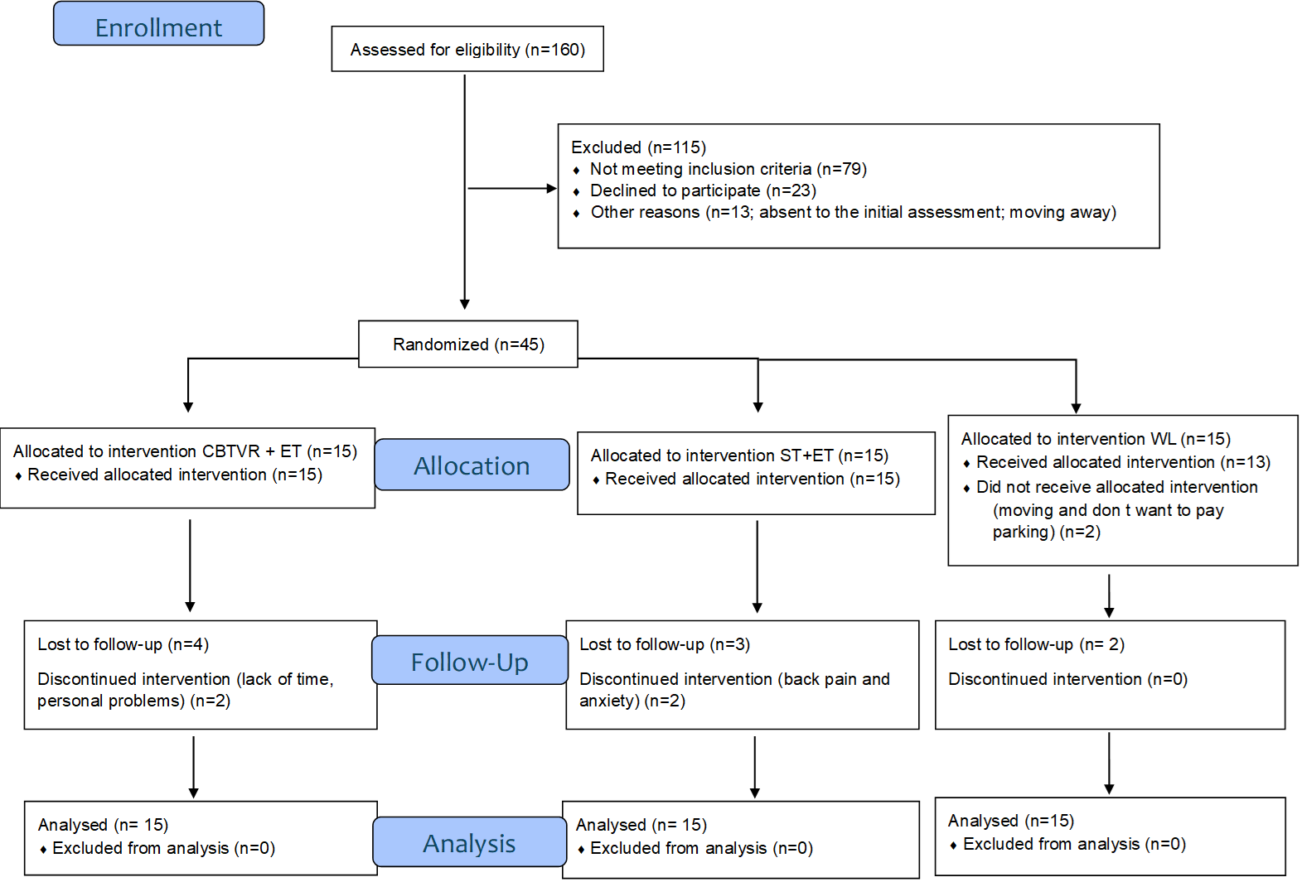

Figure 2: Consort flow diagram of participants through study phases
Note. CBTVR+ET = CBT-based psychological intervention with VR-based exposure and exercise training; ST+ET= psychological supportive intervention and exercise training

Table 1. Population baseline characteristics (N=45)

 | Group 1 (CBTVR+ET)  n = 15  M±SD or n (%) | Group 2 (ST+ET)  n = 15  M±SD or n (%) | Group 3 (WL)  n = 15  M±SD or n (%)
Sociodemographic data
Age (years) | 38.0±6.9 | 40.9±4.3 | 39.1±5.4
Relationship Status
Single/ Separated/ Divorced | 5 (33.3) | 3 (20.0) | 5 (33.3)
Married/ Common-law | 10 (66.7) | 12 (80.0) | 10 (66.7)
Have Children | 9 (60.0) | 12 (80.0) | 11 (73.3)
Profession
Full-time | 12 (80.0) | 14 (93.3) | 13 (86.7)
Student/ Unemployed/Long-term sick leave | 3 (20.0) | 1 (6.7) | 2 (13.3)
Total Household Income (CAD)
< 25,000 | 2 (13.3) | 1 (6.7) | -
25-$74,999 | 3 (20.0) | 5 (33.3) | 4 (26.7)
≥75,000 | 10 (66.7) | 9 (60.0) | 11 (73.3)
Highest Education Level
Secondary | 3 (20) | 4 (26.7) | 1 (6.7)
College | 2 (13.3) | 4 (26.7) | 2 (13.3)
University | 10 (66.7) | 7 (46.7) | 12 (80.0)
Health Conditions
Hypertension | 1 (6.7) | 1 (14.3) | 3 (20)
Dyslipidemia | 1 (6.7) | 1 (6.7) | 0 (0)
Type 2 Diabetes | 1 (6.7) | 1 (6.7) | 1 (6.7)
Sleep apnea | 1 (6.7) | 4 (26.7) | 1 (6.7)
Asthma | 1 (6.7) | 1 (6.7) | 1 (6.7)
Osteoarthritis | 1 (6.7) | 1 (6.7) | 0 (0)
Arthritis | 0 (0) | 0 (0) | 0 (0)
Heart-related | 0 (0) | 0 (0) | 0 (0)
Respiratory-related | 0 (0) | 0 (0) | 0 (0)
Mental disorder | 4 (26.7) | 7 (46.7) | 2 (13.3)
Other** | 4 (26.7) | 1 (6.7) | 2 (13.3)
Depression symptoms score | 16.5±10.1 | 20.9±6.5 | 17.7±5.9
Eating disorders score | 12.4±6.3 | 12.7±7.4 | 11.5±9.8
Anthropometry and body composition
BMI (kg/m²) | 39.8±4.9 | 41.2±5.6 | 39.4±5.5
Lean mass (kg) | 61.8±6.8 | 58.1±5.5 | 61.5±6.9
Fat mass (%) | 45.5±2.6 | 44.3±4.1 | 44.5±3.7
Waist circumference (cm) | 123.3±12.1 | 116.2±9.4 | 118.1±10.8
Lifestyle habits
Tobacco Use
Never | 9 (60) | 6 (40) | 11 (73.3)
Past | 5 (33.3) | 5 (33.3) | 3 (20.0)
Occasional | - | 1 (6.7) | 1 (6.7)
Regularly | 1 (6.7) | 3 (20)
Marijuana Use
Never | 9 (60) | 10 (66.7) | 11 (73.3)
Past | 4 (26.7) | 3 (20) | 3 (20.0)
Occasional | 2 (13.3) | 1 (6.7) | 1 (6.7)
Regularly | - | 1 (6.7)
Alcohol – Frequency
Never | 3 (20) | 2 (13.3) | 1 (6.7)
≤1/month | 1 (6.7) | 5 (33.3) | 7 (46.7)
2-4/month | 5 (33.3) | 5 (33.3) | 3 (20.0)
2-3/week | 6 (40) | 2 (13.3) | 3 (20.0)
≥4/week | - | 1 (6.7) | 1 (6.7)
Alcohol – Quantity/Day
1 or 2 | 8 (53.3) | 10 (66.7) | 12 (80.0)
3 or 4 | 3 (20) | 1 (6.7) | 2 (13.3)
5 or 6 | 1 (6.7) | 2 (13.3)
Self-reported MHPA (min/wk.) | 62.3±93.4 | 26.0±49.5 | 43.3±79.4
Device measured MHPA (min/wk.) | 197.6±88.1 | 145.0±65.3 | 217.2±107.4
BMI: Body Mass Index; CAD= Canadian Dollars; MHPA: Moderate-to-High intensity Physical Activity; **anemia, hypothyroidism, polycystic ovarian syndrome, seasonal allergies.

Primary Outcomes
Feasibility.
Over the 19-month recruitment period, 175 people contacted the research team; 160 were assessed for eligibility and research study interest (recruitment rate = 8.4 participants per month), as 15 became unreachable by phone and/or email after ≥ three attempts. Out of the 160 potential participants, 140 specified how they had heard about the study; 14 participants (11.7%) on site and by emails to employees at the UQO, five participants (4.2%) on site at Montfort Hospital, 66 participants (55.0%) on local Facebook pages, 12 participants (10%) on the UQO campus, and 23 participants (19.1%) by referrals from a relative. In addition, one participant was recruited by physician referral and four by word of mouth from participants enrolled in another study conducted by the first author (AB). Among the 160 potential participants, 23 declined to participate in the study (refusal rate = 14.4%), 79 did not meet eligibility criteria, and 13 did not attend their initial assessment session without providing reason or moved away. The most common reasons for non-eligibility were not meeting the age requirement (n = 32; 42.1%) and being unable to attend weekly intervention sessions at the UQO (n = 12; 15.8%). All participants accepted their group assignment (randomization acceptance rate =100%). Prior to T2 assessments, two participants allocated to the WL group dropped out after their T1 assessments (reasons: moving and parking cost not covered for exercise training), two allocated to the CBTVR+ET group dropped out after initiating the intervention (reasons: lack of time, personal issues), and two allocated to the ST+ET group also dropped out after initiating the intervention (reasons: back pain and too anxious to leave home), resulting in a collective retention rate of 86.7% between the baseline (T1) and post-intervention assessments (T2). Four participants in the CBTVR+ET group, three in ST+ET group and two in WL group were lost to follow-up (i.e., did not complete their T3 assessments (reasons: travelling (n=1), health problem (n=1) and unreachable (n=7)), resulting in a follow-up retention rate of 66.7% between the baseline (T1) and follow-up assessments (T3). Among the 45 enrolled participants, 36 completed the semi-structured focus groups or interviews (80.0%; six dropouts prior to T2 assessment, and three not interested). No missing data were observed for self-reported questionnaires on the LimeSurvey® plateform at any timepoint. Missing anthropometric and body composition data were minimal (1.0%) at all timepoints. Finally, 13.4% of the accelerometer MHPA data were missing across all time points, specifically: 8.9% at T1 (4/45), 15.4% at T1bis (2/13), 15.4% at T2 (6/39), and 16.7% at T3 (5/30). Of these accelerometer missing data, 41.2% were not analysed because they did not meet the validity criteria (i.e., ≥ 3 days (including at least one weekday and one weekend day) and ≥ 10 hours per day of wearing time), while 58.8% were unavailable because the accelerometer was not worn or had been lost.
Two participants in the CBTVR +ET group and two in ST+ET group did not complete the intervention as intended (total intervention attrition rate = 9.3%); two in the CBTVR+ET group and one in ST+ET group stopped all sessions, and one in the ST+ET group stopped the exercise training sessions (see reasons above in the retention rate section) which led us to a total of 43 participants. The supervised psychological and exercise training sessions attendance rates were 88.7±21.6% and 85.8±22.4%, respectively among the 43 participants who started their allocated intervention; when analyzed per group, attendance rates for psychological and exercise training sessions were 89.3±24.5% and 85.5±24.0%, respectively, for the CBTVR+ET group (n=21), and 88.1±19.1% and 86.0±21.3%, respectively, for the ST+ET group (n=22). The unsupervised exercise training sessions attendance rates were 61.0±28.6% among the 43 participants who started their allocated intervention; when analyzed per group, rates were 62.3±27.8% (CBTVR+ET group; n=19 two participants with missing data) and 59.1±25.4% (ST+ET group; n=22). Among the participants who started their allocated intervention, the compliance rate to supervised exercise duration and intensity was 74.0±19.8%; when analyzed per group, rates were 75.2±21.4% and 72.9±18.7% for participants assigned to the CBTVR+ET group (n=21) and ST+ET group (n=22), respectively. Last, the compliance rate to unsupervised exercise duration and intensity was 11.7±19.5% among the participants who started their allocated intervention; when analyzed per group, rates were 14.5±25.4% (CBTVR+ET group; n=19 two participants with missing data) and 9.1±12.0% (ST+ET group; n=22). Minor adverse events were reported by the kinesiologists during the exercise training sessions. These included, difficulty breathing due to wearing a face mask (n=1), feeling unwell before the session and having to stop during the session (n=1), dizziness (n=3; no participant stopped the session), back pain (n=4; no participant stopped the session), and foot or leg pain (n=28; one participant stopped the session, while the others managed the pain by reducing exercise intensity). No adverse events were reported by counsellors during the psychological intervention sessions.
Acceptability.
Quantitative results. Including participants initially allocated to the WL group, the anticipated and retrospective acceptability were 2.9±0.3 to 3.0±0.3 on a scale ranging from 0 (lower acceptability) to 4 (higher acceptability), respectively in the CBTVR+ET group, and 2.9±0.3 to 3.0±0.3, respectively in the ST+ET group.
Qualitative results. Nineteen participants allocated to the CBTVR+ET and 17 to the ST+ET group took part in a focus group (median duration = 37 minutes, range = 17 - 78 minutes) (n = 13 in 6 groups for CBTVR-ET; n = 9 in 4 groups for ST+ET) or 1:1 interview (n = 6 for CBTVR+ET; n = 8 for ST+ET). Data saturation (i.e., no new theme and subtheme emerged) was reached as of the coding of the 3rd focus group and coding of interviews, which followed did not offer additional information, insights, or patterns, though they confirmed themes and subthemes that emerged from the focus groups. The collective data were summarized into eight themes (noted in boldface in Table 2) that contained various sub-themes (noted in italics in Table 2). Illustrative quotes are presented in the Supplemental File, Appendix E.
Table 2. Themes and sub-themes based on content analysis of interviews (n=36)
Intervention likes
Participants enjoyed their interactions with their kinesiologist and their interactions with their psychological intervention counselors. Reasons included personal attributes (e.g., professionalism, attentiveness, likeableness, adaptability) and perceived competence which contributed to pleasant and positive experiences.
The content of the exercise training sessions, including the preplanned, personalized, varied, and enjoyable exercises, fostered participants’ engagement and motivation. Similarly, the content of the psychological interventions, including both the counselling around SPA and the support therapy, left participants with positive impressions. For group 1 (CBTVR+ET), this included the perceived relevance of the information offered, the techniques provided used by their counsellors, and the opportunities given for self-reflection. For group 2 (ST+ET), the opportunity to speak to a non-judgemental expert, who focused on their needs and asked relevant questions made them feel more secure.
Furthermore, participants appreciated the infrastructure and materials used in the exercise training sessions. Specifically, the large, private, well-equipped, and clean exercise room, as well as the usefulness, motivating nature, and easy to use heart rate monitors.
In terms of modalities for the exercise training sessions and the modalities for the psychological intervention sessions, participants enjoyed the duration of the sessions, the number of sessions per week, the 1:1 format, the ease of scheduling, and the convenient location of the UQO, which was a crucial factor for attending.
Moreover, participants appreciated the virtual reality during the psychological intervention sessions (for the CBTVR+ET group), noting that it was interesting and that it was a helpful way to work on their negative thoughts and feelings about SPA.
Finally, participants expressed appreciation for various non-specific elements of the intervention and study. Notably, the multicomponent intervention (e.g., psychological intervention plus exercise training) was well-received and highly valued, as was receiving clear expectations from the onset, receiving support from kinesiologists and counsellors, and the efficiency of intervention sessions.
Research likes
Participants discussed having positive interactions with research staff and shared that staff’s ability to offer understandable explanations and conduct assessments respectfully, while being professional, non-judgmental, and likeable were key to their favorable perceptions of the study.
Regarding the content, participants enjoyed the topics covered in the study and the comparison and the interpretation of their anthropometric data provided after the intervention. When discussing the material, participants expressed finding the accelerometer protocol realistic and non-cumbersome, and enjoyed the questionnaires and the handout received at the beginning of the study.
Last, participants listed certain non-specific appreciations, including the overall research study, short wait time between the initial contact and the start of the study, and positive evaluation experiences.
Intervention dislikes
There were specific behaviors participants disliked about the kinesiologist, including: lack of motivation, not being attentive to their needs, seeming impatient at times, and failure to offer feedback; these factors reduced their motivation and led to participant frustration. Participants also mentioned they disliked having to work with more than one kinesiologist. Additionally, participants disliked the psychological intervention counsellors who seemed inexperienced and read off their papers as it hindered the therapeutic relationship and made the process less efficient.
Dislikes regarding the content of the exercise training sessions revolved around the intensity (i.e., too light or too intense), insufficient directions for unsupervised exercise training sessions, lack of medium- or long-term objectives, difficulty adjusting their diet to match increased energy expenditure, dissatisfaction with certain exercises and session structure, and redundancy in tracking and feedback tasks. Dislikes for the content of the psychological intervention were also shared. Participants in the CBTVR+ET group disliked not knowing the topics ahead of time, challenging homework and exposure exercises, lack of flexibility and practical application, redundancy in topics, insufficient discussion of external barriers, and general dislike of the intervention/approach. Participants in the SR+ET group felt they did not receive enough guidance, where unsure what to talk about, found it unhelpful, or though it was too short-term to be impactful.
Participants expressed dissatisfaction with certain exercise-related infrastructure and material, including technical issues with the Polar watch, discomfort while using certain exercise apparatus (i.e., bike, elliptical, exercise bench), lack of variety of equipment, equipment malfunctions, uninviting exercise space, limited facilities, and accessibility concerns due to stair-only access.
Regarding the modality of the exercise training sessions, participants described dissatisfaction with frequency of sessions (2 sessions per week) and length of intervention (12 weeks), scheduling difficulties, rigid schedule (e.g., poor options to make up sessions or adjust schedules), UQO location and parking, and an unclean workout environment. Moreover, participants struggled with the sudden cessation of the structured intervention, citing that it created a gap between intensive supervised exercise and the transition to an unsupervised setting, which left them feeling abandoned and insufficiently prepared to sustain their physical activity post-intervention. Participants’ dislikes of the modality of the psychological intervention were the same, though with the addition of lengthy homework review and short sessions. When discussing virtual reality during the psychological intervention for the CBTVR+ET group, dislikes focused on the scenarios being uninteresting, long, redundant, non-anxiety inducing, or unrealistic.
Finally, certain non-specific issues were turn-offs for participants. These included the demanding nature of the intervention in light of work and family obligations, having to wear a mask during exercise training due to COVID restrictions, unexpected video recordings, and signage that highlights that the room was for studies on “obesity”.

Research dislikes
No dislikes were reported in relation to interactions with research staff in general, though miscommunication with a research staff member was noted. However, when it came to the content, participants found questionnaires long, redundant, and confusing, were unaware of accelerometer data results, and were not interested in the focus group after the study was over.
Additionally, when discussing materials, participants reported physical discomfort from the accelerometer, inconveniences due to device malfunction, and not wearing it due to forgetting, making them become less compliant over time with the protocol. They also found the stationary bike used during the initial and final assessments to be uncomfortable and perceived their initial baseline heart rate test results to be inaccurate.
With regard to the protocol and in-person modality, participants’ feedback highlighted the high participant burden and inadequate covering of all out-of-pocket expenses, such as parking and transportation costs, which reduced their satisfaction.

Benefits to participants
Participants described perceived physical benefits from participating in the study, including improved physical strength, posture, sleep, digestion, and range of mobility, as well as reduced pain. Participants also perceived psychosocial benefits from exercise training, including having the desire to exercise in public environments, increasing their belief that exercise can help cope with stress, greater comfort with social engagement, and increased mood, wellbeing, and self-confidence.
The psychosocial benefits from the psychological intervention the CBTVR+ET group cited were reduced stress and increased wellbeing. For the SR+ET group, these were increased wellbeing, ability to self-care, and facilitation of social engagement.
Additionally, behavioral gains from exercising included spending time being active with friends/family and increasing frequency and variety of physical activities. Behavioral gains from the psychological intervention for the CBTVR+ET group were decreased reassurance-seeking behaviors, and for the ST+ET group were healthier eating, no longer working from home, and continuing treatment with a therapist.
Furthermore, participants’ reflections on mechanisms of action/processes involved in making changes to their PA beyond the study included gaining knowledge about PA and about themselves, increased motivation, reflecting on barriers to PA, enhancing attitudes about PA, and being active for pleasure.
Participants’ reflections on mechanisms of action/ processes involved in making changes during the psychological intervention for the CBTVR+ET and ST+ET groups included gaining introspective ability, awareness of barriers to taking care of themselves, and knowledge about anxiety (CBTVR+ET group only), and enhanced attitudes towards PA.

Absence of benefits and adverse effects
Participants noted a gap between their intentions to implement behavioral changes to increase PA and their actual behavior, and some did not perceive benefits. Though no adverse effects (i.e., no direct, measurable negative health effects) were reported while participants took part in the study, negative outcomes and emotional consequences were noted. Physically, participants perceived that they had diminished physical health possibly linked to the study.
Moreover, the discussion on psychosocial absence of gains related to exercise gave rise to guilt about having stopped exercising after the study ended. Psychosocial absence of benefits related to the psychological intervention for the CBTVR+ET and ST+ET groups were a general absence of gains and exacerbated fear of negative evaluation of their bodies by others (CBTVR+ET group only).
Last, behaviorally in relation to exercise, participants reported an absence of change. Participants did not report or discuss absence of benefits or adverse effects behaviorally in relation to the psychological intervention.
Recommendations for the future
Participants provided numerous recommendations for improving the program. For the exercise training intervention, participants suggested extending its duration, increasing session frequency, providing follow-up support, enhancing participant engagement with personalized tools and group activities, improving exercise variety and equipment, integrating nutrition guidance and discussions on healthy living, addressing societal barriers, offering varied workout environments, ensuring facility accessibility, and streamlining tracking methods with digital options.
Additionally, recommendations for the psychological intervention in the CBTVR+ET group were varying the VR environments, increasing length and number of sessions, allowing adaptability of the intervention, integrating group sessions, and increasing concreteness of applications. In the ST+ET group, these included increasing the number of sessions, decreasing the frequency of sessions, integrating group sessions, and offering information and guidance.
Finally, participants offered non-specific recommendations such as offering discounted or free parking for intervention sessions, offering a clear schedule and cancellation procedure, allowing participants to meet each other, conducting mid-program check-ins, accommodating those with low anxiety, and presenting the benefits of PA and psychological intervention.
Note. CBTVR+ET = CBT-based psychological intervention with VR-based exposure and exercise training; PA = physical activity; SPA = social physique anxiety; ST+ET= psychological supportive intervention and exercise training; UQO = Université du Québec en Outaouais.
Secondary outcomes
Social physique anxiety (primary outcome for future efficacy trial)
The average scores for trait SPA along with individual profiles are in Figure 3 and in supplementary Tables S1 and S2 (see Supplemental File Appendix F).
In panel A, the trait SPA scores from the WL group are presented independently. In the CBTVR+ET group, the scores were 37.3±5.1, 95%CI [34.5-40.1] before the intervention (T1; n=15) and 30.8±6.4, 95%CI [27.0-34.7] post-intervention (T2; n=13) (Hedge’s g = -1.13). In the ST+ET group, the trait SPA scores were 35.8±5.5, 95%CI [32.8-38.8] before the intervention (T1; n=15) and 31.1±7.1, 95%CI [26.8-35.4] post-intervention (T2; n=13) (Hedge’s g = -0.75). Finally, in the WL group, the trait SPA scores were 35.5±4.1, 95%CI [33.3-37.7] before the waiting period (T1; n=15) and 35.4±4.1, 95%CI [33.0-37.7] after the waiting period (T1wait, n=14) (Hedge’s g = -0.04).
In panel B, data from participants initially assigned as WL are reallocated into their respective experimental group. In the CBTVR-ET group, the scores were 36.5±5.3, 95%CI [34.1-38.9] before the intervention (T1; n=21), 30.8±6.6, 95%CI [27.7-34.0] post-intervention (T2; n=19) (Hedge’s g = -0.95 ; T1 vs. T2), and 29.9±8.1, 95%CI [25.2-34.2] at the six-month follow-up (T3; n=14) (Hedge’s g = -1.01; T1 vs. T3). In the ST+ET group, the trait SPA scores were 35.9±4.7, 95%CI [33.9-37.9] before the intervention (T1; n=23), 30.9±5.9, 95%CI [28.1-33.6] post-intervention (T2; n=20) (Hedge’s g = -0.96 ; T1 vs. T2) and 30.8±7.4, 95%CI [26.8-34.8] at six-month follow-up (T3; n=16) (Hedge’s g = -0.86; T1 vs. T3).
The correlation between T1 and T2 trait SPA scores for the three groups pooled was r=0.567 95%CI [0.31, 0.75], n=39. When participants initially included in the WL were reallocated to their intervention group, the correlation between results at T1 (or T1bis) and T2 was r=0.440 95%CI [0.15-0.66], n=40.

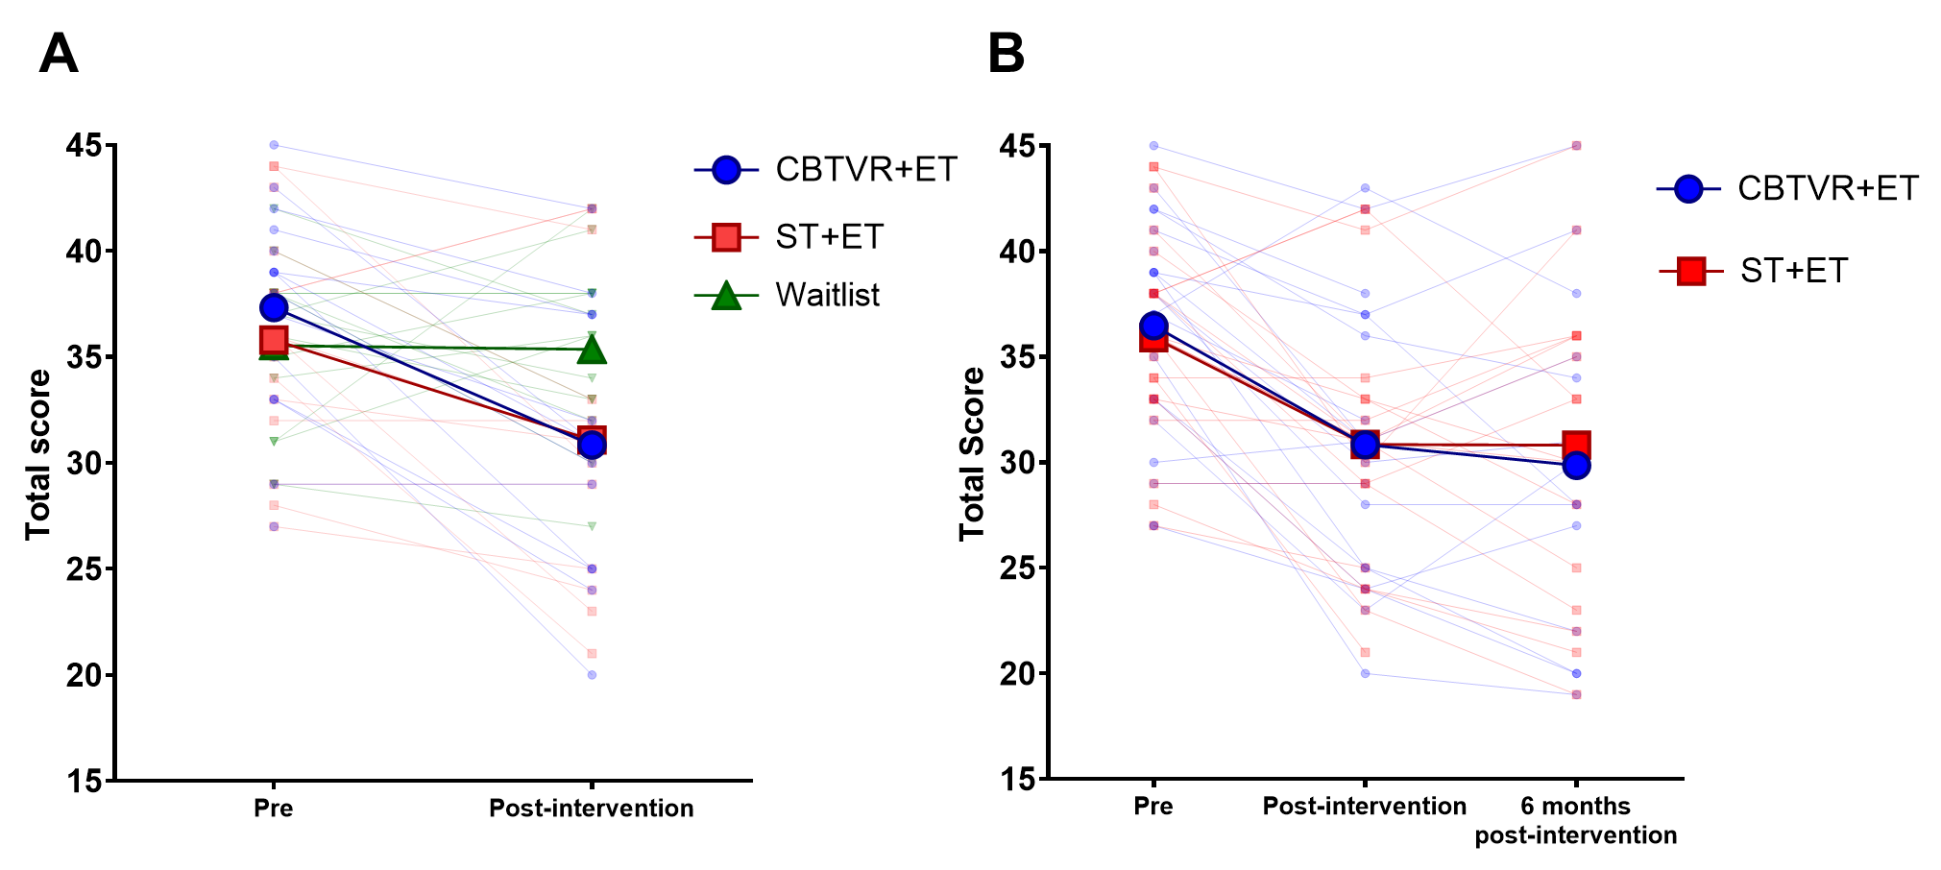

Figure 3. Trait Social Physique Anxiety scores
Notes: Means (thicker lines and makers) and individual (thinner and transparent lines and markers) scores for the Social Physique Anxiety questionnaire. Scores of each item from the questionnaire were summed to create an overall score. In Panel A, participants in the WL are presented independently as a control group and their T1Bis data are used for post-intervention (T2). In Panel B participants initially included in the WL groups are reallocated into the CBTVR+ET or ST+ET groups and their T1Bis data are used as T1 (Pre). For participants initially included in either intervention groups, Pre, post-intervention and six months post-intervention time points are representative of T1, T2 and T3, respectively. CBTVR+ET: CBT-based psychological intervention with VR-based exposure and exercise training; ST+ET: psychological supportive intervention and exercise training.

Body appreciation, weight bias internalisation and PA (secondary outcomes for future efficacy trial)
Body appreciation, weight bias internalisation and PA scores are presented in Table 3 as well as Table S3 (see Supplemental File Appendix F). Other accelerometry data (sedentary time, light PA and step counts) are presented in Tables S4 and S5 (Appendix F) for interested readers but are not further discussed as they were neither primary nor secondary objectives of the project.

Table 3. Average MHPA time, weight bias internalisation and body appreciation scores
 |  | CBTVR+ET |  |  | ST+ET |  |  | WL
 |  | n | mean±SD | 95% CI  [LB-HB] | n | mean±SD | 95% CI  [LB-HB] | n | mean±SD | 95% CI  [LB-HB]
MHPA  Accelerometer  (min/week) | T1 | 14 | 197.6±88.1 | 146.7-248.5 | 14 | 145.0±65.3 | 107.3-182.7 | 13 | 217.2±107.4 | 152.3-282.0
MHPA  Accelerometer  (min/week) | T2 | 11 | 245.2±177.8 | 125.7-364.6 | 12 | 196.5±98.9 | 133.7-259.4 | 11 | 241.6±98.7 | 175.4-307.9
MHPA  Self-reported  (min/week) | T1 | 15 | 62.3±93.4 | 10.6-114.1 | 15 | 26.0±49.5 | 0.0^{a-}53.4 | 15 | 43.3±79.4 | 0.0^{a-}87.3
MHPA  Self-reported  (min/week) | T2 | 13 | 216.9±298.5 | 36.5-397.3 | 13 | 92.3±81.1 | 43.3-141.3 | 14 | 77.1±126.0 | 4.4-149.9
WBI (score) | T1 | 15 | 5.3±1.0 | 4.7-5.9 | 15 | 4.7±1.0 | 4.1-5.2 | 15 | 5.0±0.7 | 4.6-5.5
WBI (score) | T2 | 13 | 3.7±1.2 | 2.9-4.4 | 13 | 3.9±1.1 | 3.3-4.6 | 14 | 4.7±0.9 | 4.1-5.2
BAS (score) | T1 | 15 | 2.4±0.6 | 2.1-2.7 | 15 | 2.4±0.6 | 2.1-2.8 | 15 | 2.5±0.5 | 2.3-2.8
BAS (score) | T2 | 13 | 3.2±0.6 | 2.9-3.6 | 13 | 2.9±0.8 | 2.4-3.4 | 14 | 2.6±0.5 | 2.3-2.9
Notes: ª Lower bound results for the confidence interval were negative. However, since physical activity duration can’t be negative, the value reported is 0.
T1bis values were used as T2 for the participants in the WL group. MHPA: moderate-to-high intensity physical activity; WBI: Weight bias internalisation; BAS: Body Appreciation Scale; CBTVR+ET: CBT-based psychological intervention with VR-based exposure and exercise training; ST+ET: psychological supportive intervention and exercise training; WL: Waitlist; SD: standard deviation; CI: confidence intervals; LB: lower bound; UB: upper bound.

Anthropometric and body composition
Anthropometry and body composition data are presented in Tables S6 and S7 (see Supplemental File Appendix F). BMI in the CBTVR+ET group was 41.4±5.0 kg/m², 95%CI [38.6-44.1] at T1 (n=15) and 41.5±4.9 kg/m², 95%CI [38.5-44.5] at T2 (n=13). In the ST+ET group, BMI was 39.1±5.7kg/m², 95%CI [35.9-42.3] at T1 (n=15) and 39.2±6.4kg/m², 95%CI [35.3-43.0] at T2 (n=13). Finally, BMI from participants in the waitlist group was 40.0±5.2 kg/m², 95%CI [37.1-42.9] at T1 (n=15) and 39.2±5.3 kg/m², 95%CI [36.0-42.4] at T2 (n=13). Other anthropometric variables showed similar patterns.

Discussion
The current feasibility randomized controlled study aimed to assess the feasibility and acceptability of the study protocol and the intervention among women with obesity and to analyze SPA (primary outcome for future efficacy trial) data collected at baseline to post-intervention to inform a future full-scale trial.

Feasibility and acceptability
All a priori feasibility targets were met, providing evidence that the study procedures and the intervention components are practical and acceptable enough to proceed to a larger randomized controlled trial. Specifically, recruitment, refusal, retention, randomization acceptance, missing data, intervention attendance and attrition rates were satisficing. Various strategies employed (e.g., participant compensation, recruitment via social media, absence of usual care only control group, offering varied time options for sessions to accommodate schedules) likely contributed to the trial’s success, as factors improve participant recruitment and retention by reducing financial burden on participants and offering greater autonomy over their time. Also, recruitment via social media provided access to prospective participants in a cost-effective and rapid manner, thus enhancing the trial’s reach. However, most women (≥ 65%) enrolled in the study came from a high socioeconomic background (university diploma and an annual household income ≥ $75,000), which can significantly reduce the applicability of the findings. Additional recruitment strategies should be employed to ensure future samples are more representative by increasing diversity in the participant pool based on socioeconomic background. Potential approaches could be: partnering with community organizations, using linguistically appropriate language, implementing peer recruitment models, or providing additional compensation for transportation or childcare (Yancey et al., 2006). In turn, during screening, a rigorous and systematic screening process is essential to ensure no criteria are missed and track screening criteria (e.g., MHPA) to identify potential issues with recruitment criteria and/or screening processes, allowing for real-time adjustments during the trial. Although the inclusion criteria included not meeting established MHPA guidelines (assessed via self-report), 46.7% were engaging in sufficient MHPA to meet guidelines at baseline (mean MHPA=185.8±91.2 minutes per week assessed via accelerometry), suggesting that this inclusion criteria may need to be revised to include all women in future studies to maintain successful recruitment. Alternatively, following pre-screening with self-report via phone or online surveys, more specific assessment of MHPA with a 7-day diary or accelerometry (where possible) only for those who pass the initial stage could be used to confirm eligibility.
A review of the retention rates across timepoints reveals potential issues. The rate decreased from 86.7% between the baseline (T1) and the post-intervention assessment (T2) to 66.7% between baseline (T1) and the follow-up assessment (T3), which is common in trials delivering complex interventions, such as CBT with no further intervention during the follow-up period (Liu et al., 2018; Willinger et al., 2021). The implementation of additional strategies to enhance long-term retention rates should be considered because follow-up data are critical to understand the sustained impact of interventions and high dropout rates reduce the validity of the study results (Barry, 2005). Potential strategies to consider include: providing enhanced financial support (e.g., compensating participants for follow-up sessions), reducing burden on participants (e.g., shorten session length), or regular research newsletters (Coday et al., 2005; Liu et al., 2018).
The a priori missing data target was met for all data combined; however, the missing data for accelerometry specifically exceeded 10% for post-intervention assessment (T2) and the follow-up assessment (T3). As reported in previous studies (Baillot et al., 2024; Evenson et al., 2015), having participants adhere to an accelerometry protocol to obtain valid data is always challenging. Such missing data must carefully be considered during the planning of a larger trial, as the results of this feasibility trial directly inform the sample size estimations. Still, the qualitative data provides insights into why data missing be missing, which can inform strategies to minimize it in the main trial. Indeed, participants described physical discomfort when wearing the accelerometer and having forgotten to wear it. Clear instructions with close monitoring and additional tailored reminders during the wearing period should be provided to improve the wearing compliance. Wearing the accelerometer on the wrist rather than the hip could also increase the perceived comfort, helping with compliance without reducing the validity of the MHPA assessment (Wei et al., 2025).
The acceptability scores and qualitative data support the acceptability of the research protocol, and the psychological intervention with VR exposure plus exercise training. High appreciation was reported by participants for the trial procedures and intervention components. Another aspect that may have contribute to participants’ satisfaction was the perception of physical, psychosocial and behavioral benefits. Nevertheless, the qualitative data suggest such satisfaction was not unanimous. Most of the material and infrastructure issues (e.g., lack of variety of equipment, malfunctioning equipment, accessibility of facilities, parking costs for intervention sessions) and staff-related concerns reported by some participants can easily be addressed with minor adjustments, such as additional practical training for counsellors or exercise equipment purchase. Other dislikes and participants recommendations for amendments to the study protocol and intervention components were carefully considered due to their potential positive impact on the feasibility, acceptability, or future efficacy of the intervention, and reflect in the next section.

Suggestions for Improvements
The qualitative data collected during the focus groups and individual interviews were particularly important to generate reflections about possible changes and improvements to the study protocol and intervention components, namely the psychological intervention and exercise training. Regarding the study protocol, removing the collection of secondary outcomes could reduce participant burden by limiting the length and redundancy of the questionnaires. Concerning the psychological intervention, the number of VR-based exposure sessions could be increased from two to four across the six sessions to present different virtual scenarios (e.g., gym center, swimming pool) that elicit different levels of SPA. Indeed, exposure-based interventions are grounded in the systematic, repeated confrontation with fear-evoking stimuli across varied contexts (de Jong et al., 2019; Tolin, 2016). According to the inhibitory learning model, repeated encounters in which the anticipated aversive outcome (e.g., in SPA, being negatively evaluated or ridiculed by others because of one’s physical appearance) either does not occur or occurs less frequently or less intensely than expected lead to the disconfirmation of maladaptive threat expectancies. This ongoing violation of threat expectations promotes fear reduction and affords opportunities to acquire more adaptive responses to feared contextual cues, ultimately reducing avoidance behaviors that maintain and exacerbate anxiety (Craske et al., 2008). In SPA, these principles can be implemented by exposing individuals to multiple situations in which their body may be subject to social scrutiny (e.g., fitness centers, swimming pools, beaches). Systematic engagement in such physique-evaluative contexts provides repeated opportunities to learn that anticipated negative evaluation or ridicule is unlikely or less severe than feared, thereby disconfirming maladaptive threat expectancies and promoting fear reduction in physique-salient contexts. This, in turn, supports the development of more adaptive responses and reduces the avoidance behaviors that maintain and exacerbate SPA. One advantage of VR-based exposure is the opportunity to personalize virtual environments and to create graded situations tailored to the participant’s fears (Ionescu et al., 2021; Ørskov et al., 2025). In SPA, a safe, controlled virtual environment can be used to recreate different physique-evaluative situations tailored to each participant’s specific appearance-related fears and concerns. During these VR-based sessions, participants can be exposed to real-life scenarios (e.g., 360° videos of a gym or swimming pool) featuring individuals and cues that present stigmatizing or SPA-provoking stimuli (e.g., fat-phobic advertisements, ambiguous gaze directed at the participant’s body) and can practice exercises in which the level of stressors is systematically varied.

Regarding the exercise training, group activities have been suggested by participants to improve the intervention. Thus, exercise group sessions involving women with obesity and SPA could progressively replace individual sessions during the final weeks of the intervention. This would allow them to gradually become accustomed to being exposed to others’ gaze within a safe and supportive environment. Furthermore, participants suggested that the final exercise sessions be conducted outside of the research laboratory, in a real-life setting of their choice (e.g. outside or in a gym). This could help prevent the perception of an abrupt ending to the program and provide opportunities to apply the coping strategies developed during the CBT. Finally, offering sessions online could help reduce transportation, parking, and time costs. This could facilitate the organization of both individual and group sessions and support the enrollment of a more diverse population such as individuals with family or work commitments, higher SPA, or limited mobility, thereby improving adherence and retention. These adaptations could positively influence the long-term potential effects of the intervention on SPA and MHPA in public settings without significantly compromising the feasibility or acceptability of the protocol, as such changes would not increase participant burden.

Trait SPA (primary outcome for future efficacy trial)
According to our results, the changes between pre- and post-intervention indicated a large effect size in the CBTVR+ET group (Hedge’s g = -1.13), a moderate-to-large effect size in the ST+ET group (Hedge’s g = -0.75) and a trivial effect size effect in the waitlist group (Hedge’s g = -0.04). Although, these results are encouraging and supported by previous studies showing moderate to large effect of psychological intervention with or without virtual reality exposure on social anxiety, and body image among adult population (Cesa et al., 2013; Manzoni et al., 2016; Riva et al., 2003), they must be confirmed in a future definitive randomized trial. In addition, it is worth noting that not all participants perceived benefits (i.e., no changes) and a few discussed increased fears of negative evaluation of their bodies when interviewed after the intervention. Thus, analyzing individual-level trends alongside group trends may be warranted as divergent patterns in outcomes may be masked otherwise (Grammatikopoulou et al., 2022).

Study strengths and limitations
The present study is the first to have developed and tested a CBT-based psychological intervention involving VR-based exposure and exercise training, specifically addressing SPA in women with obesity. Using complementary quantitative and qualitative methods ensured that the participants’ perspectives were explored and offers a nuanced understanding of their experiences. However, this study presents some limitations. Firstly, the sample representativity is limited due to the characteristics of the sample, such as a high socioeconomic background, and PA levels. In addition, the study was conducted in part during the COVID-19 pandemic, which could have influenced the results, primarily due to operational disruptions and changes in participants’ behaviors and environment. Finally, adherence to psychological intervention protocols was not evaluated systematically, relying instead on informal methods like reviewing recordings and holding meetings.

Conclusion
The feasibility and acceptability of the study protocol and the CBT-based psychological intervention involving VR-based exposure and exercise training are supported by our quantitative and qualitative results. With changes to the trial protocol (i.e., removing secondary outcomes assessments, enhancing compensation for follow-up assessment sessions, and using wrist-worn accelerometers) and the intervention (i.e., varying virtual environments, providing additional VR-based exposure sessions, offering counsellors additional practical training and providing group, online, and outside of the research laboratory exercises training opportunities) our promising findings could be tested in a future efficacy trial.

Acknowledgements
We wish to acknowledge the contributions of various people to the study. First and foremost, the participants without whom this project could never have happened. First and foremost, the participants without whom this project could never have happened. The kinesiologists and counsellors for their time, Maxine Berthiaume and Noemie Marcellin for their contribution to ethics and recruitment, Alexia Duciaume for the management of accelerometry data, Joseph Abdulnour for his help with statistics and Jean-Christophe Lagacé for his help with the manuscript, figure creation and submission process.

References:
Aimé, A., Saindon, R., & Dion, J. (2020). Appreciating your body during adolescence: It’s possible! [Apprécier son corps à l’adolescence : c’est possible !]. La Foucade, 20(2), 19–22.
American College of Sports Medicine. (2021). ACSM's Guidelines for Exercise Testing and Prescription (10th, Ed.). Wolkers Kluwer.
Avalos, L., Tylka, T. L., & Wood-Barcalow, N. (2005). The Body Appreciation Scale: development and psychometric evaluation. Body Image, 2(3), 285-297. https://doi.org/10.1016/j.bodyim.2005.06.002
Baillot, A., Asselin, M., Bernard, P., Lapointe, J., Bond, D. S., Romain, A. J., Garneau, P. Y., Biertho, L., Tchernof, A., Blackburn, P., Langlois, M. F., & Brunet, J. (2024). Acceptability and Feasibility of the Telehealth Bariatric Behavioral Intervention to Increase Physical Activity Before Bariatric Surgery: A Single-Case Experimental Study (Part I). Obes Surg, 34(5), 1639-1652. https://doi.org/10.1007/s11695-024-07161-0
Baillot, A., Chaput, J.-P., Prince, S., Romain, A., Colley, R., & Lang, J. (2022). Health associations with meeting the new Canadian 24-hour movement guideline recommendations according to BMI classes in Canadian adults. Health Reports, 33(11), 3-15. https://doi.org/10.25318/82-003-x202201100001-eng
Baillot, A., Chenail, S., Barros Polita, N., Simoneau, M., Libourel, M., Nazon, E., Riesco, E., Bond, D. S., & Romain, A. J. (2021). Physical activity motives, barriers, and preferences in people with obesity: A systematic review. PLoS One, 16(6), e0253114. https://doi.org/10.1371/journal.pone.0253114
Barry, A. E. (2005). How attrition impacts the internal and external validity of longitudinal research. J Sch Health, 75(7), 267-270. https://doi.org/10.1111/j.1746-1561.2005.00035.x
Bell, I. H., Pot-Kolder, R., Rizzo, A., Rus-Calafell, M., Cardi, V., Cella, M., Ward, T., Riches, S., Reinoso, M., Thompson, A., Alvarez-Jimenez, M., & Valmaggia, L. (2024). Advances in the use of virtual reality to treat mental health conditions. Nature Reviews Psychology, 3(8), 552–567. https://doi.org/ https://doi.org/10.1038/s44159-024-00334-9
Borg, E., & Kaijser, L. (2006). A comparison between three rating scales for perceived exertion and two different work tests. Scand J Med Sci Sports, 16(1), 57-69. https://doi.org/10.1111/j.1600-0838.2005.00448.x
Bouchard, S., Dumoulin, S., Robillard, G., Guitard, T., Klinger, E., Forget, H., Loranger, C., & Roucaut, F. X. (2017). Virtual reality compared with in vivo exposure in the treatment of social anxiety disorder: a three-arm randomised controlled trial. Br J Psychiatry, 210(4), 276-283. https://doi.org/10.1192/bjp.bp.116.184234
Bouton, M. E. (1993). Context, time, and memory retrieval in the interference paradigms of Pavlovian learning. Psychological bulletin, 114, 80–99. https://doi.org/https://doi.org/10.1037/0033-2909.114.1.80
Brunet, J., & Sabiston, C. M. (2009). Social physique anxiety and physical activity: A self-determination theory perspective. Psychology of Sport and Exercise, 10(3), 329-335. https://doi.org/10.1016/j.psychsport.2008.11.002
Bull, F. C., Maslin, T. S., & Armstrong, T. (2009). Global physical activity questionnaire (GPAQ): nine country reliability and validity study. J Phys Act Health, 6(6), 790-804. http://www.ncbi.nlm.nih.gov/pubmed/20101923
Canadian Society for Exercise Physiology. (2017). Pre-Screening for Physical Activity. Retrieved october from https://csep.ca/2021/01/20/pre-screening-for-physical-activity/
Cash, T. F. (2008). The Body Image Workbook: An Eight-step Program for Learning to Like Your Looks. New Harbinger Publications.
Cesa, G. L., Manzoni, G. M., Bacchetta, M., Castelnuovo, G., Conti, S., Gaggioli, A., Mantovani, F., Molinari, E., Cardenas-Lopez, G., & Riva, G. (2013). Virtual reality for enhancing the cognitive behavioral treatment of obesity with binge eating disorder: randomized controlled study with one-year follow-up. J Med Internet Res, 15(6), e113. https://doi.org/10.2196/jmir.2441
Coday, M., Boutin-Foster, C., Goldman Sher, T., Tennant, J., Greaney, M. L., Saunders, S. D., & Somes, G. W. (2005). Strategies for retaining study participants in behavioral intervention trials: retention experiences of the NIH Behavior Change Consortium. Ann Behav Med, 29 Suppl, 55-65. https://doi.org/10.1207/s15324796abm2902s_9
Colley, R. C., Guerrero, M., & Bushnik, T. (2023). Intersecting risk factors for physical inactivity among Canadian adults. Health Rep, 34(11), 12-24. https://doi.org/10.25318/82-003-x202301100002-eng
Cook, C. E., O'Halloran, B., Karas, S., Klopper, M., & Young, J. L. (2024). Treatment fidelity in clinical trials. Arch Physiother, 14, 65-69. https://doi.org/10.33393/aop.2024.3128
Cox, A. E., Ullrich-French, S., Madonia, J., & Witty, K. (2011). Social physique anxiety in physical education: Social contextual factors and links to motivation and behavior. Psychology of Sport and Exercise, 12, 555–562. https://doi.org/doi:10.1016/j.psychsport.2011.05.001
Craske, M. G., Kircanski, K., Zelikowsky, M., Mystkowski, J., Chowdhury, N., & Baker, A. (2008). Optimizing inhibitory learning during exposure therapy. Behaviour research and therapy. 46, 1, 5–27. https://doi.org/https://doi.org/10.1016/j.brat.2007.10.003
Dion, J., Saindon, R., & Aimé, A., November). I don’t like my body: Assessing body image concerns in youth and intervention strategies [Je n’aime pas mon corps : évaluer les problèmes d’image corporelle chez les jeunes et intervenir]. (2019). I don’t like my body: Assessing body image concerns in youth and intervention strategies [Je n’aime pas mon corps : évaluer les problèmes d’image corporelle chez les jeunes et intervenir]. Psychologie Québec. Ordre des psychologues du Québec.
Drolet‑Dostaler, A., & Guitard, T. (2019). Cognitive‑behavioral treatment of body dissatisfaction [Le traitement cognitivo‑comportemental de l’insatisfaction corporelle]. Psychologie Québec. Ordre des psychologues du Québec.
Dugas, M. J., & Bouchard, S. (2013). Cognitive‑behavioral treatment for generalized anxiety disorder: Therapist manual [Traitement cognitivo‑comportemental du trouble d’anxiété généralisée, manuel du thérapeute]. In U. d. Q. e. O. Department of Psychoeducation and Psychology, Gatineau, QC, Canada (Ed.).
Eldridge, S. M., Chan, C. L., Campbell, M. J., Bond, C. M., Hopewell, S., Thabane, L., Lancaster, G. A., & group, P. c. (2016). CONSORT 2010 statement: extension to randomised pilot and feasibility trials. BMJ, 355, i5239. https://doi.org/10.1136/bmj.i5239
Evenson, K. R., Sotres-Alvarez, D., Deng, Y. U., Marshall, S. J., Isasi, C. R., Esliger, D. W., & Davis, S. (2015). Accelerometer adherence and performance in a cohort study of US Hispanic adults. Med Sci Sports Exerc, 47(4), 725-734. https://doi.org/10.1249/MSS.0000000000000478
Farrell, C., Shafran, R., & Lee, M. (2006). Empirically Evaluated Treatments for Body Image Disturbance: A Review European Eating Disorders Review, 14(5), 289–300. https://doi.org/https://doi.org/10.1002/erv.693
Fernandez-Alvarez, J., Rozental, A., Carlbring, P., Colombo, D., Riva, G., Anderson, P. L., Banos, R. M., Benbow, A. A., Bouchard, S., Breton-Lopez, J. M., Cardenas, G., Difede, J., Emmelkamp, P., Garcia-Palacios, A., Guillen, V., Hoffman, H., Kampann, I., Moldovan, R., Muhlberger, A.,…Botella, C. (2019). Deterioration rates in Virtual Reality Therapy: An individual patient data level meta-analysis. J Anxiety Disord, 61, 3-17. https://doi.org/10.1016/j.janxdis.2018.06.005
Fernandez, E., Salem, D., Swift, J. K., & Ramtahal, N. (2015). Meta-analysis of dropout from cognitive behavioral therapy: Magnitude, timing, and moderators. J Consult Clin Psychol, 83(6), 1108-1122. https://doi.org/10.1037/ccp0000044
Fewtrell, M. S., Kennedy, K., Singhal, A., Martin, R. M., Ness, A., Hadders-Algra, M., Koletzko, B., & Lucas, A. (2008). How much loss to follow-up is acceptable in long-term randomised trials and prospective studies? Arch Dis Child, 93(6), 458-461. https://doi.org/10.1136/adc.2007.127316
Frederick, C. M., & Morrison, C. S. (1996). Social physique anxiety: personality constructs, motivations, exercise attitudes, and behaviors. Percept Mot Skills, 82(3 Pt 1), 963-972. https://doi.org/10.2466/pms.1996.82.3.963
Freedson, P. S., Melanson, E., & Sirard, J. (1998). Calibration of the Computer Science and Applications, Inc. accelerometer. Med Sci Sports Exerc, 30(5), 777-781. http://www.ncbi.nlm.nih.gov/pubmed/9588623
Garner, D. M., Olmsted, M. P., Bohr, Y., & Garfinkel, P. E. (1982). The eating attitudes test: psychometric features and clinical correlates. Psychol Med, 12(4), 871-878. https://www.ncbi.nlm.nih.gov/pubmed/6961471
Grammatikopoulou, M. G., Gkouskou, K. K., Gkiouras, K., Bogdanos, D. P., Eliopoulos, A. G., & Goulis, D. G. (2022). The Niche of n-of-1 Trials in Precision Medicine for Weight Loss and Obesity Treatment: Back to the Future. Curr Nutr Rep. https://doi.org/10.1007/s13668-022-00404-5
Hart, E. A., Leary, M. R., & Rejeski, W. J. (1989). The measurement of social physique anxiety. Journal of Sport and exercise Psychology, 11(1), 94-104.
Hausenblas, H. A., Brewer, B. W., & Van Raalte, J. L. (2004). Self-presentation and exercise. J Appl Sport Psychol, 16(1), 3-18. https://doi.org/10.1080/10413200490260026
Hedges, L. (1981). Distribution Theory for Glass’s Estimator of Effect Size and Related Estimators. Journal of Educational Statistics, 6(2), 107-128.
Hoffmann, T. C., Glasziou, P. P., Boutron, I., Milne, R., Perera, R., Moher, D., Altman, D. G., Barbour, V., Macdonald, H., Johnston, M., Lamb, S. E., Dixon-Woods, M., McCulloch, P., Wyatt, J. C., Chan, A. W., & Michie, S. (2014). Better reporting of interventions: template for intervention description and replication (TIDieR) checklist and guide. BMJ, 348, g1687. https://doi.org/10.1136/bmj.g1687
Jeanningros, A., Baillot, A., Corno, G., Rivard, M. C., Aime, A., & Bouchard, S. (2023). Validation of a Virtual Environment to Induce State Social Physique Anxiety in Women with Obesity and Social Physique Anxiety. J Clin Med, 12(18). https://doi.org/10.3390/jcm12186065
Johnson, M. O., & Remien, R. H. (2003). Adherence to research protocols in a clinical context: challenges and recommendations from behavioral intervention trials. Am J Psychother, 57(3), 348-360. https://doi.org/10.1176/appi.psychotherapy.2003.57.3.348
Karazsia, B. T., Murnen, S. K., & Tylka, T. L. (2017). Is body dissatisfaction changing across time? A cross-temporal meta-analysis. Psychol Bull, 143(3), 293-320. https://doi.org/10.1037/bul0000081
Knowles, K. A., & Tolin, D. F. (2022). Mechanisms of Action in Exposure Therapy. Curr Psychiatry Rep, 24(12), 861-869. https://doi.org/10.1007/s11920-022-01391-8
Leichner, P., Steiger, H., Puentes-Neuman, G., Perreault, M., & Gottheil, N. (1994). Validation of an eating attitude scale in a French-speaking Quebec population. Can J Psychiatry, 39(1), 49-54. https://www.ncbi.nlm.nih.gov/pubmed/8193998 [Validation d'une echelle d'attitudes alimentaires aupres d'une population quebecoise francophone.]
Liu, Y., Pencheon, E., Hunter, R. M., Moncrieff, J., & Freemantle, N. (2018). Recruitment and retention strategies in mental health trials - A systematic review. PLoS One, 13(8), e0203127. https://doi.org/10.1371/journal.pone.0203127
Magrini, M., Curzio, O., Tampucci, M., Donzelli, G., Cori, L., Imiotti, M. C., Maestro, S., & Moroni, D. (2022). Anorexia Nervosa, Body Image Perception and Virtual Reality Therapeutic Applications: State of the Art and Operational Proposal. Int J Environ Res Public Health, 19(5). https://doi.org/10.3390/ijerph19052533
Manzoni, G. M., Cesa, G. L., Bacchetta, M., Castelnuovo, G., Conti, S., Gaggioli, A., Mantovani, F., Molinari, E., Cardenas-Lopez, G., & Riva, G. (2016). Virtual Reality-Enhanced Cognitive-Behavioral Therapy for Morbid Obesity: A Randomized Controlled Study with 1 Year Follow-Up. Cyberpsychol Behav Soc Netw, 19(2), 134-140. https://doi.org/10.1089/cyber.2015.0208
Marquez, D. X., & McAuley, E. (2001). Physique anxiety and self-efficacy influences on perceptions of physical evaluation. Social Behavior and Personality: An International Journal, 29, 649–659 https://doi.org/doi:10.2224/sbp.2001.29.7.649
Martin Ginis, K. A., Murru, E., Conlin, C., & Strong, H. A. (2011). Construct validation of a state version of the Social Physique Anxiety Scale among young women [Validation Study]. Body Image, 8(1), 52-57. https://doi.org/10.1016/j.bodyim.2010.10.001
Paterna, A., Alcaraz-Ibanez, M., Fuller-Tyszkiewicz, M., & Sicilia, A. (2021). Internalization of body shape ideals and body dissatisfaction: A systematic review and meta-analysis. Int J Eat Disord, 54(9), 1575-1600. https://doi.org/10.1002/eat.23568
Pearl, R. L., & Puhl, R. M. (2014). Measuring internalized weight attitudes across body weight categories: validation of the modified weight bias internalization scale. Body Image, 11(1), 89-92. https://doi.org/10.1016/j.bodyim.2013.09.005
Pedersen, B. K., & Saltin, B. (2015). Exercise as medicine - evidence for prescribing exercise as therapy in 26 different chronic diseases. Scand J Med Sci Sports, 25 Suppl 3, 1-72. https://doi.org/10.1111/sms.12581
Radloff, L. (1977). A Self-Report Depression Scale for Research in the General Population. Appl Psychol Meas, 1(3), 385-410.
Ransdell, L. B., Wells, C. L., Manore, M. M., Swan, P. D., & Corbin, C. B. (1998). Social physique anxiety in postmenopausal women. J Women Aging, 10(3), 19-39. https://doi.org/10.1300/J074v10n03_03
Riva, G., Bacchetta, M., Cesa, G., Conti, S., & Molinari, E. (2003). Six-month follow-up of in-patient experiential cognitive therapy for binge eating disorders. Cyberpsychol Behav, 6(3), 251-258. https://doi.org/10.1089/109493103322011533
Sabiston, C. M., Pila, E., Pinsonnault-Bilodeau, G., & Cox, A. E. (2014). Social physique anxiety experiences in physical activity: a comprehensive synthesis of research studies focused on measurement, theory, and predictors and outcomes. International Review of Sport and Exercise Psychology, 7(1), 158-183.
Sekhon, M., Cartwright, M., & Francis, J. J. (2017). Acceptability of healthcare interventions: an overview of reviews and development of a theoretical framework. BMC Health Serv Res, 17(1), 88. https://doi.org/10.1186/s12913-017-2031-8
Shahid, S., Kelson, J., & Saliba, A. (2024). Effectiveness and User Experience of Virtual Reality for Social Anxiety Disorder: Systematic Review. JMIR Ment Health, 11, e48916. https://doi.org/10.2196/48916
Tardif, N., Therrien, C. E., & Bouchard, S. (2019). Re-Examining Psychological Mechanisms Underlying Virtual Reality-Based Exposure for Spider Phobia. Cyberpsychol Behav Soc Netw, 22(1), 39-45. https://doi.org/10.1089/cyber.2017.0711
Teresi, J. A., Yu, X., Stewart, A. L., & Hays, R. D. (2022). Guidelines for Designing and Evaluating Feasibility Pilot Studies. Med Care, 60(1), 95-103. https://doi.org/10.1097/MLR.0000000000001664
Tolin, D. F. (2016). Doing CBT: A comprehensive guide to working with behaviors, thoughts, and emotions. The Guilford Press.
Treasure, D., Lox, C., & Lawton, B. (1998). Determinants of physical activity in a sedentary, obese female population. J Sport Exerc Psychol, 20(2), 218-224. https://doi.org/10.1123/jsep.20.2.218
Tylka, T. L., & Wood-Barcalow, N. L. (2015). What is and what is not positive body image? Conceptual foundations and construct definition. Body Image, 14, 118-129. https://doi.org/10.1016/j.bodyim.2015.04.001
Wei, B., Romano, C., Pedram, M., Nolan, B., Morelli, W. A., & Alshurafa, N. (2025). Developing and comparing a new BMI inclusive energy expenditure algorithm on wrist-worn wearables. Sci Rep, 15(1), 20060. https://doi.org/10.1038/s41598-025-99963-0
Weinberger, N. A., Kersting, A., Riedel-Heller, S. G., & Luck-Sikorski, C. (2016). Body Dissatisfaction in Individuals with Obesity Compared to Normal-Weight Individuals: A Systematic Review and Meta-Analysis. Obes Facts, 9(6), 424-441. https://doi.org/10.1159/000454837
Whitehead, A. L., Julious, S. A., Cooper, C. L., & Campbell, M. J. (2016). Estimating the sample size for a pilot randomised trial to minimise the overall trial sample size for the external pilot and main trial for a continuous outcome variable. Stat Methods Med Res, 25(3), 1057-1073. https://doi.org/10.1177/0962280215588241
Willinger, N., Steele, J., Atkinson, L., Liguori, G., Jimenez, A., Mann, S., & Horton, E. (2021). Effectiveness of Structured Physical Activity Interventions Through the Evaluation of Physical Activity Levels, Adoption, Retention, Maintenance, and Adherence Rates: A Systematic Review and Meta-Analysis. J Phys Act Health, 18(1), 116-129. https://doi.org/10.1123/jpah.2019-0349
Witmer, B., & Singer, M. (1998). Measuring presence in virtual environments: A presence questionnaire. Teleoperators and Virtual Environments, 7(3), 225–240. https://doi.org/10.1162/105474698565686
Wong, K. P., Lai, C. Y. Y., & Qin, J. (2023). Systematic review and meta-analysis of randomised controlled trials for evaluating the effectiveness of virtual reality therapy for social anxiety disorder. J Affect Disord, 333, 353-364. https://doi.org/10.1016/j.jad.2023.04.043
Yancey, A. K., Ortega, A. N., & Kumanyika, S. K. (2006). Effective recruitment and retention of minority research participants. Annu Rev Public Health, 27, 1-28. https://doi.org/10.1146/annurev.publhealth.27.021405.102113
Zartaloudi, A., Christopoulos, D., Kelesi, M., Govina, O., Mantzorou, M., Adamakidou, T., Karvouni, L., Koutelekos, I., Evangelou, E., Fasoi, G., & Vlachou, E. (2023). Body Image, Social Physique Anxiety Levels and Self-Esteem among Adults Participating in Physical Activity Programs. Diseases, 11(2). https://doi.org/10.3390/diseases11020066

Appendix
Appendix A : CONSORT and TIDieR checklists
Appendix A1. CONSORT checklist of information to include when reporting a pilot trial
Section/topic and item No | Standard checklist item | Extension for pilot trials | Page No where item is reported
Title and abstract
1a | Identification as a randomised trial in the title | Identification as a pilot or feasibility randomised trial in the title | Title page
1b | Structured summary of trial design, methods, results, and conclusions (for specific guidance see CONSORT for abstracts) | Structured summary of pilot trial design, methods, results, and conclusions (for specific guidance see CONSORT abstract extension for pilot trials) | pp. 1
Introduction
Background and objectives:
2a | Scientific background and explanation of rationale | Scientific background and explanation of rationale for future definitive trial, and reasons for randomised pilot trial | pp. 3-5
2b | Specific objectives or hypotheses | Specific objectives or research questions for pilot trial | p. 5-6
Methods
Trial design:
3a | Description of trial design (such as parallel, factorial) including allocation ratio | Description of pilot trial design (such as parallel, factorial) including allocation ratio | pp. 6-7
3b | Important changes to methods after trial commencement (such as eligibility criteria), with reasons | Important changes to methods after pilot trial commencement (such as eligibility criteria), with reasons | Appendix B
Participants:
4a | Eligibility criteria for participants |  | pp. 7-8
4b | Settings and locations where the data were collected |  | p. 8
4c |  | How participants were identified and consented | pp. 6-8
Interventions:
5 | The interventions for each group with sufficient details to allow replication, including how and when they were actually administered |  | pp. 10-15
Outcomes:
6a | Completely defined prespecified primary and secondary outcome measures, including how and when they were assessed | Completely defined prespecified assessments or measurements to address each pilot trial objective specified in 2b, including how and when they were assessed | pp. 15-19
6b | Any changes to trial outcomes after the trial commenced, with reasons | Any changes to pilot trial assessments or measurements after the pilot trial commenced, with reasons | N/A
6c |  | If applicable, prespecified criteria used to judge whether, or how, to proceed with future definitive trial | N/A
Sample size:
7a | How sample size was determined | Rationale for numbers in the pilot trial | p. 7
7b | When applicable, explanation of any interim analyses and stopping guidelines |  | N/A
Randomisation:
Sequence generation:
8a | Method used to generate the random allocation sequence |  | p. 8
8b | Type of randomisation; details of any restriction (such as blocking and block size) | Type of randomisation(s); details of any restriction (such as blocking and block size) | p. 8
Allocation concealment mechanism:
9 | Mechanism used to implement the random allocation sequence (such as sequentially numbered containers), describing any steps taken to conceal the sequence until interventions were assigned |  | p. 8
Implementation:
10 | Who generated the random allocation sequence, enrolled participants, and assigned participants to interventions |  | p. 8
Blinding:
11a | If done, who was blinded after assignment to interventions (eg, participants, care providers, those assessing outcomes) and how |  | p. 8
11b | If relevant, description of the similarity of interventions |  | N/A
Analytical methods:
12a | Statistical methods used to compare groups for primary and secondary outcomes | Methods used to address each pilot trial objective whether qualitative or quantitative | pp. 19-20
12b | Methods for additional analyses, such as subgroup analyses and adjusted analyses | Not applicable | pp. 19-20
Results
Participant flow (a diagram is strongly recommended):
13a | For each group, the numbers of participants who were randomly assigned, received intended treatment, and were analysed for the primary outcome | For each group, the numbers of participants who were approached and/or assessed for eligibility, randomly assigned, received intended treatment, and were assessed for each objective | p. 22
13b | For each group, losses and exclusions after randomisation, together with reasons |  | p. 22
Recruitment:
14a | Dates defining the periods of recruitment and follow-up |  | p. 7
14b | Why the trial ended or was stopped | Why the pilot trial ended or was stopped | N/A
Baseline data:
15 | A table showing baseline demographic and clinical characteristics for each group |  | pp. 23-24
Numbers analysed:
16 | For each group, number of participants (denominator) included in each analysis and whether the analysis was by original assigned groups | For each objective, number of participants (denominator) included in each analysis. If relevant, these numbers should be by randomised group | pp. 25-27 & 31-35
Outcomes and estimation:
17a | For each primary and secondary outcome, results for each group, and the estimated effect size and its precision (such as 95% confidence interval) | For each objective, results including expressions of uncertainty (such as 95% confidence interval) for any estimates. If relevant, these results should be by randomised group | pp. 25-35
17b | For binary outcomes, presentation of both absolute and relative effect sizes is recommended | Not applicable | pp. 25-35
Ancillary analyses:
18 | Results of any other analyses performed, including subgroup analyses and adjusted analyses, distinguishing prespecified from exploratory | Results of any other analyses performed that could be used to inform the future definitive trial | Appendix F. Secondary outcomes
Harms:
19 | All important harms or unintended effects in each group (for specific guidance see CONSORT for harms) |  | N/A
19a |  | If relevant, other important unintended consequences | N/A
Discussion
Limitations:
20 | Trial limitations, addressing sources of potential bias, imprecision, and, if relevant, multiplicity of analyses | Pilot trial limitations, addressing sources of potential bias and remaining uncertainty about feasibility | pp. 38-41
Generalisability:
21 | Generalisability (external validity, applicability) of the trial findings | Generalisability (applicability) of pilot trial methods and findings to future definitive trial and other studies | p. 35-40
Interpretation:
22 | Interpretation consistent with results, balancing benefits and harms, and considering other relevant evidence | Interpretation consistent with pilot trial objectives and findings, balancing potential benefits and harms, and considering other relevant evidence | pp. 35-38
22a |  | Implications for progression from pilot to future definitive trial, including any proposed amendments | pp. 37-40
Other information
Registration:
23 | Registration number and name of trial registry | Registration number for pilot trial and name of trial registry | p. 6
Protocol:
24 | Where the full trial protocol can be accessed, if available | Where the pilot trial protocol can be accessed, if available | p. 6
Funding:
25 | Sources of funding and other support (such as supply of drugs), role of funders |  | Title Page
26 |  | Ethical approval or approval by research review committee, confirmed with reference number | pp. 6-7

Appendix A2. The TIDieR (Template for Intervention Description and Replication) Checklist*:
Item number | Item
Item number | Item | Primary paper | Other † (details)
Item number | Item | (page or appendix | Other † (details)
Item number | Item | number) | Other † (details)
 | BRIEF NAME
1 | Provide the name or a phrase that describes the intervention. | Title page  p. 8
 | WHY
2 | Describe any rationale, theory, or goal of the elements essential to the intervention. | pp. 3-5
 | WHAT
3 | Materials: Describe any physical or informational materials used in the intervention, including those provided to participants or used in intervention delivery or in training of intervention providers. Provide information on where the materials can be accessed (e.g. online appendix, URL). | pp. 10-18 & Appendix C and D
4 | Procedures: Describe each of the procedures, activities, and/or processes used in the intervention, including any enabling or support activities. | pp. 10-18
 | WHO PROVIDED
5 | For each category of intervention provider (e.g. psychologist, nursing assistant), describe their expertise, background and any specific training given. | pp. 11 & 14
 | HOW
6 | Describe the modes of delivery (e.g. face-to-face or by some other mechanism, such as internet or telephone) of the intervention and whether it was provided individually or in a group. | pp. 10 & 14
 | WHERE
7 | Describe the type(s) of location(s) where the intervention occurred, including any necessary infrastructure or relevant features. | pp. 10 & 14
 | WHEN and HOW MUCH
8 | Describe the number of times the intervention was delivered and over what period of time including the number of sessions, their schedule, and their duration, intensity or dose. | pp. 10-15
 | TAILORING
9 | If the intervention was planned to be personalised, titrated or adapted, then describe what, why, when, and how. | pp. 12-15
 | MODIFICATIONS
10.^{ǂ} | If the intervention was modified during the course of the study, describe the changes (what, why, when, and how). | p. 11
 | HOW WELL
11 | Planned: If intervention adherence or fidelity was assessed, describe how and by whom, and if any strategies were used to maintain or improve fidelity, describe them. | pp.15-16
12.^{ǂ} | Actual: If intervention adherence or fidelity was assessed, describe the extent to which the intervention was delivered as planned. | p. 25

Appendix B. Amendments to the registered protocol

Study objectives
The secondary objective initially reported on the clinical trial website (NCT04630184; 2020-11-03), was as follows: “to obtain an estimate of the effect of VR exposure intervention associated with an exercise training on SPA, compliance, adherence and persistence to the exercise training, as well as persistence in PA practice in the middle term to calculate the sample size for a future larger randomized controlled trial (RCT) in women with obesity.” We subsequently refined this objective by removing compliance, adherence, and persistence, as these are captured under feasibility outcomes (primary objective of this pilot study). We also added body appreciation and weight bias internalization as secondary outcomes in this pilot study, given their relevance to social physique anxiety, and that they will be secondary outcomes for a future efficacy trial. Finally, we removed the reference to sample size calculation as effect sizes derived from pilot studies are not recommended for this purpose. The study objectives are now reported as: “The main aim of the current study was to assess the feasibility and acceptability of a study protocol and a CBT-based psychological intervention involving VR-based exposure and exercise training in women with obesity. The secondary aim was to provide data on trait SPA (primary outcome for future efficacy trial), body appreciation, weight bias internalisation, and PA behavior (secondary outcomes for future efficacy trial) to inform a future randomized trial.”
Data collection
Initially, we planned to conduct 5 to 7 semi-structured focus groups with 6 to 8 participants each. To maximize participation and reduce potential biases, we adapted our approach by conducting focus groups with smaller numbers (3 to 5 participants) when necessary. We also incorporated one-on-one interviews to accommodate scheduling difficulties and varying recruitment timelines. Though it was planned that JB and AB would conduct the focus groups, instead the interviews and focus groups were delivered by a trained female research assistant who was not part of the research team, to avoid bias.
Labelling of feasibility outcome
We reported study refusal rate (i.e., % of persons who declined to participate in the study during the screening) instead of study participation rate (i.e., the inverse) to improve consistency and clarity.
Fidelity of the psychological intervention
We planned that each member of the therapist dyad would randomly review one-quarter of the other member's sessions and that AA would randomly view 20% of the total intervention sessions (i.e., ~ 72 sessions) to ensure consistency in the therapists’ approach. However, due to time constraints, this cross-review was not implemented. Instead, AA, who reviewed the counsellors' notes, listened to a minimum of two sessions per participant, representing 25% of the eight total sessions (i.e., ~ 90 sessions).
Increasing of exercise intensity
The exercise training intensity was initially planned to increase by 10 to 15% compared to the previous session. However, after three weeks of training with six participants, we reduced the progression to 5-10% per session as the planned increases were surpassing participants' fitness levels.

Appendix C. Virtual environment pictures
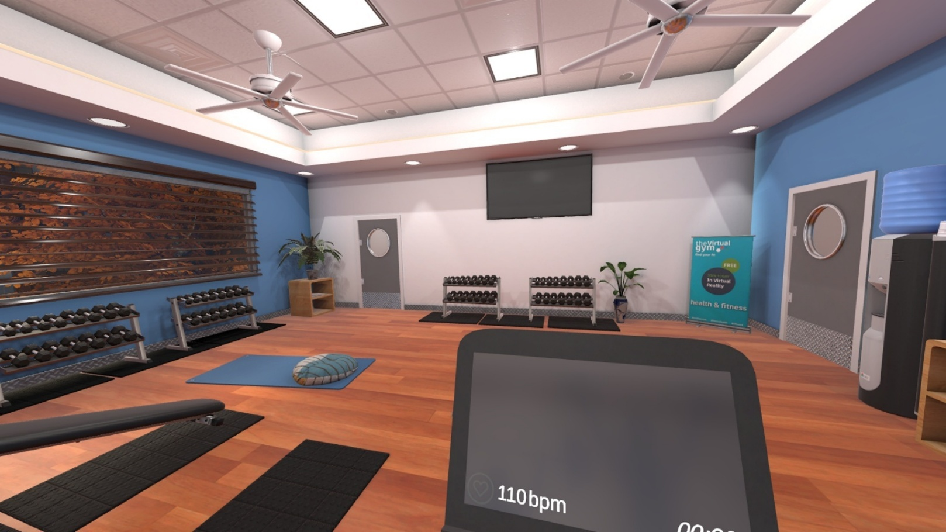
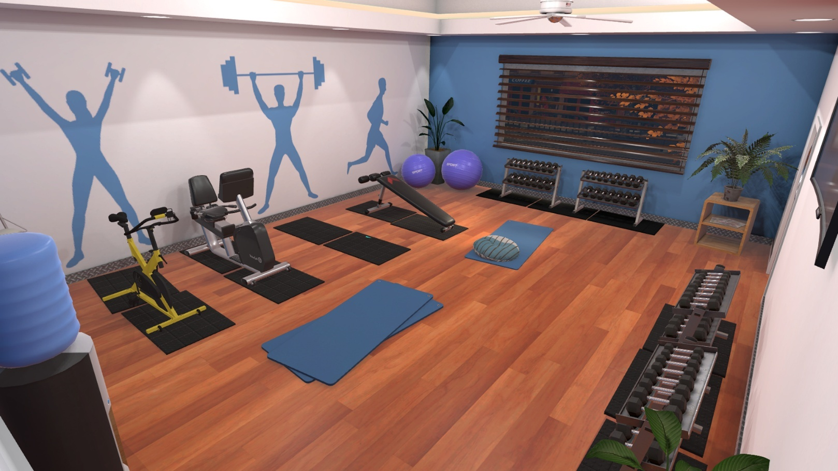
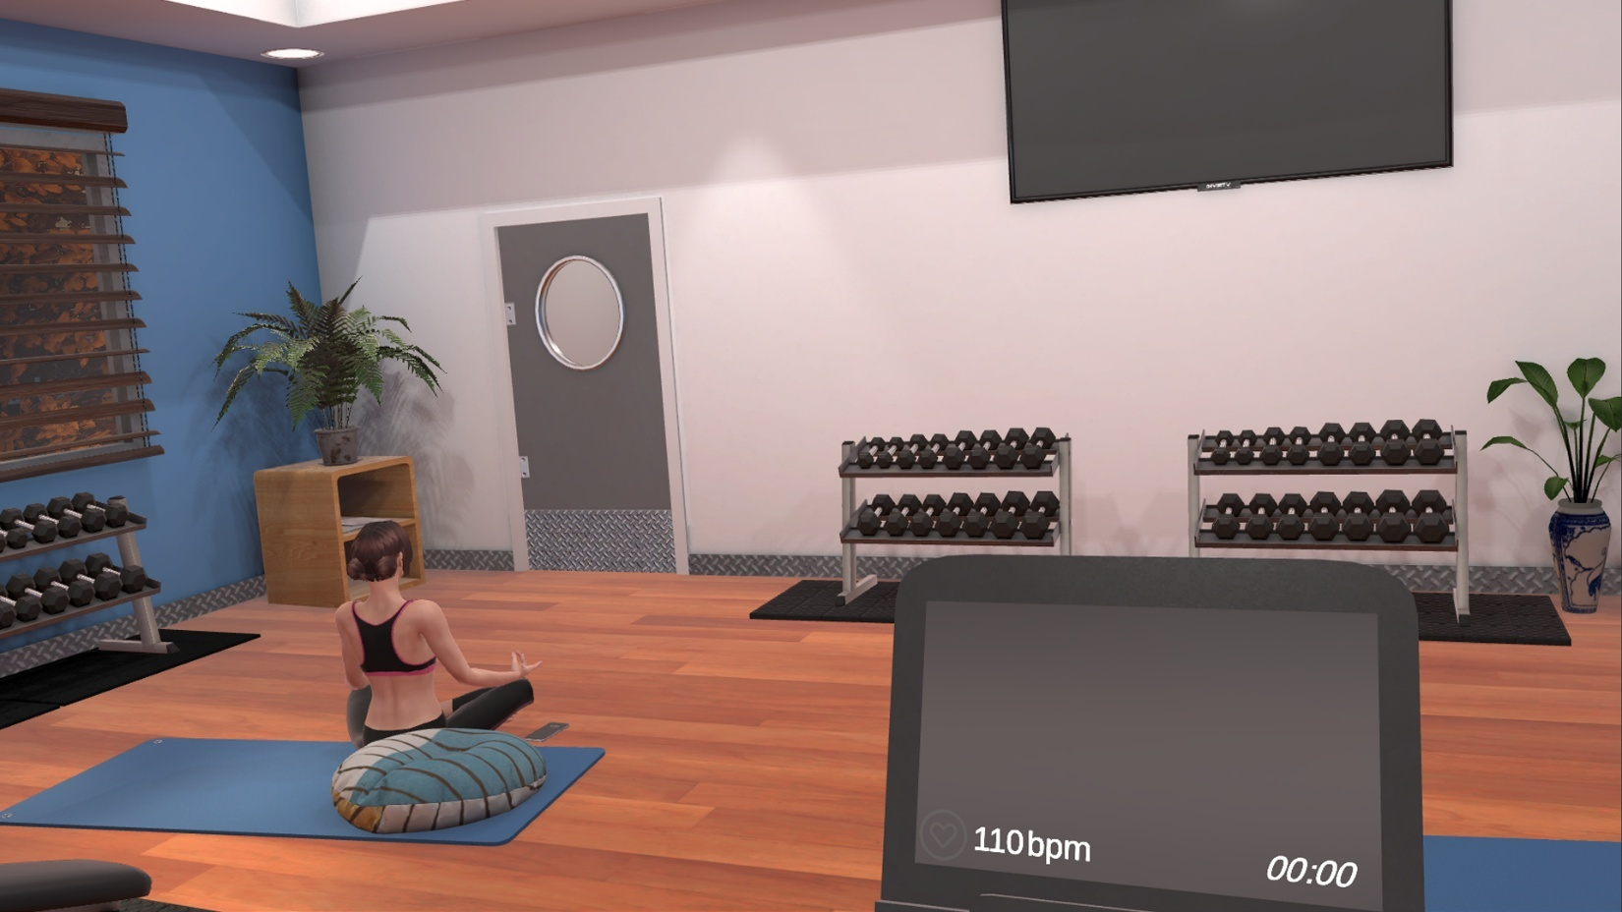

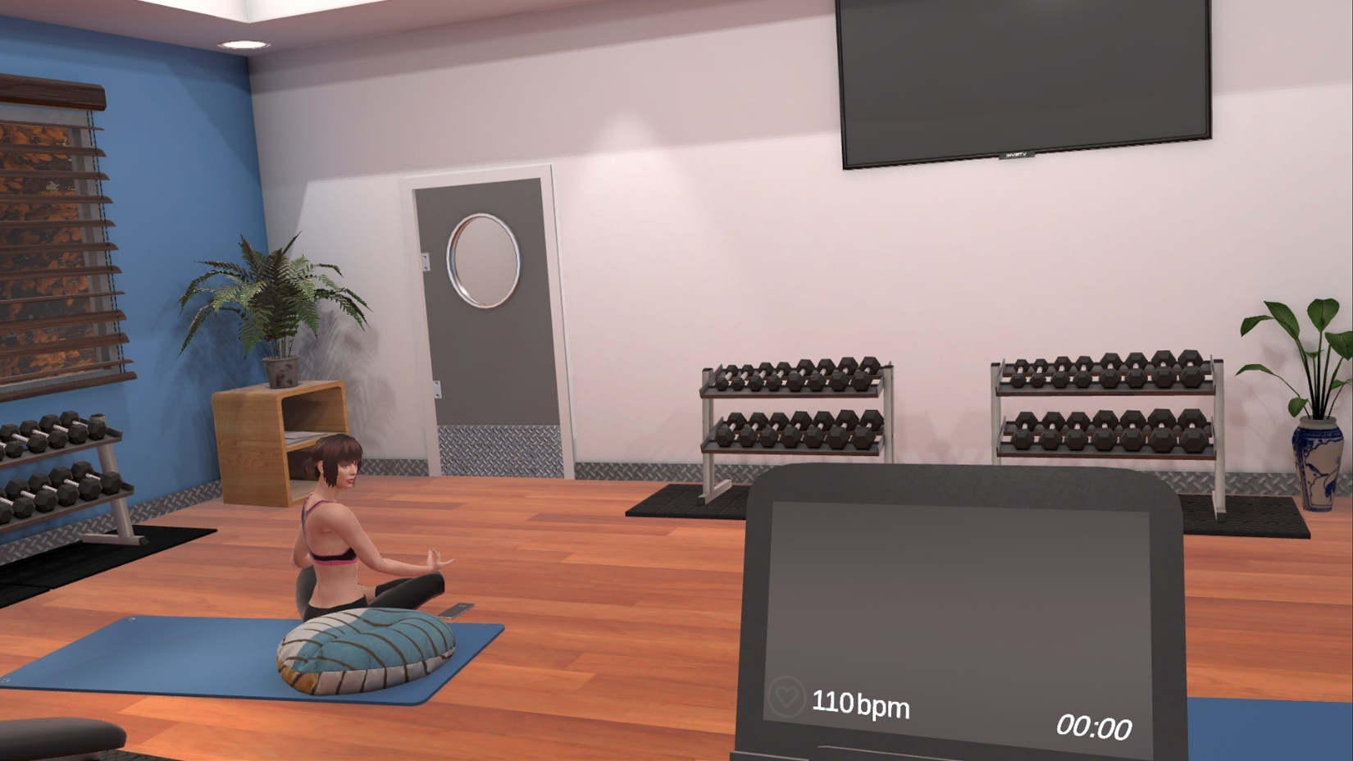

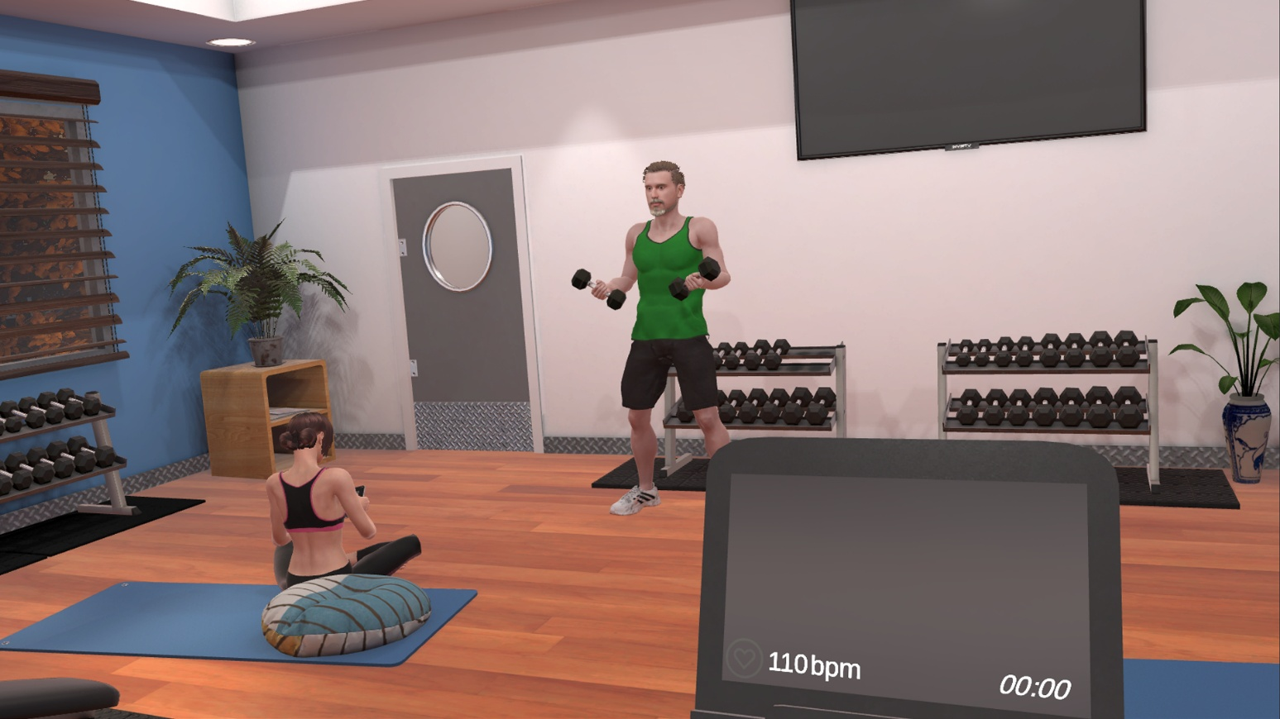
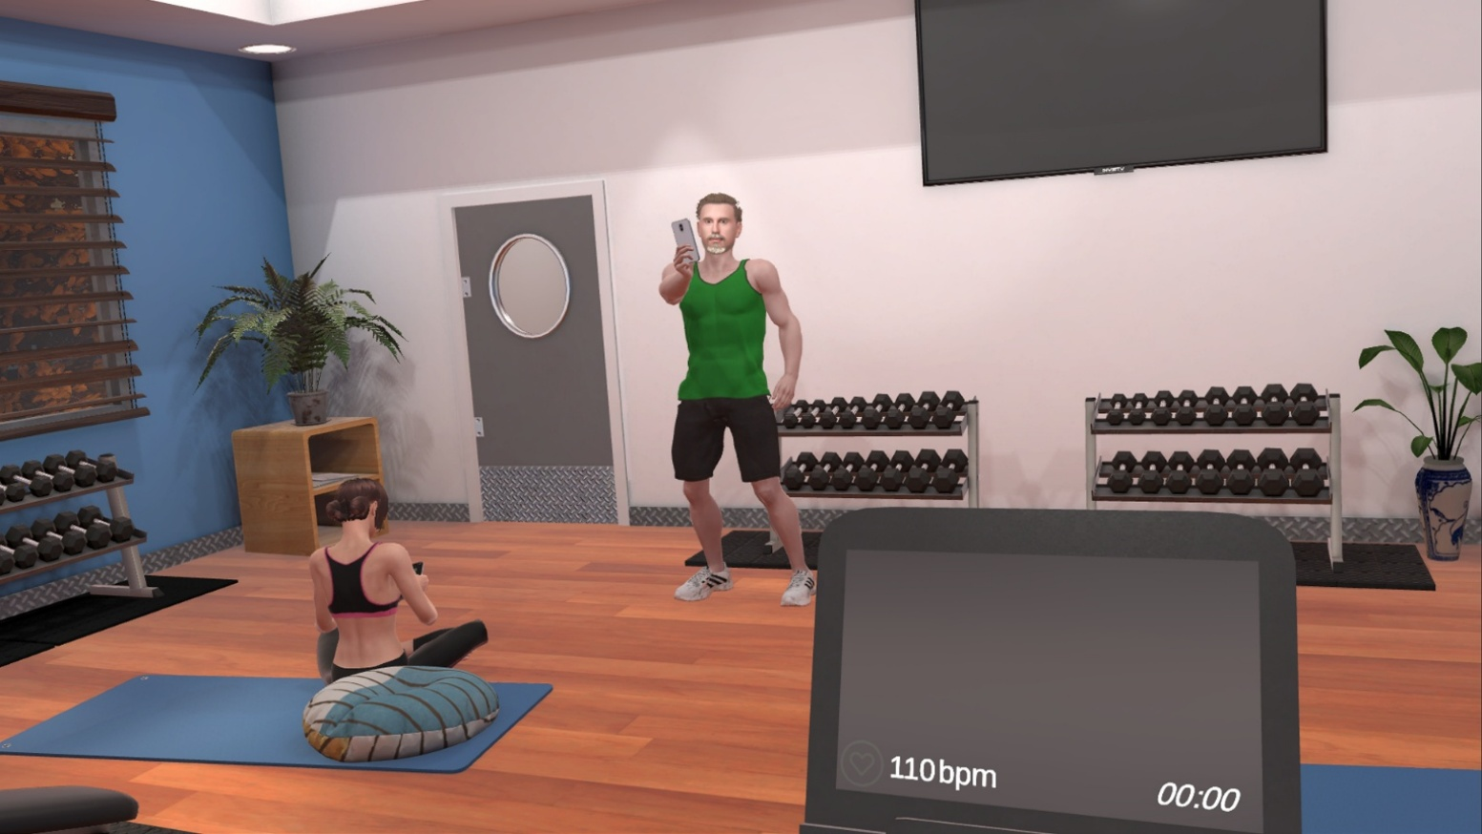

Appendix D. Questions for the interviews (translated from French by SG)
Question 1
Quelles étaient vos attentes à l'égard du projet de recherche lorsque vous avez été contactées pour la première fois?
What were your expectations of the research project when you were first contacted?

Question 2
Vos besoins ont-ils été satisfaits? Si oui - comment? Si non, pourquoi?
Were your needs met? If yes — how? If no — why not?

Question 3
Quelles sont vos impressions générales sur l’intervention reçue et le projet de recherche auquel vous avez participé (mode de diffusion, contenu, fréquence, durée, etc.)?
Quelles ont été les parties les plus utiles?
Quelles ont été les parties les moins utiles?
Qu'est-ce qui n'a pas bien fonctionné pour vous?
Y a-t-il des moyens d'améliorer l’intervention ou les évaluations de recherche ?
Si vous pouviez changer une chose, quelle serait-elle?
What are your overall impressions of the intervention you received and the research project you participated in (delivery method, content, frequency, duration, etc.)?
What were the most useful parts?
What were the least useful parts?
What didn’t work well for you?
Are there ways to improve the intervention or the research assessments?
If you could change one thing, what would it be?

Question 4
Avez-vous rencontré des obstacles ou des problèmes lors de votre participation à l’intervention ou au projet de recherche?
S'il vous plaît, expliquez.
Did you encounter any obstacles or problems while participating in the intervention or the research project?
Please explain.

Question 5
Votre participation à l’intervention a-t-elle eu un impact sur vous?
Quels changements avez-vous perçue par rapport à votre santé physique et / ou mentale, ainsi qu’à votre bien-être?
Quels changements avez-vous perçue par rapport à votre fonctionnement social?
Did your participation in the intervention have an impact on you?
What changes did you notice in your physical and/or mental health, as well as in your overall well-being?
What changes did you notice in your social functioning?

Question 6
Comment votre vie a-t-elle changé depuis votre participation à l’intervention?
Quelles activités de la vie quotidienne ont changé?
Quelles activités personnelles ou sociales ont changé?
Comment l’intervention vous a-t-elle aidé à changer les choses de manière positive?
How has your life changed since participating in the intervention?
Which daily activities have changed?
Which personal or social activities have changed?
How did the intervention help you make positive changes?

Question 7
Quelles ont été vos expériences avec la personne qui a dirigé l’intervention?
Pensez-vous qu'elle a soutenu votre engagement? Pourquoi/pourquoi pas?
Qu'aurait-elle pu faire différemment pour vous soutenir davantage et améliorer votre expérience avec l’intervention?
Qu'est-ce que vous avez aimé / n'avez pas aimé dans vos interactions avec elle?
What were your experiences with the person who led the intervention?
Do you think she supported your engagement? Why or why not?
What could she have done differently to better support you and improve your experience with the intervention?
What did you like or dislike about your interactions with her?

Question 8
Quelles ont été vos expériences avec les assistantes de recherche qui ont effectuées les évaluations ?
Qu’auraient-elles pu faire différemment pour vous mettre davantage à l’aise et améliorer votre expérience avec le projet de recherche?
Qu'est-ce que vous avez aimé / n'avez pas aimé dans vos interactions avec elles?
What were your experiences with the research assistants who conducted the assessments?
What could they have done differently to make you feel more comfortable and improve your experience with the research project?
What did you like or dislike about your interactions with them?

Question 9
Participeriez-vous à nouveau à une intervention similaire à l'avenir?
Participeriez-vous à nouveau à ce type d’étude à l'avenir?
Would you participate in a similar intervention again in the future?
Would you participate in this type of study again in the future?

Question 10
Recommanderiez-vous l’intervention à une amie?
Recommanderiez-vous à une amie de participer au projet de recherche?
Would you recommend the intervention to a friend?
Would you recommend that a friend participate in the research project?

Question 10
Sur une échelle de 1 à 10, 10 étant extrêmement satisfait, comment évalueriez-vous votre niveau de satisfaction à l'égard de l’intervention dans son ensemble?
Veuillez expliquer votre score.
Sur une échelle de 1 à 10, 10 étant extrêmement satisfait, comment évalueriez-vous votre niveau de satisfaction à l'égard du projet de recherche dans son ensemble?
Veuillez expliquer votre score.
On a scale from 1 to 10, with 10 being extremely satisfied, how would you rate your overall satisfaction with the intervention?
Please explain your score.
On a scale from 1 to 10, with 10 being extremely satisfied, how would you rate your overall satisfaction with the research project?
Please explain your score.

Question 11
Y a-t-il autre chose lié à l’intervention ou au projet de recherche dont vous aimeriez discuter que nous n'avons pas couvert?
Is there anything else related to the intervention or the research project that you would like to discuss that we haven’t covered?

Appendix E. Illustrative quotes of the themes and subtheme from the qualitative analysis
Thème | Sous thème | Unité de sens - code |  | Verbatim
Intervention likes | Engagement and interaction with the physical activity counselor | Reference to the counsellor’s attributes and acting qualities, including: encouraging/motivating, non-judgmental, professional, respectful, helpful, likeable, patient, supportive, attentive, reassuring/calm, trustworthy, wanting the best for participants, doing the exercises with participants, quick to adapt to participants’ needs, explained exercises well, believed in participants, accessible/available, smiling/good mood(positive attitude), and helped participants stay focused.  Contributed to participants’ commitment to the program  Talking with the counselor was pleasant/ made the time go by faster  Particular liking for one or two of the counselors over the others/ enjoyed having had more than one counselor  Good cultural fit  Appreciated having a female counselor  Reference to the extent that the counsellor delivered content energetically, passionately, and competently. |  | « Elle pouvait changer les exercices selon nos besoins (P2 indique oui de la tête) du moment. Puis c'était toujours toujours fait, avec un grand respect, puis avec beaucoup de d'écoute. Je la trouvais vraiment génial » F04 G1P1  « J'aimais mieux l'approche de quelqu'un qui était à côté de moi, qui me pousse à aller un petit peu plus loin là. » F05 G2P1  « they're very patient when you needed to be patient. There was no. I guess there's never a dumb question no matter what I asked, it made me feel. And they made me feel like they wanted me to be there. That they wanted me to work they wanted me to achieve my goals.” F14 G2I
Intervention likes | Engagement and interaction with the psychological intervention counselor | Reference to the counsellor’s attributes and acting qualities, including: good listener, adapted to participants’ needs, likeable, non-judgmental, reassuring, easy to talk to, good listener, kind, open, professional, friendly, encouraging, trustworthy, patient, supportive, attentive, and available.  Learned a lot  Contributed to participants’ commitment to the program  Reference to the extent that the counsellor delivered content passionately, and competently. |  | « Donc j'ai bien apprécié comme elle m'écoutait elle, elle me comprenait, puis elle faisait son possible pour résumer ce que je disais, donc j'étais bien appréciée. » F04 G1P2  « Pi psychologue x Ben je l’ai trouvé super structurée, amicale tout ça. Tu sais, j'ai pas rien à dire non plus sur elle, vraiment tu sais, elle était, tu sais. C'était agréable que tu sais, des fois elle disait Ah Ben Wow, je suis contente, c'était vraiment forcé pour ton devoir, puis tout ça, tu sais, tu voyais qu’elle prenait à cœur qu'on avait pris à cœur. » F07 G1I
Intervention likes | Content – Physical activity | Descriptions of the intervention as a source of relevant information to learn or review, as well as receive tips and examples.  Extent that content was motivating, relevant, pleasant/enjoyable, and made participants move  Content variety / alternating between cardio and muscle training  Capacity for the counsellor to deliver personalized content and adjust timeframes as necessary.  Having access to a kinesiologist  Enjoyed feeling good after exercise  Focus is on being active rather than losing weight  Enjoyable muscle training (rather than cardio)  Participants felt pride after PA sessions  Access to pre-planned PA sessions  Exercises allowed participants to improve  Helpful to have warmups  Enjoyed flexibility for type of PA on 3rd day  Enjoyed music during PA |  | « j'ai aimé qui pousse pour la musculation parce que quelque chose que j'aurais, je pense pas fait intuitivement. Je pense pas, je serais capable de faire ça toute seule non plus » F06 G2P1  « Ça me donnait de l'énergie là, surtout quand je sortais de la musculation là, on dirait là, j'étais fière de moi là » F11 G1I  « J'avais vraiment peur de me blesser, moi ça a toujours été ça quand je me remettais à faire de l'exercice. Souvent, je je me blessais, puis il fallait que j'arrête le mon programme pour à cause de blessures, mais là ça s'est bien passé, on était bien entouré, on était à un rythme qui était comme adapté à nous. » F19 G2P1  « Le plus utile (hausse sourcils), ça a été la présence des kins. Pour justement les, les postures, les bonnes façons de faire les mouvements, puis tu sais être bien encadré. » F22 G2I
Intervention likes | Content – Psychological Intervention | Group 1  Descriptions of the intervention as a source of relevant information, as well as receive tips, techniques and examples  Enjoyed exercises/ follow-up  Extent that content was interesting, pre-planned, and pleasant/enjoyable  Learned they have social physique anxiety  Reflections on their thoughts/behavior  Allowed participants to notice improvements  Having sessions centered on themselves |  | “j'ai fait la plupart des devoirs, là il y en a un, là qui qui est pas venu me chercher, m'interpeller mais non, ça a quand même donné des petits trucs, le côté anxiété, puis le stress là. » F11 G1I  « ça m'a apportais à réfléchir sur des comportements que oui j'ai fait, ou des pensées que je peux avoir que l'autre personne a » F07 G1I
Intervention likes | Content – Psychological Intervention | Group 2  Enjoyed ability to speak to a counsellor/ someone neutral/ someone to listen  Appreciated counsellor’s questions/ explanations about certain concepts  Discussions centered around well-being rather than weight loss  Felt good after sessions  Focus was on participants’ needs |  | « La plus utile, c'est la suivi psychologique avec psychologue x. Je l'ai trouvé (gros yeux) important pour le cheminement qu'on fait parce que de de de parler de n'importe quoi, de de parler tsais » F21 G2I  « elle me posait juste des questions (plisse yeux) pour m'amener à réfléchir un peu plus loin. J'ai vraiment trouvé qu'elle était vraiment très, très (hausse sourcils) euh, elle était là pour moi là vraiment. » F19 G2P2
Intervention likes | Material – Physical activity | Monitor to track PA is motivating/ pleasant/ helpful to optimize exercises/ performed well/ easy to use  Equipment in gym or comments on the room: large room, private room, well equipped, easy to access, enjoyed treadmill, enjoyed stand-up bike, enjoyed variety of equipment, general appreciation of equipment  Cleanliness of room and equipment |  | « grâce à cet exercice là puis à pouvoir le faire à à reprendre confiance sur un vélo. Ben maintenant, j'en fais cette année, puis je suis super fière de ça. Tsais, j'ai comme recommencé à utiliser mon (hausse sourcils) vrai vélo. » F19 G2P1  « Le petit brassard que j'avais, tsé ça m'encourageait, parce que ça dit vraiment, là, tu sais ton ton cœur, comment ce qui bat. Fait que tu sais, c'est où ce que tu. Où ce que tu bouges le plus, c'est quoi qui est mieux fait que on dirait c'est c'est venu me chercher, ça m'aidait, ça m'encourageait là. À essayer d'atteindre un volume un petit peu plus haut là pour dire OK là mon cœur, il travaille là, ça m'aide, ça l'aide mon corps. » F11 G1I
Intervention likes | Material – Psychological Intervention | None
Intervention likes | Modalities – Physical activity | Length of sessions was appropriate  Number of weeks/sessions was appropriate  Helpful that one person handled all the appointments  Motivated by/ appreciated delivery modality (one-on-one appointments with a kinesiologist)  Reference to convenience and flexibility of scheduling / appreciated having the same time every week  Glad to have a reason to get out of the house  Convenience of location (UQO), nearby parking  Helpful to have PA and PI on the same day; enjoyed doing PA right after PI  Appreciated verbal appointment confirmations  Timing of program was convenient |  | « She was always willing to accommodate, you know I'm single mom with two kids so It's it's a busy time and so she was always willing to accommodate schedules, and so I thought it was great and. The ability to do stuff at home as well as at the University, of course, was a great balance, and I think a really good way to be able to incorporate what we're doing at the university into real life. » F13 G2I  « I think it was just the right time. 12 weeks is good. I think you need the 12 weeks because to change a habit you have to at least try it a few times first. » F14 G2I
Intervention likes | Modalities – Psychological Intervention | Length of sessions was appropriate  Number of weeks/sessions was appropriate  Direct access to counsellor’s office (without seeing other people)  Helpful that one person handled all the appointments  Reference to flexibility with scheduling  No wait time to start sessions  Convenience of location (UQO), nearby parking  Easy to find room in UQO  Helpful to have PA and PI on the same day  Appreciated verbal appointment confirmations  Session recordings facilitated therapist switch  Timing of program was convenient |  | « S'il y a quelque chose qui a rendu les choses plus faciles, définitivement kinésiologue x, psychologue x sont très flexibles » F05 G2P1
Intervention likes | Non-specific | Would participate again or recommend to a friend  Very satisfied with the project/PA and PI programs (high score on ten)  Appreciated all the people involved  Enjoyed the combination of PI and PA programs  General appreciation of the program  Gave participants a reason to get out of the house  Appreciation of the value of the program (would be costly)  Expectations from participants were clear from the beginning  Enjoyed the level of support  Appreciated efficiency of appointments |  | « Mais, ça a été une super belle expérience. Vraiment là moi aussi c’était une super belle expérience. Tsais là j'ai été contente » F02 G1P2  « Je te dirais que pour moi c'est un coup de pied dans le derrière là de faire comme OK, (hausse sourcils) t'as la chance de vivre ça. Go tsais parce que je ne pourrais pas me le payer justement » F21 G2I
Intervention likes | Virtual Reality – Psychological Intervention | Having VR was interesting/ fun  VR was a way to work on negative thoughts/ feelings |  | « En fait, c'étais le fun de le faire dans un environnement que après 10 Min j'enlevais, puis c'étais partie (sourire). C'était fort apprécié (petit rire). Je pouvais fuir rapidement l'endroit. » F18 G1I
Research likes | Interaction with research staff | Reference to the ways staff answered participants’ questions, communicated well, offered understandable explanations, and conducted assessments respectfully  Staff were professional, non-judgemental, and kind/likeable(sympathique).  Positive interactions with research staff |  | « Non, puis je pense, ça a été bien fait parce que là tu sais, les évaluations avec la prise de poids puis tout ça là c'est vraiment pas le fun là, puis je trouve que ça a été fait vraiment très respectueusement là. » F01 G1P3  « she did all the measurements and she did. All the you know, the weights and all that kind of stuff and percentages and really sat down and sort of explained it to me. I thought that was that was fantastic because I can just see you know, I feel different and I can actually see on the numbers that they're different but also just taking away. I think you know, just when you weigh yourself and she's like, well, it's not all about the numbers, right. You've gotta check this like the percentage here and the percentage there, and that's where the big difference is and that's where you want to see that difference and stuff. So I think that was really helpful » F13 G2I
Research likes | Content | Interesting to see the before and after/ to learn what it means  Appreciated post-intervention discussion  Questionnaires went well/ were doable/ prompted reflection  Initial testing went well  Handout in the beginning was helpful  Glad to understand the goal of the research project |  | « Pi je sais pas par rapport à vos données de recherche, mais c’était quand même intéressant de faire le pré le poste comme ça la, de se prendre le temps comme ça pour de de voir les effets » F01 G1P1  « il y avait des je pense au début, puis à la fin, il y avait un questionnaire plus long à remplir ouin. C'était correct ça aussi. C'était pas ben ben compliqué, puis ça se faisait quand même assez vite ouin. » F09 G1I
Research likes | Material | Extent to which the accelerometer protocol was realistic and wearing it did not interfere with daily activities. |  | « l'accéléromètre, oui, oui. Pour ça, j'ai pas eu de problème non plus. Je le mettais le matin, puis je l'enlevais le soir-là, c'était pas, ça pas posé de problème. » F16 G2I  « Non, c'est pas inconfortable ou quoi que ce soit, non. » F08 G1I
Research likes | Non-specific | High satisfaction ratings with the research process/ would participate again  Evaluation generally went well  Initial contact was quick after having indicated interest in the project |  | “Oui, j'ai une belle expérience avec moi, le recommencer quelque chose de similaire. Oui, j'ai aucun problème parce que c'est une belle expérience quand même. » F02 G1P1  « Ok, parfait. Euh les deux 10 (hausse les sourcils & petit rire des 2). C'est pas compliqué pour de vrai changerais rien, c'était super, puis j'ai aimé ça (sourire). » F11 G1I
Research likes | Virtual Reality | Having VR before and after was interesting/ allowed participant to notice progress  Enjoyed experience with VR  Found the VR experience realistic |  | « Moi, j'ai aimé ça (sourire), mais tu sais dans le sens que c'était, c'était comme curieux, c'était différent. Fait que je trouvais ça intéressant de de parce que c'était, c'est la seule fois que j'ai participé à la réalité virtuelle fait que j'étais contente » F06 G2P1
Intervention Dislikes | Counselor –  Physical activity | Didn’t enjoy exercise with certain kinesiologists (preferred one/ two) who wasn’t as: motivating/ encouraging, attentive/available to offer feedback, present, patient, friendly, invested  Too quick to bring down the intensity of the exercises  2 kinesiologists + an intern was too many people at once (happened 1 time)  Didn’t like changing kinesiologists |  | « Kinésiologue y, elle est très gentil tout ça, mais un peu plus en retrait fait que elle nous laissait aller à nos nos occupations. Puis c'était moins, disons moins moins dans l'accompagnement, on va dire ça plus. » F05 G2P2  « There's almost, especially with the weights I was afraid of injuring myself because she was on her phone. » F14 G2I
Intervention Dislikes | Counselor –  Psychological intervention | Counselor seemed inexperienced/ lacked agility  Counselor read off paper |  | « Je trouvais que (hésitation). Il y avait, je vais le dire comme ça, je pense qu'il y avait un manque d'expérience de sa part. J'ai dis à mon psychologue c'est un bébé psychologue tsais c'est pas la même affaire » F10 G1I
Intervention Dislikes | Content – Physical activity | Didn’t know what type of PA they would do ahead of time  Intensity was too high in the last 2 (or few) weeks / was in pain the last few weeks  Intensity was generally too high/ heart rate goal was too high  Instructions for at home exercise were unlear/ lack of follow-up / found it difficult to do exercise at home  No clear medium-/long-term objectives/ Not knowing how to continue after the 12 weeks/ not enough resources to be independent  Not knowing what to eat before/ after / how to adjust diet when exercising  Didn’t like cardio sessions / muscle training / PA  Having to complete the full cardio session on the same machine  Was discouraged to hear the heart rate needed for weight loss  Didn’t like having music during sessions  Too much talking/ encouragements  Sessions were fast paced  Writing down exercises done at home was redundant/ unpleasant/ a big task / hard to remember  Questionnaires after each session were redundant |  | « je peux pas dire que j'ai adoré la parce qu'il y a des moments, non mais, je te le jure, là, le cardio, je détestais ça » F15 G2I  “Puis parce qu'il y avait vraiment comme une petite anxiété à la fin de dire je veux pas le perdre, mes habitudes, je sais pas vraiment vers quoi m'enligner maintenant pour pas perdre ça. Je me sentais un peu laissée à moi-même là-dedans là. » F19 G2P1  « Je trouvais qu'il y avait peut-être plus de difficultés à savoir qu'est-ce qu'on devrait faire à la maison. On est un peu laissé à soi-même sur euh. Nous-mêmes gérer qu'est-ce qu'on va faire à la maison. Il y avait pas vraiment de suivi sur bon cette semaine à la maison, c'est quoi tes objectifs? Qu'est-ce que tu vas faire? » F20 G1P1
Intervention Dislikes | Content – Psychological Intervention | Groupe 1  Found it difficult  Didn’t like now knowing the topic ahead of time/ not having time to reflect on the topic ahead of time  Finding time to do homework/ remembering to do it was difficult  Homework was challenging / hard to understand  Long-term objectives were unclear  Exposure was insufficient/ Written exposure exercise was too hard  Discussions didn’t include societal perceptions / external barriers  Certain topics were redundant  Could’ve done without PI / found content irrelevant  Lack of flexibility/ adaptability of content  Content was overly theoretical and lacked application / discussion questions were too vague  Too much session time spent on homework  Wanted to know ahead of time that exposure would require 15 minutes of biking  General dislike of PI |  | « J'ai trouvé des fois l'information ou le, les exercices étaient pas mal redondantes, comme il y en avait certains qui se répétaient, puis on faisait comme j'avais pas. (…) comme je me répétais, on n'allait pas plus loin que ça » F04 G1P2  « mais le le, la Psy là vraiment, j'ai pas compris vraiment c'était quoi le but. Comme j'ai pas eum. Je me suis demandé après si j'avais mal répondu au premier questionnaire, qui parle de l'anxiété, puis tout ça. (…) Pour moi, ça m'a pas servi. » F09 G1I
Intervention Dislikes | Content – Psychological Intervention | Groupe 2  Wanted guidance/ advice rather than just a support role  Didn’t know what to talk about / felt pressure to arrive with a topic  Wasn’t helpful/ was boring  Was too short to have an impact  Felt more like chatting with a friend than therapy |  | « Honnêtement, c'est la partie du programme que je trouvais plus lourde, peut-être un petit peu moins aidante. Puis j'avais de la misère à comprendre parce que ma psychologue, elle me disait vraiment que elle avait eu comme indication d'être vraiment en support, puis de pas donner de conseils, puis moi, j'aurais aimé ça, peut-être avoir le volet conseil. » F12 G2I  « It was challenging sometimes having to show up and having a topic in mind and just sort of talking about that » F13 G2I
Intervention Dislikes | Material – Physical activity | Difficult to remember Polar watch / remember to charge it  Polar watch would flip upside down  Problems with phone application / setup / connectivity issues  Tracking heart rate was discouraging/ stressful / didn’t represent perceived effort  Would’ve preferred an electronic rather than paper journal  Exercise room was unpleasant / walls were bare / ceiling full of pipes / no curtains on windows  Heavier weights needed/ Bike 1 was uncomfortable/ unpleasant/Couldn’t reach pedals / Bike 2 led to backside injury (1) / Biking in general was unpleasant / Not enough cardio equipment variety/general dislike of equipment / Exercise bench was too thin / Elliptical was hard to use / Exercise elastics snapped during use  Room was too full (after additional equipment was brought in) / too small  Stairs leading to the exercise room aggravated knee problems  No nearby bathroom/ nearby bathroom only had small stalls to change in  Glare from window onto treadmill screen was unpleasant |  | « que ça soit au sous-sol pour les gens des fois en surpoids qui ont des problèmes de genou avant et après les entraînements, j'avais des fois de la difficulté, moi avec ces escaliers là. » F02 G1P1  « Je déteste le vélo pour quelqu'un avec un surplus de poids, la façon que le vélo est fait quand qu’on pédale Ça, ça les genoux ne rendent dans le ventre, c'est tout sauf confortable » F05 G2P1
Intervention Dislikes | Material – Psychological Intervention | None
Intervention Dislikes | Modalities – Physical activity | - End of PA sessions was abrupt  - 2x/week was a lot/ not enough / hard to fit in schedule / starting at 3x/week was fast  - 12 weeks is too much / not enough  - Scheduling: Not enough evening availability / session times moved around too much, prevented planning ahead of time / difficult to balance sessions and bus schedule / scheduling mix ups (type/date of exercise) / general issues with communication  - Exercise was never in a non-private gym / didn’t prepare for life after sessions  - Missed weeks were not rescheduled / not knowing that missed weeks would not be rescheduled / missed sessions were added to already busy schedule / unsure about cancelation protocol  - UQO was far  - Parking payment machine/ parking meter didn’t work / finding parking was stressful / expensive parking  - Room was unclean / garbage was not collected |  | « l'arrêt est un peu brusque, comme là tu faisais toute ça là puis là bien là c'était un petit peu OK, je peux pas avoir ça là ce contexte one on one 2 fois par semaine avec un entraîneur dans un petit studio privé fait que là, comment je, le retour à la réalité est un peu est un peu abrupte » F01 G1P3  « Le stationnement, c'est gossant parce que faut que tu le payes à chaque fois. Moi, je pilote avec l'angoisse, ça c'est angoissant pour moi, évidemment, et que je me stationne en haut là, ******* machine à sous à manger de mes pièces. » F15 G2I
Intervention Dislikes | Modalities – Psychological Intervention | - Not enough time to go in depth / homework took up too much time  - Too many / not enough PI sessions  - Scheduling : Not enough evening availability / session times moved around too much, prevented planning ahead of time / difficult to balance sessions and bus schedule / scheduling mix up / had less sessions than planned / missed sessions were not rescheduled  - Unsure about cancelation protocol  - UQO was far  - Parking payment machine/ parking meter didn’t work / finding parking was stressful / expensive parking |  | « Je pense que entre, quand il y avait des séances où il y en avait pas, moi j'en aurais mis quand même là. Comme entre la 6e séance, la 9e séance y avait comme un trou, moi j'aurais quand même mis des séances. » F20 G1P1  « en même temps, des fois assez d'aller dans le creux du sujet. Sachant qu'il n'aurait pas de suivi par la suite (plisse yeux), j'ai pas vraiment voulu aller dans tu sais trop dans le creux. Fait que ça se peut que je me suis gardée quand même une petite gêne ou une petite barrière. » F22 G2I
Intervention Dislikes | Virtual Reality – Psychological Intervention | Disappointed to be in a gym / not enough characters in gym / scenario uneventful / scenarios were too similar / scenarios didn’t induce anxiety / were boring  No possibility to adapt the scenario  Doing it twice was redundant / was too long  Bike pedals in VR didn’t work / Worried about adjacent bike in VR scenario  Mask malfunctioned and caused nausea / headset wasn’t properly adjusted  VR didn’t feel real / gym didn’t seem real  General dislike of VR |  | « Mais on dirait que j'ai trouvé la situation un peu trop simple. Peut-être que mon anxiété est peut-être pas assez plafonnée pour pour l'avoir vécu différemment, peut-être si ça leur était en vrai vrai vrai, j'aurais peut-être eu plus d'anxiété, mais on dirait qu'il y avait pas assez de personnes dans la réalité virtuelle pour m'avoir stressé » F07 G1I  « Je me sentais pas dans une salle de sport ou ou dans une situation stressante ou quoique ce soit et du coup je trouvais ça assez assez long. » F20 G1P2
Intervention Dislikes | Non Specific | Came to take a video without prior notice  Program was demanding overall / was too tired to go some weeks  There was a poster that read “group of studies on obesity” on the door  Exercising with the mask was hard  Kinesiologist’s dog was bothersome/ smelly  No need for COVID questionnaire  Kinesiologists ate nuts, participant allergic |  | « j'ai comme été un peu sur le spot, tu sais, oh on vient prendre des photos. Êtes-vous d'accord voulez-vous signer fait que finalement je l'ai signée, je l'ai fait mais sûrement que j'y aurais pensé 2 fois, tu sais à dire oui ou non si je veux l'être, puis aussi de peut-être, je m'aurais habillé autrement cette journée là où tu sais peigner autrement, peu importe pour faire, sachant que je vais faire un vidéo tu sais. » F07 G1I  « tsais y avait quand même une pancarte qui disait, groupe d'études sur l'obésité. Là quand je montais en haut, ben là il y avait des gens qui attendaient dans le gym fair que ça je trouvais ça un petit peu moins, j'étais moins à l'aise » F12 G2I
Research Dislikes | Interaction with research staff | None
Research Dislikes | Content | Questionnaires were long / redundant / confusing / hard to understand / paper / not useful / too many answer options  Didn’t want to participate in discussion group  Posters unclear / hard to read / length of intervention unclear / not enough information online  Not made aware of their results / why they had to wear accelerometer  First test was hard |  | « En fait, j'ai trouvé l'annonce assez compliquée, euh, c'était pas clair. Puis c'était assez difficile d'avoir plus d'informations. Tu sais, il a fallu que. Je me souviens que j'avais trouvé ça compliqué, j'étais comme ben voyons donc. Comme tsais si je voulais juste avoir l'information, il a fallu quand même que j'appelle quelqu'un. Tu sais au bout du compte, moi j'aurais préféré comme juste avoir à faire avec un ordinateur » F09 G1I  « je suis sur qu'il y a un but de reposer la même question différemment de 2, 3 façons, pour voir si tu fais des erreurs. Sauf que c'est mêlant (gros yeux) des fois là » F17 G2I
Research Dislikes | Material | Accelerometer; reference to device wear : wouldn’t stay in place, unpleasant, one week was too long, forgot to wear it, elastic was coming apart, didn’t know what data it collected, falling straps showed under clothing, device broke  Didn’t like doing initial/ final test on the bike |  | « l'accéléromètre est juste pas confortable au niveau de la taille là (sourire). Selon notre physionomie là, moi je trouve qu'il montait tout le temps en dessous de la brassière. » F21 G2I  « mais j'ai trouvé ça difficile parce que faut pas l'oublier, là fallait je l'enlève pour le bain. Une fois, j'ai oublié de la remettre après mon bain. » F11 G1I
Research Dislikes | Modalities | Felt pressured to keep up intensity because it’s a research project  Initial pulse reading was not accurate due to stress  Participant told they were screened-out when they weren’t  15$/ evaluation doesn’t cover transport/parking cost |  | « Moi, mon cœur chez nous, là quand je suis au repos c'est 62. (…) puis elle mon cœur au repos, elle l'a eu à 78. Fait (…) qu'il fallait que je monte mettons euh. Selon les séances, fallait qu'elle le fasse monter selon notre pouls au repos. C'est sur que mon pouls au repos chez nous, il était plus calme que quand j'étais avec kinésiologue x que je connais pas encore lors de la première séance la tsais. Puis que je suis un peu stressée qu'on sait pas où ce qu'on s'en va. » F06 G2P2  « Moi j'avais compris que je recevais 15,00$ à chaque visite, à la place du 15$ par évaluation qui devrait clarifier en gros dans le contrat. Parce que tsais on se dit le gaz, le déplacement, le stationnement. » F17 G2I
Research Dislikes | Virtual Reality | Bodysuit was hard to wear / too small / embarrassing / left chest exposed / wrong size / unpleasant to wear in cold room  Scenario was slow-paced / not enough activity / felt long/boring / didn’t induce anxiety / didn’t like having the same scenario twice / characters were too pixelized/not realistic  Stressful not knowing what will happen  Felt fake / wasn’t useful / like looking at a screen / took time to feel immersed / general dislike of VR  Was not immersed because of chair/ office  Glasses didn’t fit under mask  Couldn’t hear what characters were saying |  | « Fak tsais c'est dur à dire pour moi si j'ai cheminé par rapport à ça, parce que les c'était pas assez intense pour m'avoir stressé. » F07 G1I  « Je comprenais qu'on se mettait, on nous mettait dans une situation virtuelle (plisse yeux) qu'on voulait que ça soit comme vrai. Mais c'était tellement jeux vidéo que c'était comme difficile de voir comment on voulait qu'on réagisse. Je sais pas, j'ai trouvé ça un peu bizarre. » F22 G2I
Benefits to participants | Physical | Feels more balanced/ solid  Generally less out of breath, improvements in physical fitness, stronger heart/ lungs, less asthma  Improved posture, flexibility, endurance  Back/knee injury improved/ body pain disappeared  Easier to sit on the ground and get up  Improved sleep, more energy  Muscle definition/ gained muscle  Better digestion |  | « L'autre chose qui que j'ai beaucoup apprécié si on si on niveau de de mon dos, je me suis blesse il y a quand même quelques années, mais c'est souvent, je tourne mal, je fais quelque chose, puis ça me cause des douleurs pour des mois encore, mais depuis, depuis janvier ça marche bien. Espérons que ça continue. » F03 G1P2  « La capacité aussi là. Je le vois aussi quand je monte les marches moins essoufflée qu'avant et tout ça. » F12 G2I
Benefits to participants | Psychosocial – Physical activity | Desire to exercise in public  Using exercise as a coping mechanism  Reference to the intervention as helpful to improve mood, wellbeing, self-esteem/confidence, reduce stress, and collectively motivating each other to engage in behavior change, as well as facilitating social contact. |  | « mais ça a aussi amélioré mon humeur en général à la maison. Définitivement, je suis plus de bonne humeur. Je suis plus enjoué, plus de motivation moins patate de sofa si on veut aussi dans les interactions autant avec mon conjoint qu'avec ma fille ça l'a apporté beaucoup d'améliorations. » F05 G2P1  « Fait que sur ce je le vois le comme j'ai plus le goût de participer à des activités. Dans mon quartier avec mes amis, avec mon conjoint, parce que c'est plus facile, fait que je le je le sens au niveau de mes muscles, de mes envies. » F16 G2I
Benefits to participants | Psychosocial – Psychological Intervention | Groupe 1  Reduced stress and increased wellbeing |  | « Je peux dire au niveau de la santé mentale c'était super bien pour moi » F03 G1P2
Benefits to participants | Psychosocial – Psychological Intervention | Groupe 2  Increased wellbeing and confidence, learned to take care of themselves  Reference to the intervention as facilitating social engagement |  | « Et puis ben, il a la santé mentale forcément, vu que je fais plus d'activités, ben tsé je fais plus de social fait que on se sent forcément mieux aussi parce que on échange plus. » F16 G2I
Benefits to participants | Behavioral –  Physical activity | Reference to the intervention as helpful to engage in behavior change and spend time with family/friends actively  Descriptions of moving more, and trying new activities, exercising regularly, continuing same exercises, feeling the need to move, bought exercise equipment, biking/walking to run errands, revisiting old activities, physically able to do more, sign up to exercise class/ gym, playing with children, tracking exercise with watch, set exercise goals, frequent walks, going out more, family is more active |  | « Puis les enfants sont super contents. On est allé en vélo à l'épicerie, les 3 ensemble fait que si j'essaye de de retrouver une espèce de de façon de bouger avec les enfants avec la famille. » F02 G1P1  « Après-midi là, quand j'avais terminé mon mon chiffre de travail parce que je travaille en avant d'un ordinateur dans mon sous-sol, fallait que je sorte là. Tsais faut que j'aille bouger là parce que je sentais pas cette urgence là avant, mais là c'est là maintenant là » F19 G2P1
Benefits to participants | Behavioral – Psychological Intervention | Groupe 1  Stopped doing certain reassurance seeking behaviors |  | « On dirait que c'est plus j'ai comme plus besoin de faire certains gestes que je posais avant, puis certaines pensées que j'avais avant, je me rends compte que je les ai plus non plus » F02 G1P1
Benefits to participants | Behavioral – Psychological Intervention | Groupe 2  Changed jobs to not work from home  Got a therapist to continue work  Engaging in healthier/intuitive eating |  | « Puis les enfants sont super contents. On est allé en vélo à l'épicerie, les 3 ensemble fait que si j'essaye de de retrouver une espèce de de façon de bouger avec les enfants avec la famille. » F06 G2P2
Benefits to participants | Reflections on mechanisms of action / processes involved in making changes –  Physical activity | Reference to gaining knowledge, motivation, discipline, and self-efficacy, reflecting on barriers to PA (time) and solutions/ ways to make it more realistic, enhancing self-perceptions and attitudes towards PA, and seeking others support, mindset shift regarding PA (PA not as intimidating), dissociating PA from weightloss, doing PA for pleasure/ to take care of self  Pride in having been able to exercise 3-4x/week for 12 weeks / knowing they can do it (may be part of self-efficacy / enhancing self-perception) |  | « pas nécessairement aller chercher la performance où aller chercher le les les, les pertes de poids ou les affaires de même en être, mais tsais juste le plaisir de faire. Puis dans le fond, c'est ça d'aller rechercher le plaisir dans tout ça. » F01 G1P1  « Pour moi, ça a été une révélation tant qu’au point de vue physique de voir ce que j'étais capable de faire » F02 G1P1  « maintenant, je je, je me sens, comme si je me dis Bah c'est c'est possible de le faire je suis capable de le faire. Ça, comme débloquer quelque chose, même si je le fais pas de façon aussi assidu que que que pendant le la période d'activité. Mais je sais que c'est quelque chose que je suis capable de de faire et que si je veux m'y mettre et continuer, je suis capable » F05 G2P2
Benefits to participants | Reflections on mechanisms of action / processes involved in making changes –  Psychological Intervention | Groupe 1  Reference to gaining knowledge about one’s self/one’s behaviors, and techniques to manage anxiety. Reference to intervention helping with self-acceptance, enhancing attitudes towards PA, reflecting on barriers to taking care of one’s self and shifting mindsets |  | « Puis tu sais de de de penser ce que l'autre va penser. Tu sais ça, je le faisais déjà, puis je le fais encore, mais là, aujourd'hui, j'essaie de moto corriger puis me dire OK, non, tsais ou tu sais, oui, il te voit, mais il va t'oublier dans 30 secondes, mais tu sais, c'est pas, c'est pas son centre d'intérêt nécessairement » F07 G1I
Benefits to participants |  | Groupe 2  Reference to gaining knowledge about one’s self/one’s behaviors/one’s emotions, and techniques to manage stress, to live a healthier lifestyle, reflecting on barriers and solutions to PI and taking care of oneself, enhancing attitudes towards PA |  | « c'était positif dans nos vies là ouais. D'apprendre à à exprimer ce que je vivais avec des mots avec des eum. C'est ça, ça, sortir les les choses en à l'extérieur de moi puis ouais. De réaliser comment ça fait du bien à la tête, puis qu'on est bien d'écouter de la musique, puis ça, c'est mon moment à moi, puis je le (hausse sourcils) vaux. En fait, c'est vraiment que je le vaux ce temps-là, que je pensais que je le valais pas avant. » F21 G2I
Benefits to participants | Impact TBD | Wanting to continue PA, but haven’t yet |  | « Pas encore. J'essaie de les travailler dans ma tête parce que je veux faire les changements, c'est juste, on dirait que c'est l'exécution. Il manque le le bout, le le le le switch à ON là pour l'exécution comme tel. » F22 G2I
Absence of benefits and adverse effects | Physical | Possible contribution to diminished physical health  Didn’t notice any differences |  | « Je côté physique (plisse yeux)? Pas vraiment. C'est ça, j'ai eu comme de la misère à voir une différence. Je sais qu'il y a une des kin, elle essayait de dire, Ouais mais ça peut être (plisse yeux) très minime. Là je suis comme, y a absolument (hausse sourcils) rien que j'ai vu différent côté physique. » F22 G2I
Absence of benefits and adverse effects | Psychosocial –  Physical activity | Feeling badly about not having continued PA  Not as much change as was hoped for |  | « Là, ben je suis dans la culpabilité de pas avoir repris donc ça c'est quelque chose que je je je trouve plate. Fait que je me dis je n'aurais pas dû le faire, tsais parce que là, je me sens mal. Non, c'est pas vrai, c'est pas vrai, c'est pas vrai, mais je me sens mal présentement. » F06 G2P3
Absence of benefits and adverse effects | Psychosocial –  Psychological Intervention | Absence of benefits (G1 & G2)  Worsened social physical anxiety (G1) |  | « Puis, mais j'avoue que pour l'anxiété physique sociale, moi, ça m'a pas tellement aidé. Ça m'a même à l'inverse, apporté encore plus de conscience sur mon corps et tout. » F20 G1P1
Absence of benefits and adverse effects | Behavioral –  Physical activity | Absence of change/ didn’t continue PA/develop new habits |  | « Non, ça m'a pas vraiment servi à rien. Je maintenant ça fait, ça fait quelques mois là. Je pourrais-je pourrais te dire que j'ai tsais j'ai pas changé mes habitudes. Comme ça. Il aurait fallu que ça dure plus longtemps, vraiment pour moi. » F09 G1I
Absence of benefits and adverse effects | Behavioral –  Psychological Intervention | None
Recommendations for future | Intervention – Physical activity | Intervention should span a longer timeframe, include more sessions per week, or include follow-up sessions after the 12 weeks  Not end session early if participants do exercises quickly  Offer tools/guide to help participants continue exercise after program ends / to organize group exercise sessions after 12 weeks / allow participants to get in touch / allow participants to lead PA sessions at the end to get feedback / teach participants how to calculate their ideal heart rate  Remind participants of what PA they did each week  Have something to look at during exercise (e.g., television, posters, artwork)  Allow participants to listen to their choice of audio  Have more variety of exercise equipment (elliptical, stair-master, a stand-up bike)  Include access to a nutritionist / information on what to eat before/after PA  Include discussions on leading a healthy lifestyle  Consider PA difficulties due to societal perceptions not encouraging people with obesity to engage in PA (G1)  Include a PA session in a real gym (as long as participants are informed ahead of time) or outside/ a place other than UQO to spare the long drive / offer optional group/dyad exercise sessions  Access to a bathroom  Follow-ups on/ reminders about the 3rd day of exercise and sheets to fill out  Get a discount code for participants to buy a cardiofréquencemètre  Include interesting types of cardio (e.g., Zumba)  Keep equipment maintained (e.g., elastics)  Electronic rather than paper homework / more space to write on sheet  Use a watch instead of cardiofréquencemètre |  | « Je pense ça, ça aurait été intéressant, c'est de peut être de mesurer, tu sais, de voir si on se sent à l'aise à un moment donné d'aller dans la salle de sport avec la Kinésiologue, ça, ça aurait été intéressant. Je pense, moi, que au début j'aurais pas pu. J'aurais dit Ouh là là, non non non, mais effectivement peut être que vers la fin » F05 G2P2  « ça aurait peut-être été le fun. Tsais peut-être pendant quelques mois après d'avoir encore une séance échelonné, tsais juste pour qu'on garde le rythme, garder le contact, de voir, tu sais si on fait encore les choses correctement, puis voir et l'évolution aussi par rapport à aux efforts qu'on a fait. Pi tu sais, au pire ça aurait pu être même groupé rendu là. » F07 G1I
Recommendations for future | Intervention – Psychological Intervention | Group 1  Vary VR environments (e.g. zumba class) / have more people / use other environments than gym  Longer session times / more sessions  Talk more about dealing with societal perceptions / dealing with that long term / more concrete applications of interventions  Adapt intervention to each person  Indicate how to continue PI work after program ends  Include group sessions  Allow participants to bring topics they want to talk about |  | « C'est vrai que des fois, c'est quelque fois j'aurais pris un petit 15 Min 20 Min de plus à discuter pour continuer la discussion là » F02 G1P1  « Mais c'est c'est vrai que ça aurait été cool de qu'elle soit ou qu'elle ajuste les séances face à la personne devant elle. Comme soit l'âge, niveau d'anxiété, problème expliqué, je sais pas là » F04 G1P2
Recommendations for future | Intervention – Psychological Intervention | Group 2  Include more sessions near the end of the program / less frequent sessions  Include discussions on leading a healthy lifestyle  Include group sessions  Not just listen, but give advice / add exposure to anxiety |  | « Ben si c'est vraiment un groupe de, c'est vraiment juste le support qu'on va aller chercher dans ces réunions, là je me demande si on l'aurait pas autant dans le fond, peut-être plus avec les participantes, les mêmes participantes là qui, concrètement font le programme, puis ont des trucs. » F12 G2I  « C'est ça, l'intervention Psy, ben peut-être que plus espacée. J'aurais peut-être eu la chance de penser à ce qu'on s'était dit, puis ramener d'autres sujets » F16 G2I
Recommendations for future | Initial and final assessments | Not use same VR situation both times / more activity in situation  Increase VR quality  Allow participants to cover up when wearing body suit (VR) / warn about wearing body suit  Use spa setting instead of pool setting  Do beginning and final test on stand-up bike rather than the sit down bike |  | « Puis moi ce qui me rendait mal à l'aise à ça, c'est pas que c'était serré, c'est qu'on voyait une bonne partie de ma poitrine. Puis moi, ça me mettait très mal à l'aise (…) Je pense qu'il faudrait fournir quelque chose au moins pour cacher les parties intimes là, parce que là, c'est sûr que mon stress était super élevé » F20 G1P1
Recommendations for future | Non-specific | Discounted/free parking / parking pass  Allow participants to meet/support each other  Have a schedule/ guide indicating all research and intervention related activities with dates  Clear session cancelation procedure  Allow those with low anxiety to participate  Check-in on participants halfway through program  Discuss benefits of PA and PI
Events that could impact PA | Physical activity | PA had to be altered due to injury  Had to miss sessions due to weather/illness / had to wear mask during PA sessions  Living far from UQO was an obstacle / generalised anxiety was an obstacle  Time of the year made it tough/affected performance (just before holidays) / affected level of PA when wearing accelerometer  Too busy to incorporate 3rd PA day per week | « Il a fallu j'annule une semaine complète parce que j'ai eu la COVID, puis ça c'était une semaine perdue, ça a pas été déplacé » F06 G2P1  « mais j'étais dans un temps très très fatigué. Tsais, le novembre, c'est mon mois terrible. Fait que c'est sûr que l'avoir fait exemple le printemps là, probablement que ça aurait eu plus d'impact. Ou encore mieux, tsais je pense que mon étude aurait été encore meilleure côté performance. » F17 G2I
Events that could impact PA | Psychological Intervention | Constraints due to time of year (summer/ holidays)  Illness caused absences  Living far from UQO / generalized anxiety was an obstacle | « J'ai attrapé. J'ai eu le COVID, en plus d'une sinusite, fait que c'est comme écourté de 4 semaines aussi fait que j'aurais. J'aurais aimé ça aussi continuer un peu. » F05 G2P1
Recruitment process |  | Friend’s Facebook post / Imavie/ISM Facebook page / other Facebook page  Info letter at work  Poster at UQO  Recommended by friend / colleague | « Euh sur Facebook, j'ai vu l'annonce passer dans un groupe de (fronce sourcils) mon voisinage » F18 G1I

Appendix F. Secondary outcome results
Table S1. Social Physique Anxiety (2 groups)
 |  | CBTVR+ET |  |  | ST+ET
 |  | n | mean±SD | 95% CI  (LB-UB) | n | mean±SD | 95% CI  (LB-UB)
Social physique anxiety scores | T1 | 21 | 36.5±5.3 | 34.1-38.9 | 23 | 35.9±4.7 | 33.9-37.9
Social physique anxiety scores | T2 | 19 | 30.8±6.6 | 27.7-34.0 | 20 | 30.9±5.9 | 28.1-33.6
Social physique anxiety scores | T3 | 14 | 29.9±8.1 | 25.2-34.5 | 16 | 30.8±7.4 | 26.8-34.8
Notes: T1bis values were used as T1 for the participants initially allocated to the waitlist group. CBTVR+ET: CBT-based psychological intervention with VR-based exposure and exercise training; ST+ET: psychological supportive intervention and exercise training

Table S2. Social Physique Anxiety (3 groups)
 |  | CBTVR+ET |  |  | ST+ET |  |  | Waitlist
 |  | n | mean±SD | 95% CI  (LB-UB) | n | mean±SD | 95% CI  (LB-UB) | n | mean±SD | 95% CI  (LB-UB)
Social physique anxiety scores | T1 | 15 | 37.3±5.1 | 34.5-40.1 | 15 | 35.8±5.5 | 32.8-38.8 | 15 | 35.5±4.0 | 33.3-37.7
Social physique anxiety scores | T2 | 13 | 30.8±6.4 | 27.0-34.7 | 13 | 31.1±7.1 | 26.8-35.4 | 14 | 35.4±4.1 | 33.0-37.7
Notes: T1bis values were used as T2 for the participants in the waitlist group. CBTVR+ET: CBT-based psychological intervention with VR-based exposure and exercise training; ST+ET: psychological supportive intervention and exercise training; SD: standard deviation; CI: Confidence intervals; LB: Lower bound; UB: Upper bound

Table S3. Average MHPA time, weight bias internalisation and body appreciation scores
 |  | CBTVR+ET |  |  | ST+ET
 |  | n | mean±SD | 95% CI  (LB-UB) | n | mean±SD | 95% CI  (LB-UB)
MHPA accel. (min/week) | T1 | 19 | 212.8±94.3 | 167.4-258.3 | 20 | 170.5±84.2 | 131.1-209.9
MHPA accel. (min/week) | T2 | 15 | 274.6±178.6 | 175.7-373.6 | 18 | 208.8±93.2 | 162.5-255.1
MHPA accel. (min/week) | T3 | 12 | 247.3±131.4 | 163.8-330.8 | 13 | 256.4±161.0 | 159.1-353.7
MHPA self-reported (min/week) | T1 | 21 | 71.7±95.3 | 28.3-115.0 | 23 | 39.1±93.0 | 0.0ª-79.3
MHPA self-reported (min/week) | T2 | 19 | 260.5±305.2 | 113.4-407.6 | 20 | 166.0±287.1 | 31.6-300.4
MHPA self-reported (min/week) | T3 | 14 | 322.5±456.2 | 59.1-585.9 | 16 | 279.7±378.3 | 78.1-481.2
WBI (score) | T1 | 21 | 5.05±1.16 | 4.52-5.58 | 23 | 4.75±0.85 | 4.39-5.12
WBI (score) | T2 | 19 | 3.73±1.42 | 3.05-4.42 | 20 | 3.77±0.98 | 3.31-4.23
WBI (score) | T3 | 14 | 4.14±1.48 | 3.28-4.99 | 16 | 3.88±1.48 | 3.09-4.67
BAS (score) | T1 | 21 | 2.5±0.5 | 2.3-2.8 | 23 | 2.4±0.6 | 2.2-2.7
BAS (score) | T2 | 19 | 3.2±0.7 | 2.9-3.6 | 20 | 3.0±0.7 | 2.7-3.3
BAS (score) | T3 | 14 | 3.2±0.9 | 2.7-3.7 | 16 | 3.1±0.8 | 2.6-3.5
Notes: ª Lower bound results for the confidence interval were negative. However, since physical activity duration can’t be negative, the value reported is 0.
T1bis values were used as T1 for the participants initially classified in the waitlist group. MHPA: moderate-to-high intensity physical activity; WBI: Weight bias internalisation; BAS: Body Appreciation Scale; CBTVR+ET: CBT-based psychological intervention with VR-based exposure and exercise training; ST+ET: psychological supportive intervention and exercise training; SD: standard deviation; CI: confidence intervals; LB: lower bound; UB: upper bound.

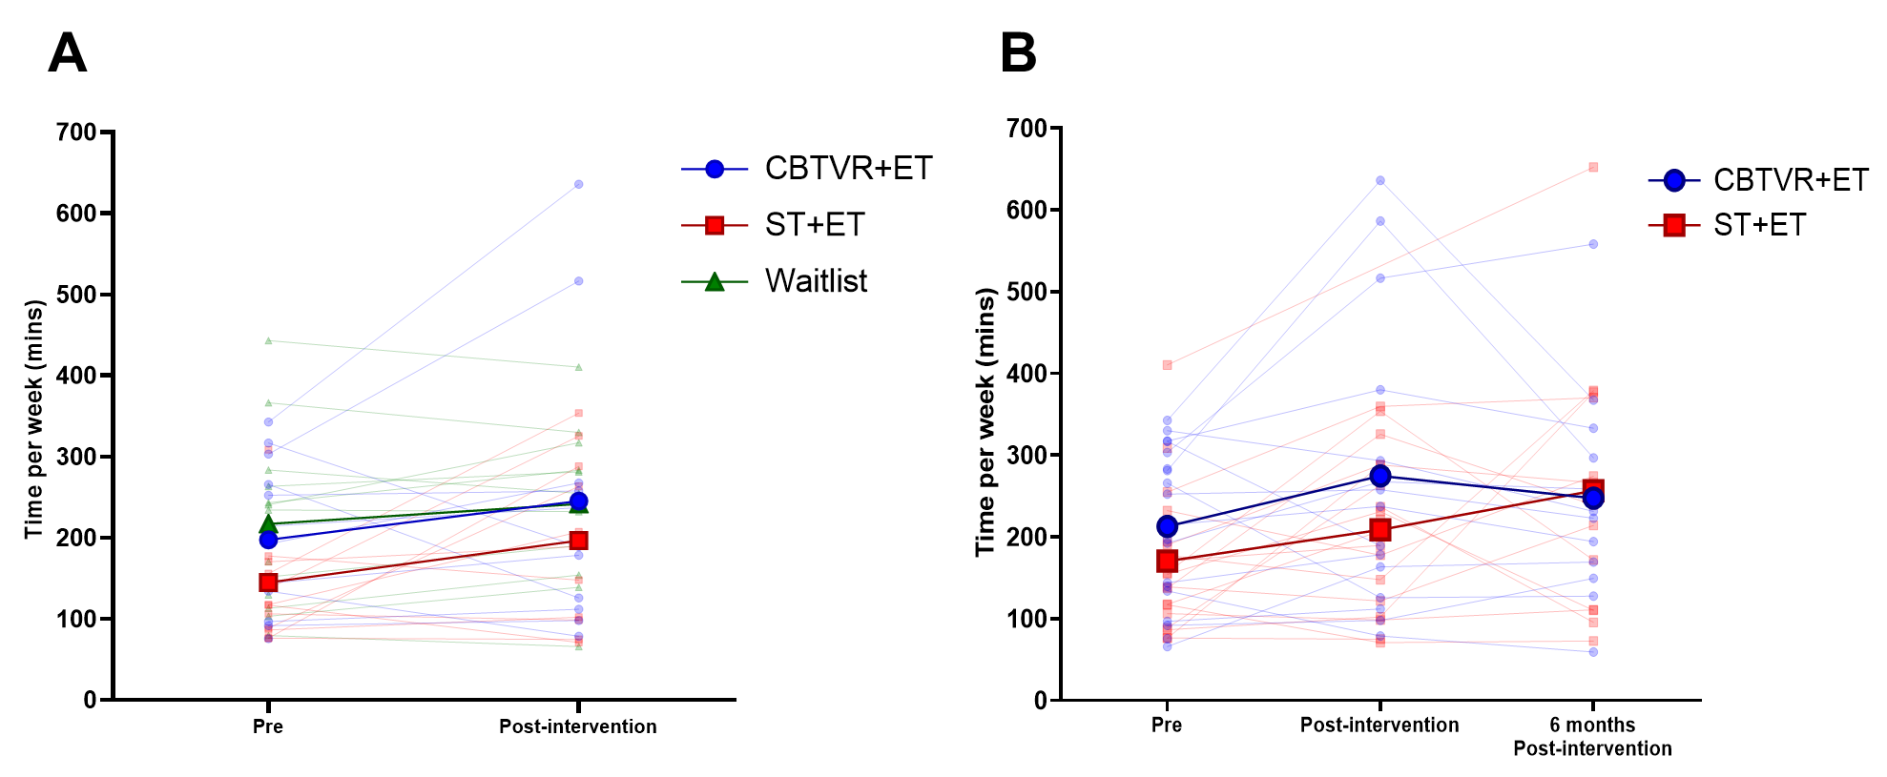
Figure S1. Weekly moderate-to-high intensity physical activity (accelerometry)
Accelerometry-derived means (thicker lines and markers) and individual (thinner and transparent lines and makers) weekly time spent doing moderate to high intensity physical activity. In Panel A, participants in the waitlist are presented independently as a control group and their T1Bis data are used for post-intervention (T2). In Panel B participants initially included in the waitlist groups are reallocated into the CBTVR+ET or ST+ET groups. Their T1Bis data are used as T1 (Pre). For participants initially included in either intervention groups, Pre, post-intervention and six months post-intervention time points are representative of T1, T2 and T3, respectively.

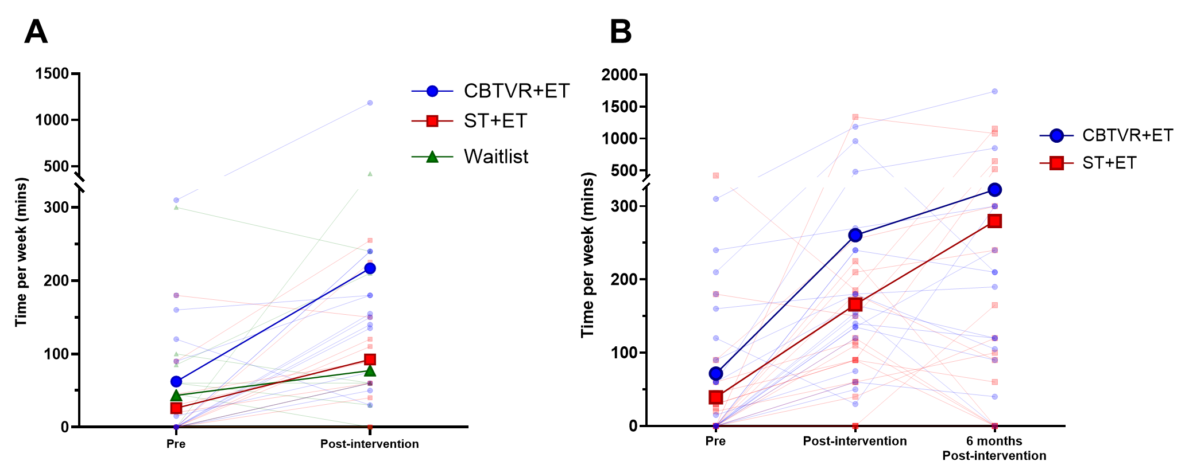
Figure S2. Weekly self-reported moderate-to-high intensity physical activity
Self-reported means (thicker lines and markers) and individual (thinner and transparent lines and makers) weekly time spent doing moderate to high intensity physical activity – assessed with General Physical Activity Questionnaire (GPAQ). In Panel A, participants in the waitlist are presented independently as a control group and their T1Bis data are used for post-intervention (T2). In Panel B participants initially included in the waitlist groups are reallocated into the CBTVR+ET or ST+ET groups. Their T1Bis data are used as T1 (Pre). For participants initially included in either intervention groups, Pre, post-intervention and six months post-intervention time points are representative of T1, T2 and T3, respectively.

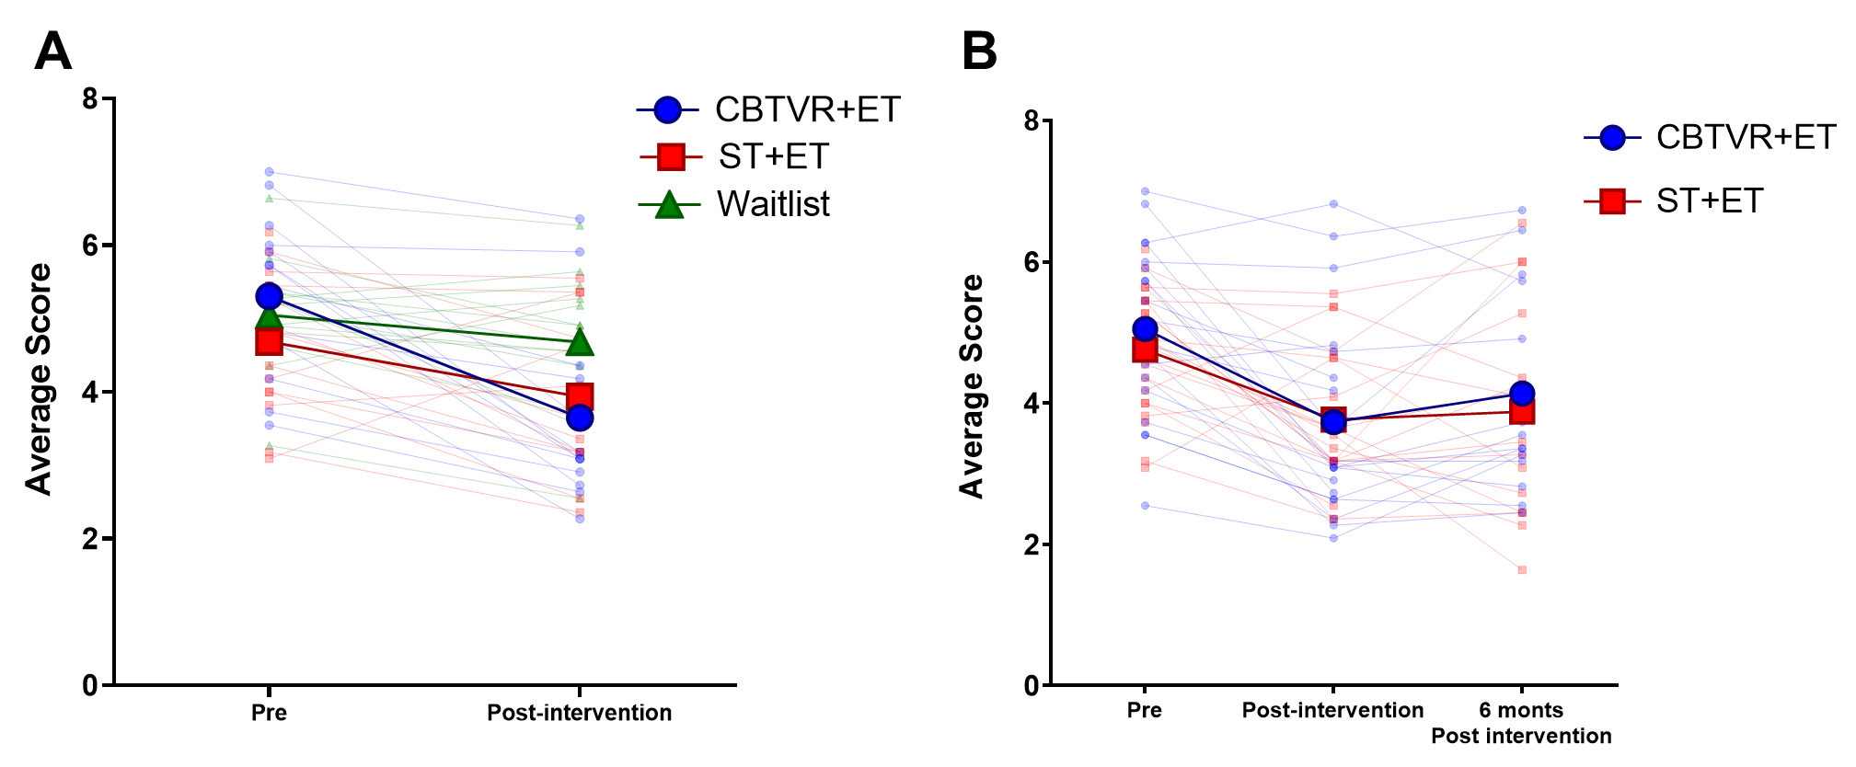
Figure S3. Weight bias internalisation scores
Means (thicker lines and makers) and individual (thinner and transparent lines and markers) scores for the weight bias internalisation questionnaire. Scores of each item from the questionnaire were averaged in an overall score. In Panel A, participants in the waitlist are presented independently as a control group and their T1Bis data are used for post-intervention (T2). Panel B participants initially included in the waitlist groups are reallocated into the CBTVR+ET or ST+ET groups and their T1Bis data are used as T1 (Pre). For participants initially included in either intervention groups, Pre, post-intervention and six months post-intervention time points are representative of T1, T2 and T3, respectively. In

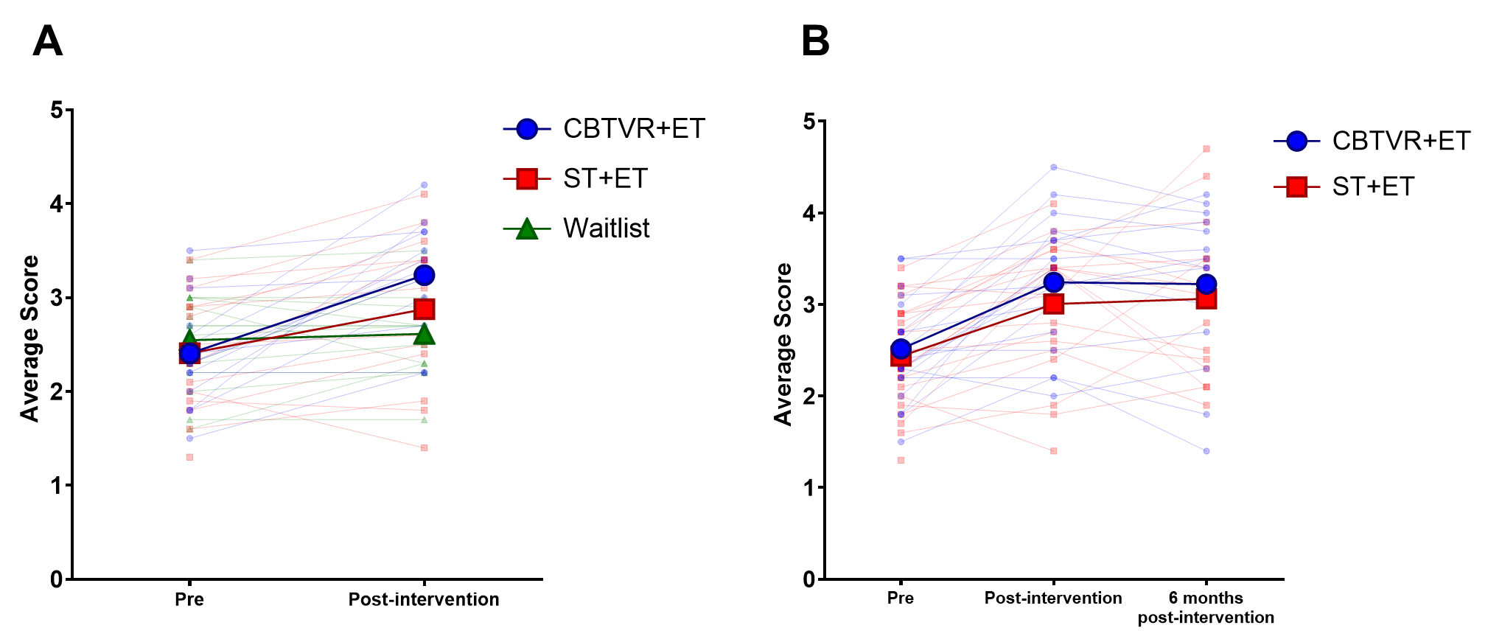
Figure S4. Body appreciation scale scores
Means and individual scores for the body appreciation scale. Scores of each item from the questionnaire were averaged in an overall score. In Panel A, participants in the waitlist are presented independently as a control group and their T1Bis data are used for post-intervention (T2). In Panel B participants initially included in the waitlist groups are reallocated into the CBTVR+ET or ST+ET groups and their T1Bis data are used as T1 (Pre). For participants initially included in either intervention groups, Pre, post-intervention and six months post-intervention time points are representative of T1, T2 and T3, respectively.

Table S4. Daily sedentary behaviors and physical activity derived from accelerometer data (2 groups)
 |  | CBTVR+ET |  |  | ST+ET
 |  | n | mean±SD | 95% CI  (LB-UB) | n | mean±SD | 95% CI  (LB-UB)
Sedentary time (h/day) | T1 | 19 | 10.8±1.1 | 10.3-11.4 | 20 | 10.8±1.1 | 10.3-11.3
Sedentary time (h/day) | T2 | 15 | 10.5±1.4 | 9.7-11.3 | 18 | 10.6±1.3 | 10.0-11.3
Sedentary time (h/day) | T3 | 12 | 10.9±1.1 | 10.2-11.6 | 13 | 10.6±1.4 | 9.8-11.5
LPA  (h/day) | T1 | 19 | 2.6±0.9 | 2.2-3.0 | 20 | 2.5±0.6 | 2.3-2.8
LPA  (h/day) | T2 | 15 | 2.5±0.9 | 2.0-3.0 | 18 | 2.5±0.5 | 2.2-2.7
LPA  (h/day) | T3 | 12 | 2.4±0.7 | 2.0-2.9 | 13 | 2.5±0.6 | 2.1-2.8
Step count (n/day) | T1 | 19 | 4893.1±1824.2 | 4013.8-5772.3 | 20 | 4128.8±1334.2 | 3504.4-4753.2
Step count (n/day) | T2 | 15 | 6040.4±3028.5 | 4363.2-7717.5 | 18 | 4771.9±1361.4 | 4094.9-5448.9
Step count (n/day) | T3 | 12 | 5490.2±2034.3 | 4197.7-6782.7 | 13 | 5547.8±2571.8 | 3993.7-7102.0
Notes: T1bis values were used as T1 for participants initially allocated to the waitlist group. LPA: Light Physical Activity; CBTVR+ET: CBT-based psychological intervention with VR-based exposure and exercise training; ST+ET: psychological supportive intervention and exercise training; SD: standard deviation; CI: Confidence intervals; LB: Lower bound; UB: Upper bound

Table S5. Daily sedentary behaviors and physical activity derived from accelerometer data (3 groups)
 |  | CBTVR+ET |  |  | ST+ET |  |  | Waitlist
 |  | n | mean±SD | 95% CI  (LB-UB) | n | mean±SD | 95% CI  (LB-UB) | n | mean±SD | 95% CI  (LB-UB)
Sedentary time  (h/day) | T1 | 14 | 11.0±1.0 | 10.4-11.6 | 14 | 10.8±1.1 | 10.1-11.4 | 13 | 11.1±1.1 | 10.4-11.7
Sedentary time  (h/day) | T2 | 11 | 10.7±1.4 | 9.8-11.7 | 12 | 10.4±1.4 | 9.5-11.2 | 11 | 10.6±1.1 | 9.8-11.3
LPA  (h/day) | T1 | 14 | 2.5±0.9 | 2.0-3.1 | 14 | 2.4±0.4 | 2.1-2.6 | 13 | 2.5±0.7 | 2.1-2.9
LPA  (h/day) | T2 | 11 | 2.4±0.9 | 1.8-3.1 | 12 | 2.4±0.4 | 2.1-2.6 | 11 | 2.8±0.8 | 2.3-3.3
Step count (n/day) | T1 | 14 | 4662.4±1733.5 | 3661.5-5663.3 | 14 | 3731.5±994.0 | 3157.5-4305.4 | 13 | 4797.0±2129.8 | 3510.0-6084.1
Step count (n/day) | T2 | 11 | 5417.8±2814.7 | 3526.8-7308.7 | 12 | 4458.4±1481.6 | 3517.0-5399.8 | 11 | 5275.5±1795.7 | 4069.1-6481.9
Notes: T1bis values were used as T2 for the waitlist group. LPA: Low-intensity physical activity; MHPA: Moderate-to-high intensity physical activity; CBTVR+ET: CBT-based psychological intervention with VR-based exposure and exercise training; ST+ET: psychological supportive intervention and exercise training; SD: standard deviation; CI: Confidence intervals; LB: Lower bound; UB: Upper bound

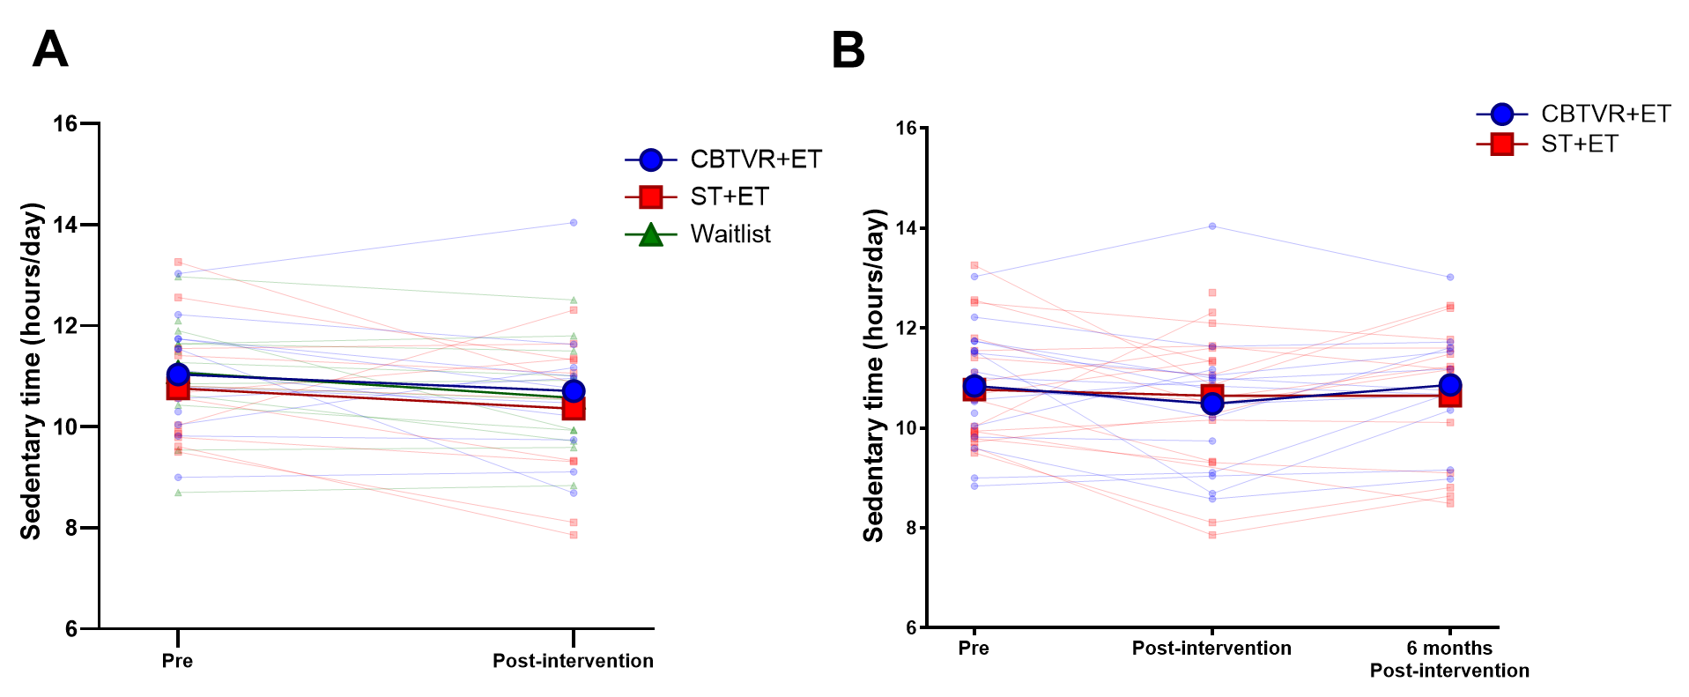

Figure S5. Daily sedentary time
Accelerometry-derived means (thicker lines and markers) and individual (thinner and transparent lines and makers) daily time spent doing sedentary activity. In Panel A, participants in the waitlist are presented independently as a control group and their T1Bis data are used for post-intervention (T2). In Panel B participants initially included in the waitlist groups are reallocated into the CBTVR+ET or ST+ET groups. Their T1Bis data are used as T1 (Pre). For participants initially included in either intervention groups, Pre, post-intervention and six months post-intervention time points are representative of T1, T2 and T3, respectively.

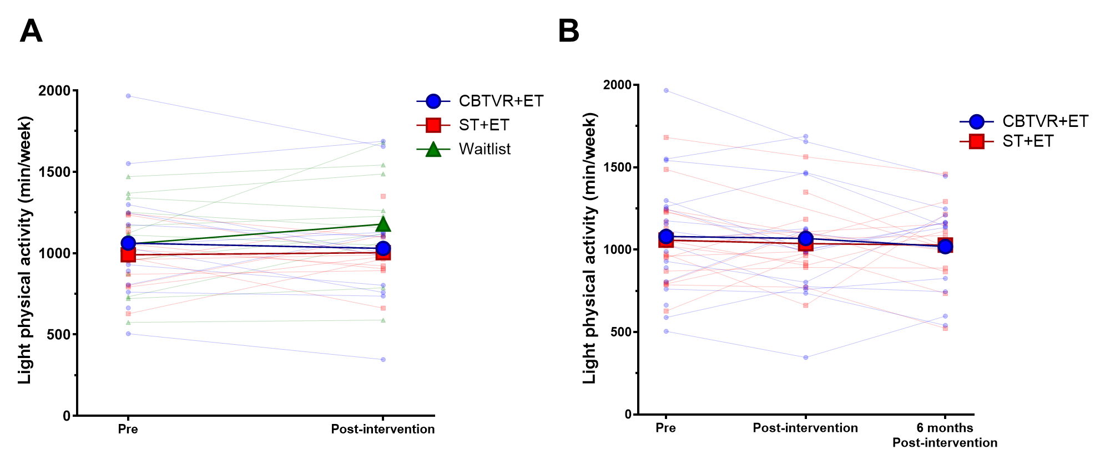
Figure S6. Daily light physical activity
Accelerometry-derived means (thicker lines and markers) and individual (thinner and transparent lines and makers) weekly time spent in light physical activity. In Panel A, participants in the waitlist are presented independently as a control group and their T1Bis data are used for post-intervention (T2). In Panel B participants initially included in the waitlist groups are reallocated into the CBTVR+ET or ST+ET groups. Their T1Bis data are used as T1 (Pre). For participants initially included in either intervention groups, Pre, post-intervention and six months post-intervention time points are representative of T1, T2 and T3, respectively.

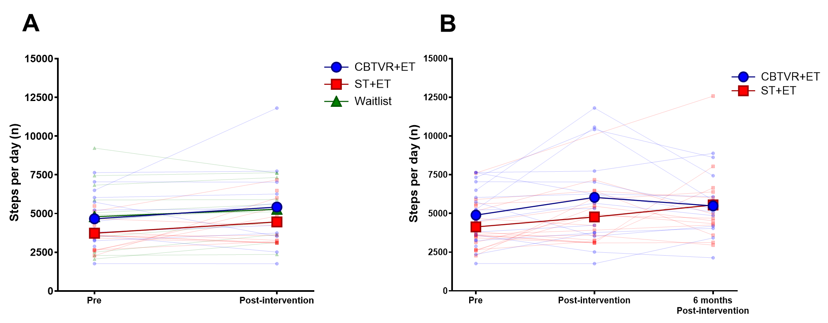
Figure S7. Steps per day
Accelerometry-derived means (thicker lines and markers) and individual (thinner and transparent lines and makers) daily step count. In Panel A, participants in the waitlist are presented independently as a control group and their T1Bis data are used for post-intervention (T2). In Panel B participants initially included in the waitlist groups are reallocated into the CBTVR+ET or ST+ET groups. Their T1Bis data are used as T1 (Pre). For participants initially included in either intervention groups, Pre, post-intervention and six months post-intervention time points are representative of T1, T2 and T3, respectively.

Table S6. Anthropometry and body composition (2 groups)
 |  | CBTVR+ET |  |  | ST+ET
 |  | n | mean±SD | 95% CI  (LB-UB) | n | mean±SD | 95% CI  (LB-UB)
BMI (kg/m2) | T1 | 21 | 40.7±5.0 | 38.5-43.0 | 22 | 39.2±5.7 | 36.7-41.7
BMI (kg/m2) | T2 | 19 | 40.5±5.0 | 38.1-42.9 | 20 | 39.1±6.0 | 36.3-41.9
BMI (kg/m2) | T3 | 14 | 40.2±5.2 | 37.3-43.2 | 15 | 37.4±5.6 | 34.3-40.5
WC (cm) | T1 | 21 | 121.9±12.5 | 116.2-127.6 | 22 | 116.6±10.1 | 112.1-121.1
WC (cm) | T2 | 19 | 121.3±12.3 | 115.4-127.3 | 20 | 115.2±9.4 | 110.8-119.6
WC (cm) | T3 | 14 | 117.6±13.7 | 109.7-125.5 | 15 | 110.8±10.7 | 104.9-116.6
FM (%) | T1 | 21 | 45.1±2.6 | 43.9-46.3 | 22 | 44.3±4.2 | 42.4-46.2
FM (%) | T2 | 19 | 45.0±1.8 | 44.2-45.9 | 20 | 43.2±4.5 | 41.1-45.3
FM (%) | T3 | 14 | 45.0±2.9 | 43.3-46.7 | 15 | 42.2±6.5 | 38.6-45.8
FM (kg) | T1 | 20 | 51.0±9.1 | 46.8-55.3 | 22 | 47.8±10.4 | 43.2-52.4
FM (kg) | T2 | 19 | 50.8±7.9 | 47.0-54.7 | 20 | 46.5±10.9 | 41.4-51.6
FM (kg) | T3 | 14 | 50.9±9.2 | 45.6-56.3 | 15 | 44.1±13.0 | 36.9-51.2
LM (%) | T1 | 21 | 54.8±2.5 | 53.6-55.9 | 22 | 55.7±4.2 | 53.8-57.6
LM (%) | T2 | 19 | 55.0±1.8 | 54.1-55.8 | 20 | 56.8±4.5 | 54.8-58.9
LM (%) | T3 | 14 | 55.0±2.9 | 53.3-56.7 | 15 | 57.8±6.4 | 54.2-61.4
LM (kg) | T1 | 20 | 61.4±7.3 | 57.9-64.8 | 22 | 59.0±5.4 | 56.6-61.4
LM (kg) | T2 | 19 | 61.8±7.8 | 58.1-65.6 | 20 | 60.0±6.0 | 57.1-62.8
LM (kg) | T3 | 14 | 61.8±7.9 | 57.2-66.4 | 15 | 58.3±5.3 | 55.3-61.2
Notes: T1bis values were used as T1 for the participants initially allocated to the waitlist group. BMI: Body mass index; WC: Waist circumference; FM: Fat mass; LM: Lean Mass; CBTVR+ET:CBT-based psychological intervention with VR-based exposure and exercise training; ST+ET: psychological supportive intervention and exercise training;

Table S7. Anthropometry and body composition (3 groups)
 |  | CBTVR+ET |  |  | ST+ET |  |  | WL
 |  | n | mean±SD | 95% CI  (LB-UB) | n | mean±SD | 95% CI  (LB-UB) | n | mean±SD | 95% CI  (LB-UB)
BMI (kg/m2) | T1 | 15 | 41.4±5.0 | 38.6-44.1 | 15 | 39.1±5.7 | 35.9-42.3 | 15 | 40.0±5.2 | 37.1-42.9
BMI (kg/m2) | T2 | 13 | 41.5±4.9 | 38.5-44.5 | 13 | 39.2±6.4 | 35.3-43.0 | 13 | 39.2±5.3 | 36.0-42.4
WC (cm) | T1 | 15 | 123.3±12.1 | 116.6-130 | 15 | 116.2±9.4 | 111.0-121.4 | 15 | 118.1±10.8 | 112.1-124.0
WC (cm) | T2 | 13 | 122.9±11.8 | 115.8-130 | 13 | 116.4±7.3 | 112.0-120.8 | 13 | 117.8±12.5 | 110.2-125.4
FM (%) | T1 | 15 | 45.5±2.6 | 44.0-46.9 | 15 | 44.3±4.1 | 42.0-46.6 | 15 | 44.5±3.7 | 42.4-46.5
FM (%) | T2 | 13 | 45.7±1.5 | 44.8-46.6 | 13 | 43.1±4.5 | 40.4-45.8 | 13 | 44.2±3.7 | 42.0-46.4
FM (kg) | T1 | 15 | 52.0±8.8 | 47.1-56.8 | 15 | 47.1±10.2 | 41.4-52.7 | 15 | 49.8±9.9 | 44.3-55.3
FM (kg) | T2 | 13 | 52.3±7.6 | 47.7-56.9 | 13 | 45.7±11.1 | 39.0-52.4 | 12 | 48.9±10.5 | 42.3-55.6
LM (%) | T1 | 15 | 54.5±2.6 | 53.1-56.0 | 15 | 55.7±4.1 | 53.4-58.0 | 15 | 55.5±3.7 | 53.5-57.6
LM (%) | T2 | 13 | 54.3±1.5 | 53.4-55.2 | 13 | 56.9±4.5 | 54.2-59.6 | 13 | 55.6±3.7 | 53.3-57.8
LM (kg) | T1 | 15 | 61.8±6.8 | 58.1-65.6 | 15 | 58.1±5.5 | 55.0-61.1 | 15 | 61.5±6.9 | 57.7-65.3
LM (kg) | T2 | 13 | 62.0±7.6 | 57.4-66.6 | 13 | 59.2±6.8 | 55.1-63.3 | 12 | 61.0±6.6 | 57.0-65.0
Notes: T1bis values were used as T2 for the participants in the waitlist group. BMI: Body mass index; WC: Waist circumference; FM: Fat mass; LM: Lean Mass; CBTVR+ET: CBT-based psychological intervention with VR-based exposure and exercise training; ST+ET: psychological supportive intervention and exercise training; WL: Waitlist; SD: standard deviation; CI: Confidence intervals; LB: Lower bound; UB: Upper bound

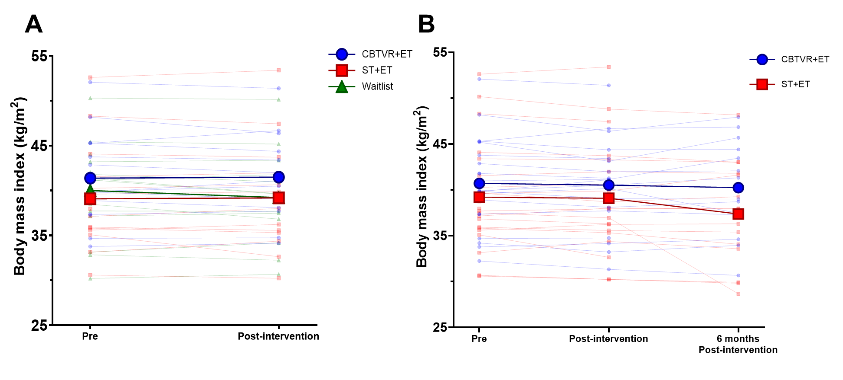

Figure S8. Body mass index
Means (thicker lines and markers) and individual (thinner and transparent lines and makers) value of body mass index. In Panel A, participants in the waitlist are presented independently as a control group and their T1Bis data are used for post-intervention (T2). In Panel B participants initially included in the waitlist groups are reallocated into the CBTVR+ET or ST+ET groups. Their T1Bis data are used as T1 (Pre). For participants initially included in either intervention groups, Pre, post-intervention and six months post-intervention time points are representative of T1, T2 and T3, respectively.

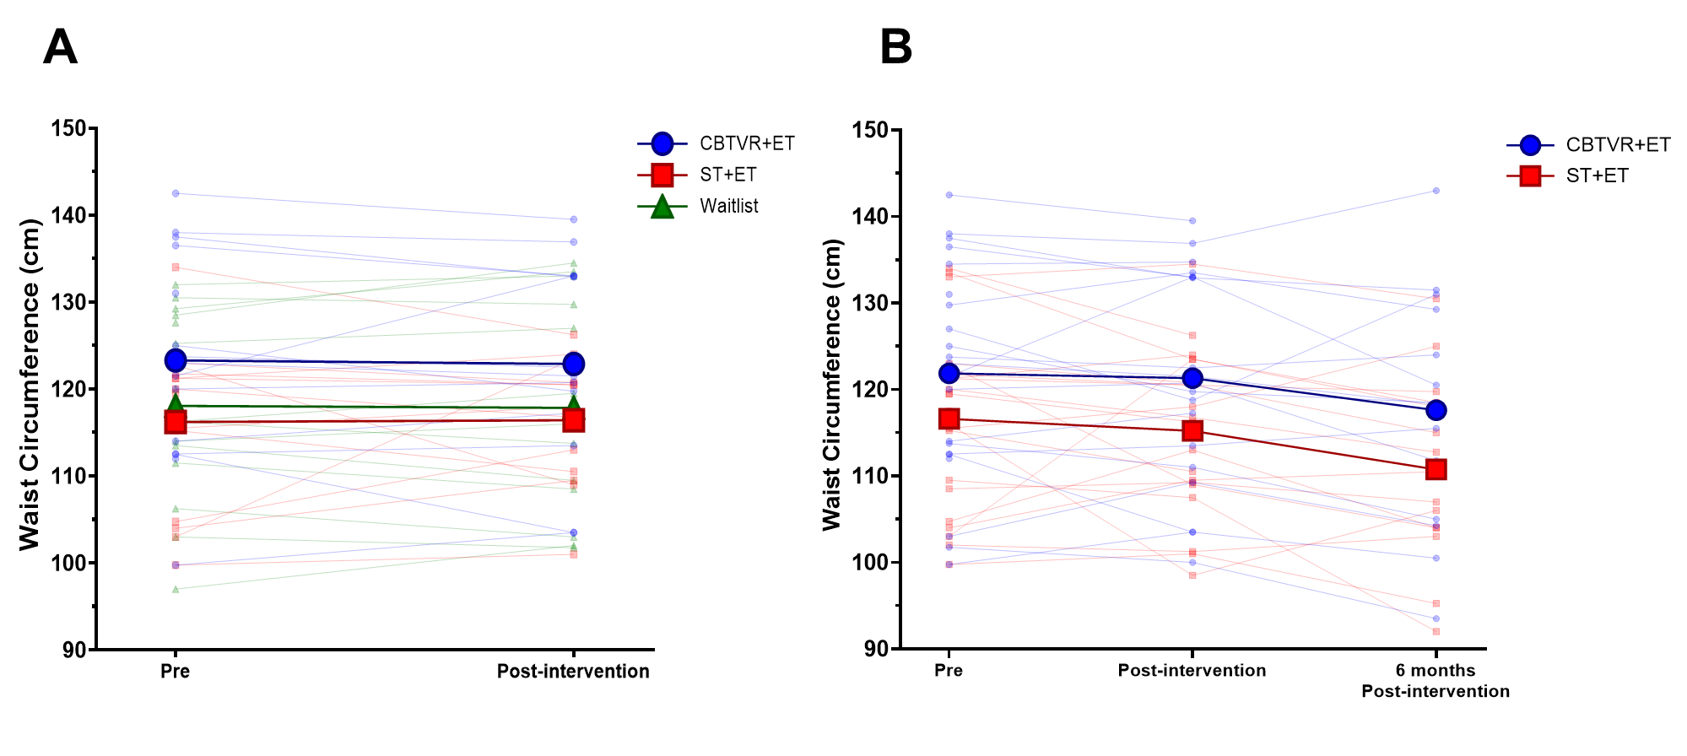

Figure S9. Waist circumference
Means (thicker lines and markers) and individual (thinner and transparent lines and makers) value of waist circumference. In Panel A, participants in the waitlist are presented independently as a control group and their T1Bis data are used for post-intervention (T2). In Panel B participants initially included in the waitlist groups are reallocated into the CBTVR+ET or ST+ET groups. Their T1Bis data are used as T1 (Pre). For participants initially included in either intervention groups, Pre, post-intervention and six months post-intervention time points are representative of T1, T2 and T3, respectively.

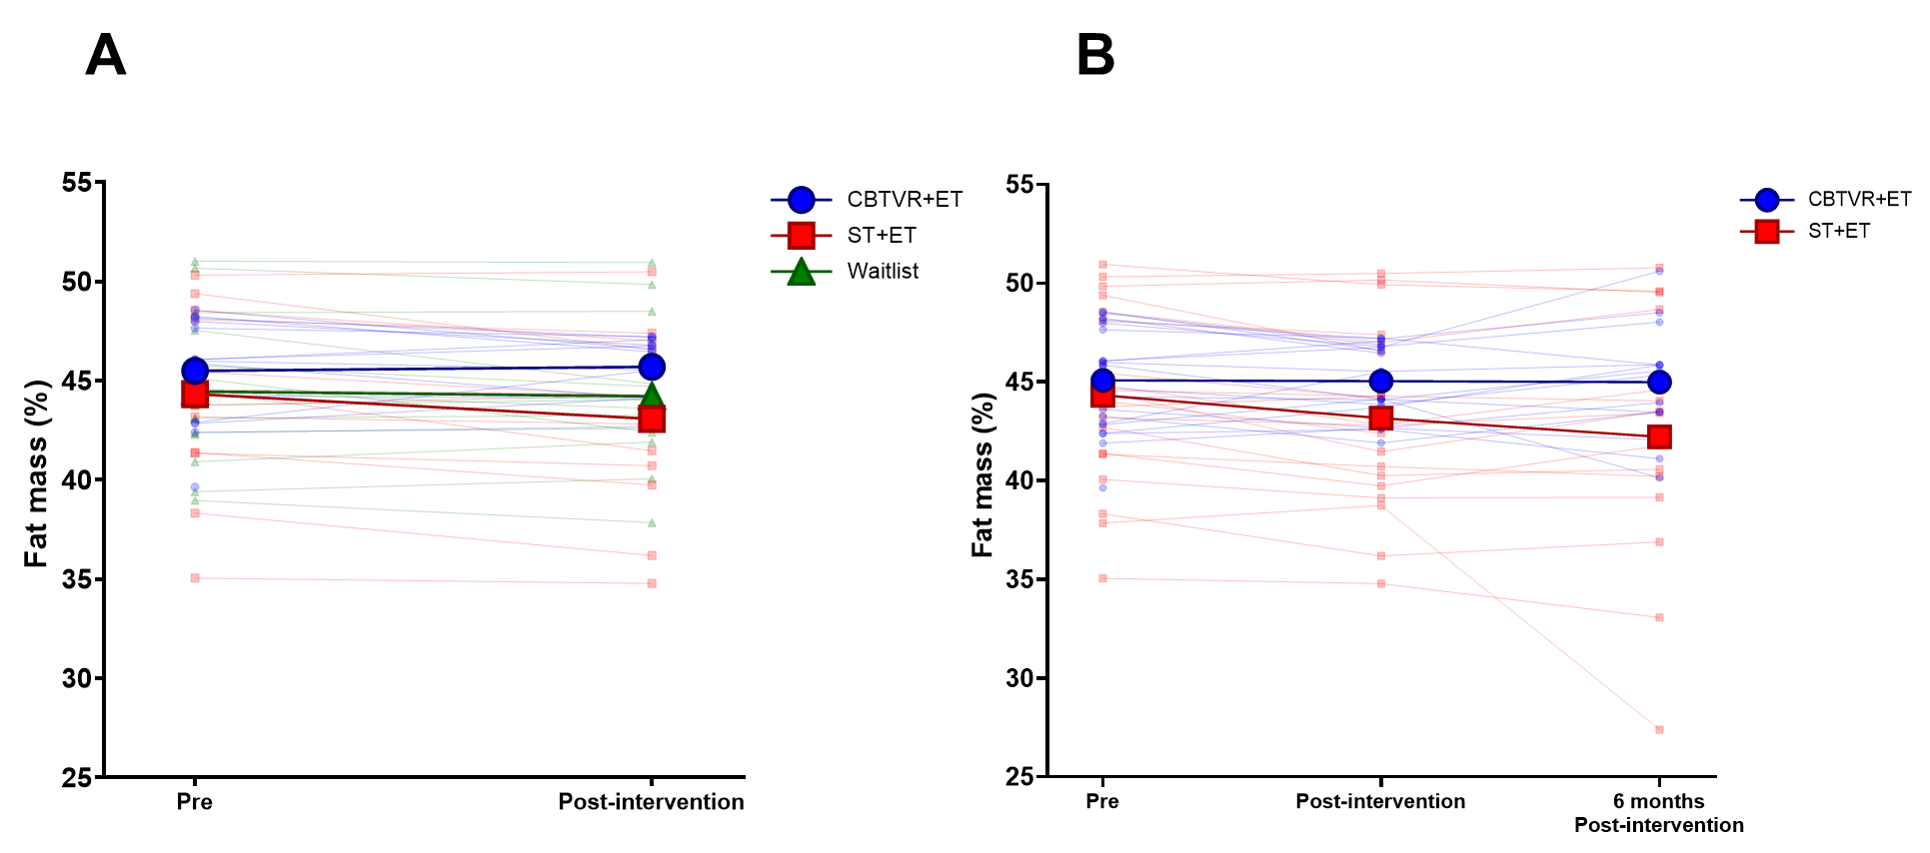

Figure S10. Fat mass percentage
Bio-impedance-derived means (thicker lines and markers) and individual (thinner and transparent lines and makers) values of fat mass percentage. In Panel A, participants in the waitlist are presented independently as a control group and their T1Bis data are used for post-intervention (T2). In Panel B participants initially included in the waitlist groups are reallocated into the CBTVR+ET or ST+ET groups. Their T1Bis data are used as T1 (Pre). For participants initially included in either intervention groups, Pre, post-intervention and six months post-intervention time points are representative of T1, T2 and T3, respectively.

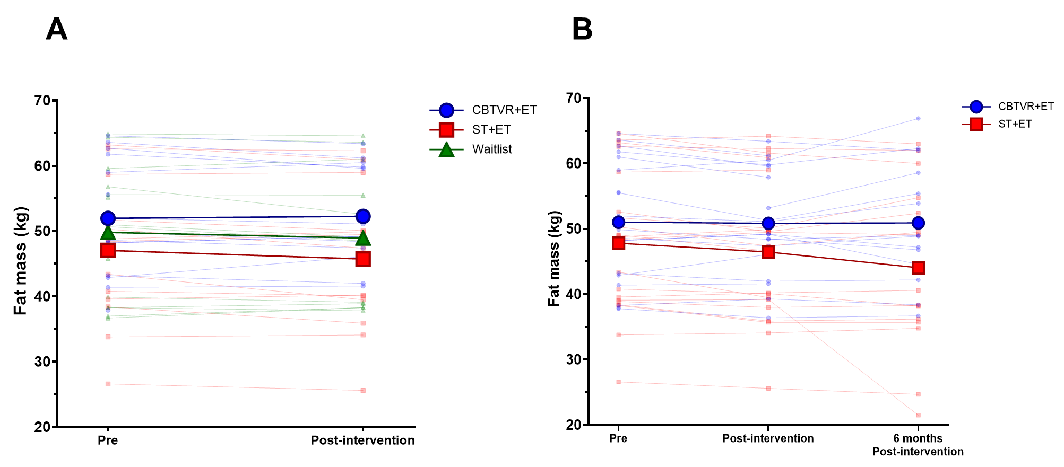

Figure S11. Fat mass
Bio-impedance-derived means (thicker lines and markers) and individual (thinner and transparent lines and makers) values of fat mass. In Panel A, participants in the waitlist are presented independently as a control group and their T1Bis data are used for post-intervention (T2). In Panel B participants initially included in the waitlist groups are reallocated into the CBTVR+ET or ST+ET groups. Their T1Bis data are used as T1 (Pre). For participants initially included in either intervention groups, Pre, post-intervention and six months post-intervention time points are representative of T1, T2 and T3, respectively.

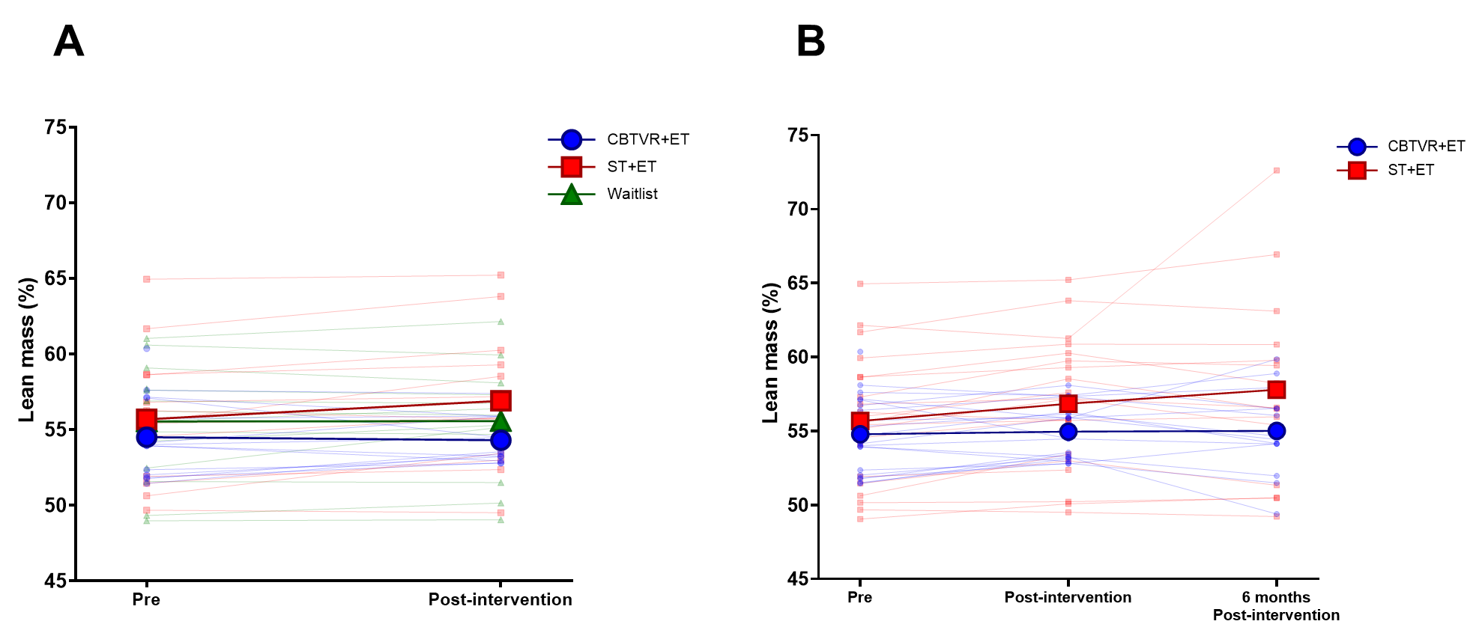

Figure S12. Lean mass percentage
Bio-impedance-derived means (thicker lines and markers) and individual (thinner and transparent lines and makers) values of lean mass percentage. In Panel A, participants in the waitlist are presented independently as a control group and their T1Bis data are used for post-intervention (T2). In Panel B participants initially included in the waitlist groups are reallocated into the CBTVR+ET or ST+ET groups. Their T1Bis data are used as T1 (Pre). For participants initially included in either intervention groups, Pre, post-intervention and six months post-intervention time points are representative of T1, T2 and T3, respectively.

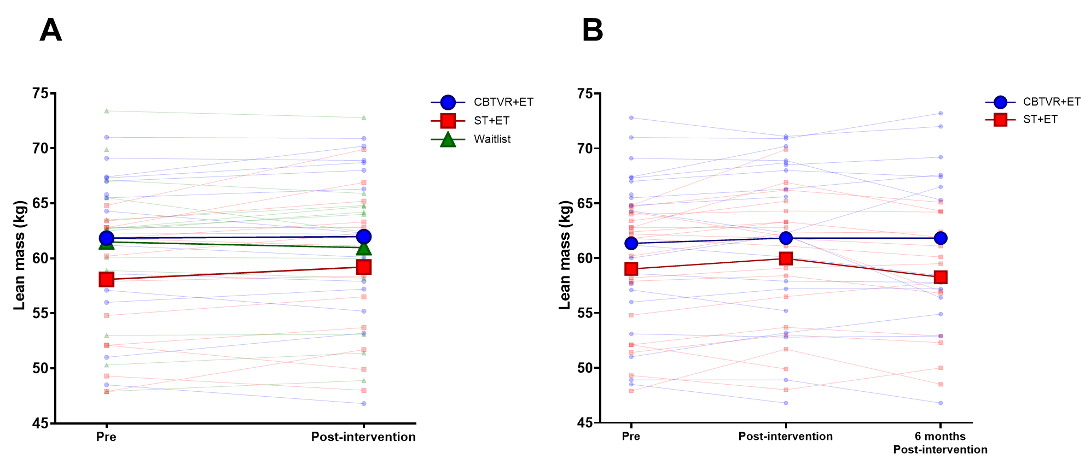

Figure S13. Lean mass (kg)
Bio-impedance-derived means (thicker lines and markers) and individual (thinner and transparent lines and makers) values of lean mass. In Panel A, participants in the waitlist are presented independently as a control group and their T1Bis data are used for post-intervention (T2). In Panel B participants initially included in the waitlist groups are reallocated into the CBTVR+ET or ST+ET groups. Their T1Bis data are used as T1 (Pre). For participants initially included in either intervention groups, Pre, post-intervention and six months post-intervention time points are representative of T1, T2 and T3, respectively.

